**“Medical Appointment System**

**(Drmedizone)”**

**A Project Report**

Submitted in partial fulfilment of

Requirement for award of Degree of

**BACHELOR OF SCIENCE (INFORMATION TECHNOLOGY)**

**By**

Mr. SIDDHESH SANJAY LANJEKAR

4019076

**Under esteemed guidance of**

**Mrs. ADITI CHIKHALIKAR**

**Asst Professor**



**DEPARTMENT OF INFORMATION TECHNOLOGY**

**BUNTS SANGHA’S S.M. SHETTY COLLEGE OF**

**SCIENCE, COMMERCE**

**& MANAGEMENT STUDIES**

**(Affiliated to University of Mumbai)**

**MUMBAI 400076**

**MAHARASHTRA**

**2022-23**

**BUNTS SANGHA’S S.M. SHETTY COLLEGE OF SCIENCE, COMMERCE & MANAGEMENT STUDIES**

**(Affiliated to University of Mumbai)**

**CITY-MAHARASHTRA-400076**

**DEPARTMENT OF INFORMATION TECHNOLOGY**



**CERTIFICATE**

This is to certify that project entitled, **"Medical Appointment System (Drmedizone)",** is Bonafede effort of **Mr. Siddhesh Sanjay Lanjekar** bearing **Seat No: 4019076** submitted in partial fulfilment of necessities for award of degree of BACHELOR OF SCIENCE in INFORMATION TECHNOLOGY from University of Mumbai.

**Internal Guide Coordinator**

**Date: External Examiner**

# **ACKNOWLEDGEMENT**

project presented, as part of curriculum, was first experience of this kind for me. I had considered this project not only as a program of studies to be completed, but as a goal to learn, study, develop & test commercial software technologies. I am pleased to be able to say that, in an acceptable manner. I have achieved my goals & goals to make this project a result. I would like to thank & thank support of some who have helped physically, mentally & intellectually during this project Foremost regards to my guide **Asst.** **Prof, Aditi Shashank Chikhalikar** I would thank **Principal, Dr. Sridhara Shetty** who made available facilities required for project effort. I also want to mention tacit support of my parents who, as always, helped me as much as possible to make my job a success. contribution made by my friends & mates, directly or indirectly was indispensable, & will always be remembered This opportunity has given me a valuable experience about software development.

-Siddhesh Lanjekar

# **DECLARATION**

**Medical Appointment System (Drmedizone)** place where project is done, has not been in any case duplicated to submit to any or university for award of any degree. To best of my knowledge or than me, no one has submitted to any or university. project is done in partial fulfilment of necessities for award of degree of BACHELOR OF SCIENCE (INFORMATION TECHNOLOGY) to be submitted as final semester project as part of our curriculum.

-Siddhesh Sanjay Lanjekar

**INDEX**

|  |  |  |
| --- | --- | --- |
| **Sr. No.** | **Content** | **Page No.** |
| **Chapter 1** | **Introduction** | **1-2** |
| 1.1 | Background | 1 |
| 1.2 | Objectives | 1 |
| 1.3 | System Overview | 1 |
| 1.4 | Purpose | 1 |
| 1.5 | Scope | 2 |
| 1.6 | Applicability | 2 |
| **Chapter 2** | **Survey of Technology** | **3-5** |
| 2.1 | Description of Project | 3 |
| 2.2 | Available Technologies | 3 |
| 2.3 | Justification of Platform | 4 |
| 2.4 | Feasibility Study | 4 |
| **Chapter 3** | **Necessities & Analysis** | **6-10** |
| 3.1 | Problem Definition | 6 |
| 3.2 | Hardware & Software Necessities | 6 |
| 3.3 | Software Necessities for User | 6 |
| 3.4 | Functional Necessities | 7 |
| 3.5 | Project Constraints | 8 |
| 3.6 | Gian Chart | 9 |
| **Chapter 4** | **System Design** | **10-40** |
| 4.1 | Basic Module | 10 |
| 4.2 | Creation of Diagrams | 10 |
| 4.2.1 | ER Diagram | 10 |
| 4.2.2 | Flow Chart | 16 |
| 4.2.3 | Activity Diagram | 18 |
| 4.2.4 | Data flow Diagram | 24 |
| 4.2.5 | Use-Case Diagram | 26 |
| 4.2.6 | Sequence Diagram | 28 |
| 4.2.7 | Class Diagram | 29 |
| 4.3 | List of tables with attributes & constraints | 33 |
| 4.4 | Test Cases | 38 |
| **Chapter 5** | **Implementation & Testing** | **41-48** |
| 5.1 | Model Used | 41 |
| 5.2 | Detail of tools & technology used | 41 |
| **Chapter 6** | **Testing** | **49-53** |
| 6.1 | Testing Approach | 49 |
| **Chapter 7** | **User Interface** | **54-82** |
| **Chapter 8** | **Result & Discussion** | **83** |
| 8.1 | Test Report | 83 |
| 8.2 | Project Information | 83 |
| **Chapter 9** | **Conclusion** | **84** |
| 9.1 | Future Scope | 84 |
| **Chapter 10** | **Bibliography** | **86** |

Drmedizone

Submitted By:

Siddhesh Lanjekar

Seat no: 4019076

Project Guide:

Asst Prof. Aditi Shashank Chikhalikar

**Chapter 1 - INTRODUCTION**

“Drmedizone" was developed to overcome problems prevalent in practical manual systems. This software is supported to remove & possibly mitigate problems met by this present system. In adding, system is designed with specific needs of people in mind, allowing operations to run smoothly & effectively.

If you enter invalid data, an error message is displayed. No formal knowledge is required for users to use this system. That alone proves its usability. Drmedizone above can be bug-free, secure, reliable & fast system. It helps users focus on or activities instead of focusing on record keeping.

Drmedizone is an online doctor appointment booking system this is web-application which allows public of a specific area to book appointment on your choice & order medicines. This system delivers a login & registration for doctor & patients. Doctor is creating account by giving required details like timings, fees, category, etc. After successful creating account, doctor & patient can log-in by giving a user-name & password. doctor reviews patient's request for an appointment, & if request is accepted, status indicates that appointment has been confirmed for patient. Patients must register & enter to select doctors based on category & type of problem patient is facing. search results will show list of doctor’s similar patient’s required norms & he can select one & send a request, request will be forwarded to doctor & if he is available, he will send approval back to patient. patient can view status. After confirming appointment send confirmation email to patients.

**1.1 BACKGROUND:**

This digital world makes our lives easier & better. All kinds of industries are changing us technology. All things go from offline-to-online, saving time & using this time for or things therefore, medical industry is also moving from offline to online. So Drmedizone is Python-based Web-application. I am embarking on expedition to improve health of you & family. At Drmedizone, all surgeons are cheap to all patients & our surgeons a well-trained & qualified. Our projects are adaptable to our needs.

**1.2 OBJECTIVES:**

cause of this Web-application is to bring amity of thoughts to both doctors & sufferers. sufferers mutually visit health-centre for appointments & other reasons, wasting money & time. se problems are conquered via this challenge. Globally available physicians seek based totally on patient. We can also a set to up & lab take a look at dates for you. Drmedizone great Web-application for mutual place diseases & ugly condition.

main cause of Drmedizone responsibility is to control surgeons, medical surgeon agendas, clinical news & health physician details. projects are made completely on admin facet, so simple directors are as definite get entry to. cause of this undertaking is to create a software to reduce guide paintings associated with handling medical doctors, appointments, medical expenses & sufferers. saw all affected person, appointment & doctor time table info.

**1.3 System Overview: -**

**Description of existing system. :-**

This platform was created to save you money, & time make & your life easy; Over this project, I am going to meet you with best & most educated doctors. Sometimes patients are in very trouble finding experts doctors; So, over this project, patients can find & meet a doctor very easily. Using this project, patients make doctor appointments, Lab appointments & order medicines.

**1.4 PURPOSE:**

Persistence of project is Doctor appointment system that Delivers Doctors & also Patients. A doctor gives appointment time & days (how much time/day appointment taking is open) & also in this project I include medicine e-commerce system. This project is two types of appointment-based project; one is video calling meeting appointments & or is a face-to-face meeting appointment. This project overcome problems managing & booking an appointment over doctor & patient. Patients taking appointments as per schedule after opening appointment time to before closing time.

Patients are buying online medicines. Any appointment-taking messages are also given to patient’s registered mobile number or email. This project also provide options for appointment is video meeting & personal meeting; patient also cancelling appointment option is present. In this project some additional features are available; doctors give health reports to a patient over application & also downloading facility is available for patients. Doctors decide how future appointments are taken by patients. Patients also chose doctors as per required criteria. This project saves doctors’ as well as patients’ time.

**1.5 SCOPE:**

This project aims to save you time & give you satisfaction. doctor also checks patients if clinic is not available because doctor is decided which types of appointments (online or offline) are taken. doctor/doctor’s assistant are managing appointments. Doctors upload patient health care reports on patients’ accounts. A patient quickly locates a nearby doctor or clinic/hospital in his/her locality & books an appointment. Search doctors by doctor’s speciality wise /city wise/ fesswise. Get updated appointment notifications are send by mobile number & email address. A Patient can buy online medicines also on this Web-application. Patients are meat overall world’s specialist doctors without living in our homes.

**Who will be using this software?**

This software are patients & doctors will be used. Over this project doctor are given treatment for any patients from any state & countries’ patients also meat world’s best expert doctors & taking treatments. Patients takes advanced appointments also & save over time & Patients can buy medicines on this Web-application; Using this project a patient & doctor also meat in online mode means video calling over

**Reports of Drmedizone: -**

* It generates file on doctor, appointment, physician fees, medicine invoice.
* Provide reports on patient, booking, doctor schedule.
* You can easily download health report PDF from doctor, appointment booking receipt, buying medicines.

**1.6 Applicability:**

Life is too busy to make an in-person doctor's appointment & get proper health care. main knowledge of this paintings is to provide patients with ease & comfort when making an appointment with a doctor, & at same time, it solves problems that patients have to deal with when making an appointment. Dremdizone Web-application as a client, while a database containing doctor, patient, appointment, medicines etc. details is maintained by a Web-application that acts as a server.

**Chapter 2 - SURVEY OF TECHNOLOGY**

* 1. **DESCRIPTION OF PROJECT:**

Drmedizone is an appointment-based & ecommerce medicine system; this project is suitable for buying medicines; doctors & patient interaction with each or. Over this project both are save over time to giving & taking appointments. Most of time this project is so useful for patient more than doctors; because patient can make an appointment with any doctors from anywhere & also buying medicines. Patients can usually find kind of speciality's doctor y want. This project is useful for doctors also. In this project doctors are giving a time & days when doctors are available; use given time & days by doctor’s patient are taking appointment for personal meeting or video calling.

* 1. **AVAILABLE TECHNOLOGIES:** 
     1. **FRONT END TECHNOLOGIES:** 
        + Html5:

It is markup language used to create structure of a web page. It is n only body of web pages. It is foundational technology & is very popular for making modern Web-application s. It is very easy & useful language for any creating Web-application s.

* + - * CSS:

CSS stand for Cascading Style Sheet; CSS is used for make html page is beautiful & user friendly. CSS thoroughly html page is customized. CSS defined of html attributes are displayed.

* + - * Java Script:

It is most popular language. It is also interpreted compiled language; JavaScript is a type scripting language; It is brain of Web-application s. If we are making attractive Web-application so JavaScript are use in this Web-application. It is use to make Web-application dynamically.

* + - * Bootstrap:

It is an open-source Cascading Style Sheet CSS framework which is used to make responsive frontend Web-application. It Delivers CSS & JavaScript templates for different attribute of HTML. Bootstrap are combination of html CSS & JavaScript.

* + 1. **BACKEND TECHNOLOGIES:**
       - **PROCEDUREING TECHNOLOGY:**
         * **Python/Django:**

Python is easy language comparatively or languages; for writing a syntax & also easy to learn. Python is also ideal backend language because of its many libraries & frameworks. Django & Flask are web development frameworks.

* + - * **DATABASE TECHNOLOGY:** 
        + **MySQL:**

MySQL is an open-source database structure query language; It is use for relational databases. Using MySQL manage over data into database. This is very popular language for relational database. Most of biggest companies used MySQL for store over data.

* 1. **JUSTIFICATION OF PLATFORM:**
     1. **FOLLOWING TECHNOLOGIES WILL BE USED IN FRONTEND:**
        + **HTML:**

Html is language very easy & it's free; html is used for developing Web-application page. it is very easy to developing Web-application page. Html syntax is very easy & understandable. Html language is also used for making responsive web pages; If we are using HTML for developing web pages so this web page is very well responsive to any type of device. Html language has supported all types of browsers. This is user-friendly language.

* + - * **Bootstrap:**

Bootstrap is also free open-source framework. It is used for manipulative purpose. Bootstrap is help to over normal web page is making attractive & beautiful with responsive web page. It is also easy to used. We are customized web page.

* + - * **CSS:**

CSS is also used manipulative over html page is beautiful. If we are using CSS in over creating web page so this page is loaded faster than without used CSS page. It’s also user friendly. CSS is also easy to learn & design web pages.

* + - * **JavaScript:**

JavaScript is a type script language. It is brain over Web-application page; Without JavaScript over web page is static. If we are making attractive webpage so used JavaScript. JavaScript is also used backend. If we are making over page animated so also used JavaScript.

* + 1. **FOLLOWING TECHNOLOGIES WILL BE USED FOR BACKEND**

**BUSINESS LOGIC:**

* + - * **Python/Django: -**

Python is easy to used & learn; we are writing a programme faster than or types of languages. In python many frameworks & libraries are available. From python we are make any types of projects. A Django, flask are frameworks of python; both are used developing a webpage. In python easy to write a project related logic. I learned python from one year. Python is also very popular & demanding language this time.

* + 1. **FOLLOWING TECHNOLOGIES WILL BE USED IN DATABASE:**
       - **MySQL: -**

It is storing a many data into database. I know that about MySQL language. If we are used relational database in over project so used MySQL. MySQL is a totally free & it is an open source. In databases MySQL are most demanding technology; most of companies are used.

* 1. **Feasibility study:**

main thing of probability study is testing practical, Affording & Inexpensive feasibility of adding new things & debugging or manipulating old running system. re are features in feasibility study helping of initial examination. A probability study is an estimation & investigation of a project or system proposed by someone. This study attempts to control where development is critically & economically. Financially viable in this situation means where development is possible within predictable costs. feasibility study also controls where plan makes commercial sense, i.e., where it is profitable. Simply put, this study analyses how simply or positively you can complete something. We also try to determine if it is profitable or not. Corporations & administrations typically conduct proof-of-concept studies when it is costly. probability study evaluates probability of a proposed plan or project. In a portion of a probability study, feasibility of development or plan is checked to control where it will be positive. As name proposes, feasibility studies-are used-to control feasibility of an idea. me. Ensuring legal & technical feasibility & economic feasibility of development. Indicates where plan is wealth investing in. In some cases, project may not start. Different types possible reasons for this. For example, if you need too many resources, not only can those resources get in way of doing or things, but it can cost a company more money than it takes to recoup & pay for lossy project.

**There are four type of Feasibility studies:**

* **Economic feasibility:**

This is very important aspect to be considered while developing a project. We decided technology based on minimum possible cost factor. All hardware & software cost has to be biome by organization. Overall, we have appraised that aids body is going to accept from planned system will confidently overcome early costs & future on running cost for system.

* **Operational feasibility:**

No distrust planned system is fully Gui built that is user friendly & all efforts to be taken all transparent even to a layperson. Besides, a proper training has been conducted to let know core of system to users so that y feels comfortable with new system. As far our study is connected clients are comfortable & happy as system has cut down if loads & doing.

* **Technical feasibility:**

This is involved study of function & presentation 7 limitations that may affect capability to reach a suitable system. For feasibility-study, we studied whole functionality to be providing in system check if all was likely using dissimilar type of frontend & backend platforms.

* **Schedules feasibility**:

A project will flop if it takes too long to be finished previously itis useful. This means guessing how long system take to progress, & if it can be finished in a given time period using some methods like profit dated. It is definite of how realistic development schedule is. Based on given data system make given tasks. Preparation a project plan & building a project schedule to

* + Complete project within time & budget.
  + Resource management system.
  + Increase project success rate.
  + Realize significant time & resource savings.

I tried to complete software within time limit. & almost I can do it. proposed system easily be accessible & it will be well organized & delivered right information in right place.

**Chapter 3 - Necessities & Analysis**

1. **Problem Definition:**

Astechnologyadvances, many new things have been developed & are helping us in a big manner. One of my is Appointment Application over which can get appointment simply sitting at home.

Drmedizone wants increase over a Web-application so that people will be able to get appointments easily without going to Doctor’s clinic. This Application will make taking appointments more compatible.

1. **Hardware & Software Necessities:**
   1. **Hardware necessities for development:**
      * Ram: - minimum 2GB,
      * Procedure or: - minimum 1GHz
      * Storage: - 2GB or more
2. **Software requirement for development: -**

Operating system: - Windows

Frontend: - HTML, CSS, JavaScript,

Bootstrap

Backend: -

Business logic language: - Python (Django)

Database: - MySQL

1. **Software requirement for user:**
   * + User devices: Smartphone or computer
     + Windows :7/8/10/11
     + &roid 4.1 or higher
     + iOS 6 or higher
     + Mac OS 10.5 or higher
     + User software: Latest version of browsers
2. **Software requirement for user:**

function of this platform is to cater to all needs of doctors & patients. In order to make it easier for patient to get all information from mobile, laptop or desktop, it is easy for patient to get all information from mobile, laptop or desktop, giving complete information about educated & many types of doctors shown on your platform. & accordingly, patients choose doctor & makes an appointment.

re are necessities that end users demand from system:

* Search & visit Web-application easily:

Patients & doctor also must be able to search application easily

* Have a secured account:

Patients & doctor can register & login with if self-information without any fear of data privacy & have a secured account

* Retrieve Account:

Patients & doctor should be able to retrieve account with phone number, email, security question or previous password if y forget password

* Option to search:

re must be option for patients to search for if necessities related doctors Filter Options available on doctor’s speciality, fees & user rating of doctors. Patient also search Lab-tests & medicines.

* Contact for help:

`If re is any regarding application re must be option to contact customer service via email or phone number of customer service.

* Give & view feedback:

Patients can give & view feedback after visit to doctor or related Web-application & give feedback about medicines.

* Payment:

Patients can pay bill of appointment & buying medicines.

* Give & Take appointment:

After registration doctor give time & days for taking appointment; doctor also give advanced appointment days.

* Buy medicines:

After registration patients buy medicines on this Web-application.

1. **Functional Requirement:**

Astechnologyadvances, many new things have been developed & are helping us in a big manner. One of Appointment Application over which we can get appointment easily sitting at home.

Drmedizone wants enlarge this over a Web-application that people will be able to get appointments easily without working to Doctor’s clinic. This Web-application will make taking appointments more compatible.

**Functionalities provide by Drmedizone are as follows: -**

* Delivers searching services based on many features. Such as Doctor’s names, medicines names & etc.
* Drmedizone also accomplish doctors fee detail, appointment booking details, doctor schedule detail, medicine details, showing doctors, showing lab-tests, showing medicines etc.
* It tracks all information of booking appointment, fees, doctors.
* Show all information about doctors, patients, lab test, medicines.
* Manage information of all doctors, patients, lab-tests & medicines.
* Admin can Edit, add, update, & delete of patients’, doctors’, lab-tests’ & medicines’ records.
* Manage appointment booking information & buying medicine information.
* Choose doctors. Lab-tests & medicines from Filtering by patients.
* Two types of appointment booking; 1) Personal meeting & 2) Video calling meeting.
* Send & download health report & or reports.
* Feedback for doctors from patients.
* Feedback for medicines from patients.
* Feedback for Web-applications from users.
* Send appointment messages from patients’ mobile numbers.
* 2 to 3 types of forgetting passwords.
* Find nearby doctors.

**What users can do?**

* Admin: -

Access all Web-applications & CRUD-related operations. Manages all Web-applications. Solve queries from doctors & patients, & also solve some technical problems, manage doctors & patients send alerts, login, register, forget username & password, fix bugs. Manage all over Web-application.

* Doctor: -

Self-Register & clinic register, login, give health related report for patients; Doctor schedules appointment, forget password; show some patient details, received appointment, give fees, view alert message, give appointment, forget password, update profile, give feedback.

* Patient: -

Register, update profile, Take & cancel appointments; Buy medicines; Pay bills; Download health report from doctors; video chatting appointment options are available; find nearby specialist & forget password, search & filter doctors, received messages, view & download appointment, buy medicines & payment confirmation receipt, give & view feedback, login, update profile.

* Unregister users:

View Drmedizone Web-application, Register, search & filter doctors & Medicines, view doctor’s & medicine’s details, view feedbacks

1. **Project Constraints:** 
   * + **Compatibility:**

This Web-application is a python (Django), HTML & CSS-based Web-application. It doesn’t have so much of a gleam. This appointment scheduling Web-application is available on any smartphone or desktops or laptop. Web-application is designed for especially doctors & patients to give & take appointments. This Web-application runs smoothly anywhere on mobiles or desktops.

* + - **Reliability & availability:**

You can easily find this Web-application of our platform over link. Patients can easily find doctors & take an appointment with particular doctors. This Web-application Delivers best educated & trained doctors. Using this Web-application, you save your time as well as money.

* + - **Performance:**

performance of Web-application is very smooth & students can use it very comfortably. It will be no difficult to give & take appointments, & find doctors. You can also download your medical reports from doctor.

1. **Gantt Chart:**

A Gantt chart is a sequential, horizontal bar chart, an easy & complete timeline that converts your project details into a clear graphical representation. Gantt chart is strongly related with waterfall type project-management. In further words, each project stage must broad before next step can begin, & phases are never repeated.

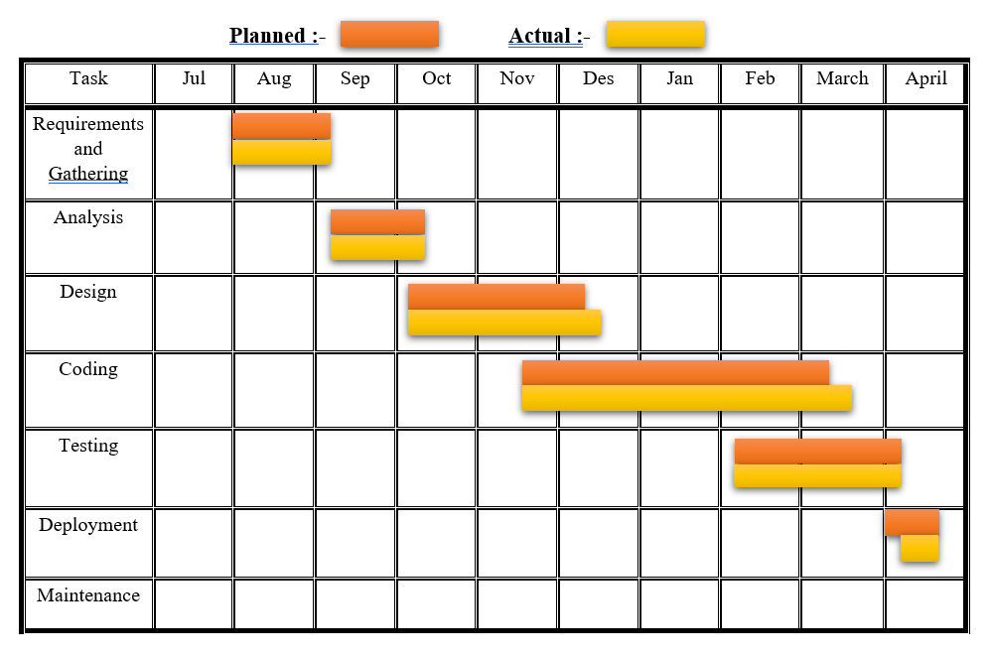

**Figure No. 3.6: - Gantt Chart**

**Chapter 4 - System Design**

1. **Basic Modules:**

Drmedizone is appointment-based project. Any user can take choice from doctor & take lab appointments & buy medicines. This is Web-application. re are some modules present in this Web-application.

* Doctor appointment module
* Registration module
* Login module
* Search module
* Doctor management module
* Patient management module
* Appointment scheduled management module
* Payment module
* Filter module
* Medicine shop module
* Lab appointment module
* Admin module

1. **Creation of Diagram:**
2. **ER diagram:**

An entity Relationship diagram is a type of flow chart. ER diagram is used to developing relationship between data-base & show relationship between user & project. In this diagram are used many symbols rectangle, diamond shape, ovals, & connecting lines to show interconnection of entities, relationships & attributes. It is focus on relationship of basics within entities instead of relationship between entity.

**Entity:**

* + - Entity is real world object.
    - Entity is shown in rectangular structure.
    - In entity are two types of categories; 1 is weak object & second is an associative entity.
    - Weak entity is shown in rectangular figure.
    - Associative entity is shown in diamond shape figure.

**Attribute:**

* + - Attribute is a property of entity.
    - Attributes are shown in oval shape.
    - Two types of attributes categories, one single value attributes & second is Multivalued attributes.
    - In single value attribute are only one attribute value, e.g., birthday date, username etc.
    - In multi-valued attributes are more than one attribute value is denoted, egg Multiple address, phone numbers etc.

**Cardinality:**

* + - Describes numerical characteristics of relationship between two entities.
    - three main cardinal relationships are Unary(one-to-one), Binary(one-to-many), & Ternary(many-many).
    - Cardinality relationship diagram are shown in following: -

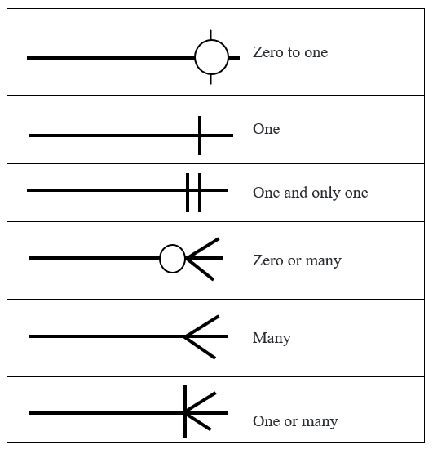

* + **description: Entity Relationship’s shapes &**

|  |  |  |
| --- | --- | --- |
| Shapes name | Shapes | Meaning |
| Rectangle |  | **Entity set** |
| Double outline rectangle |  | **Weak Entity** |
| Diamond | null | **Relationship set** |
| Double outline diamond | null | **Identifying relationship set** |
| Ellipse |  | **Attribute** |
| Ellipse with underline |  | **Primary key attribute** |
| Double line ellipse |  | **Multi-valued attribute** |
| Dashed ellipse |  | **Derived attribute** |
| Line |  | **Link between an entity & relationship** |
| Double line |  | **Total Participants** |

* + **ER diagram part of Drmedizone application:**

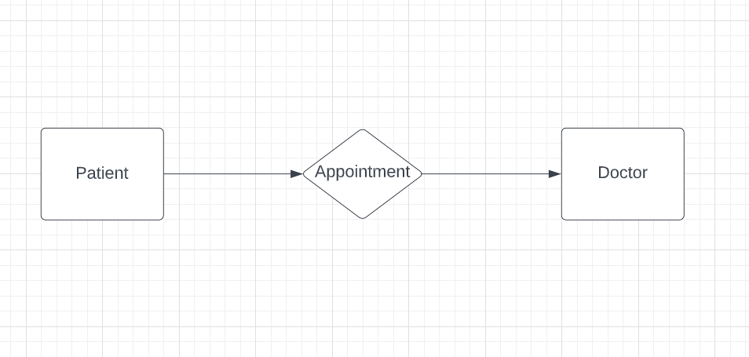

**ER Figure No.: - 1**

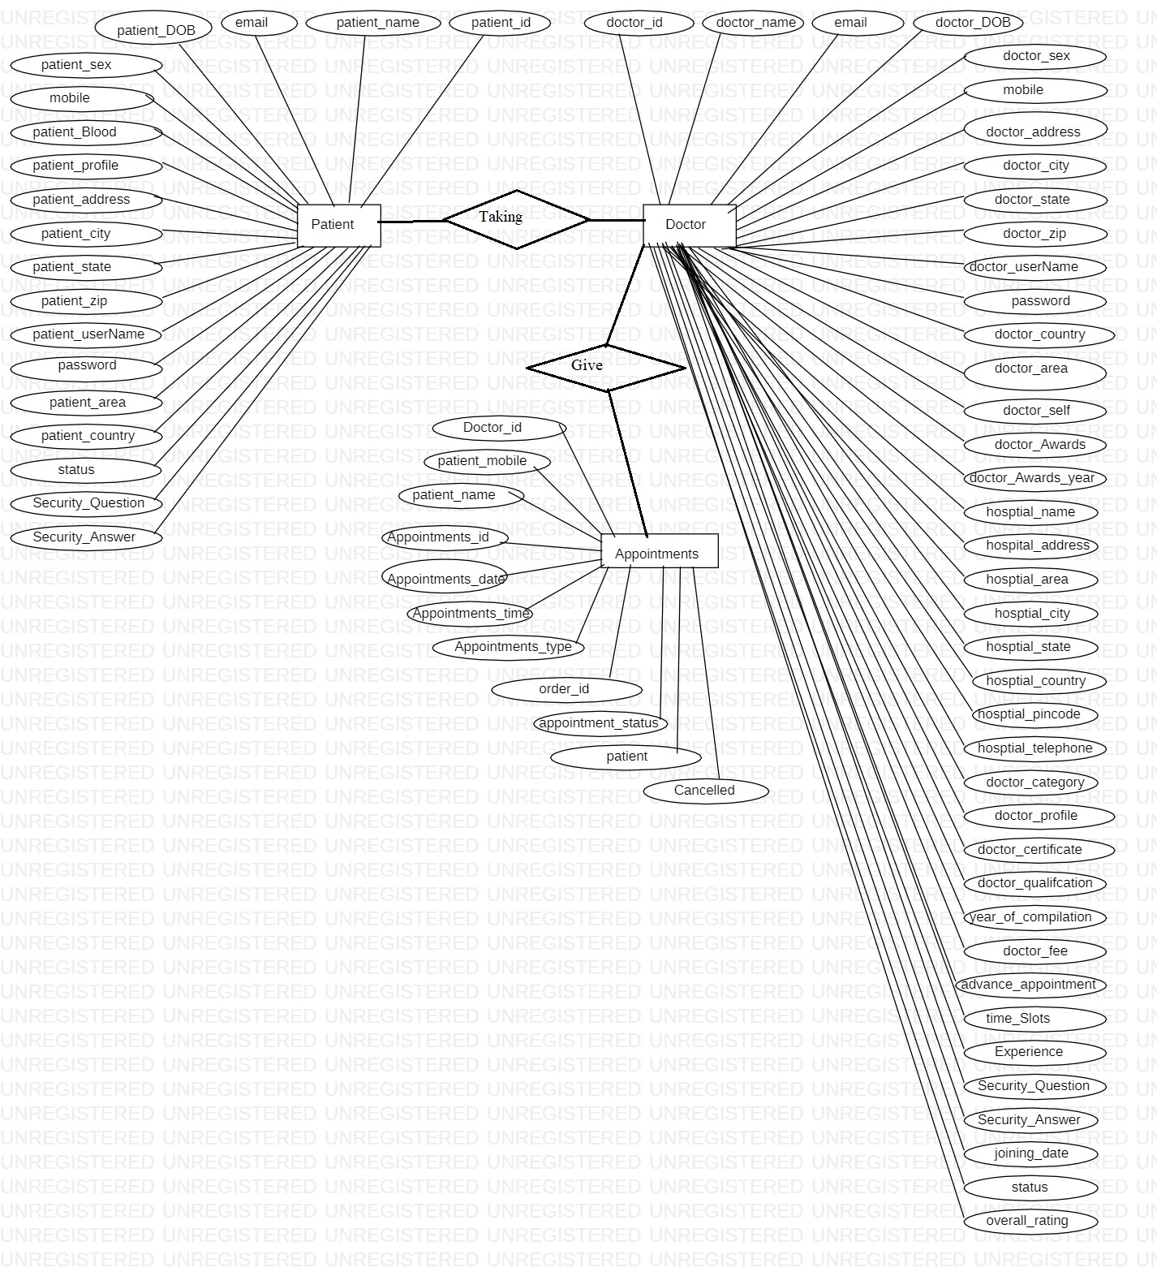

**ER Figure No.: - 2**

* + **ER diagram for Drmedizone database:**

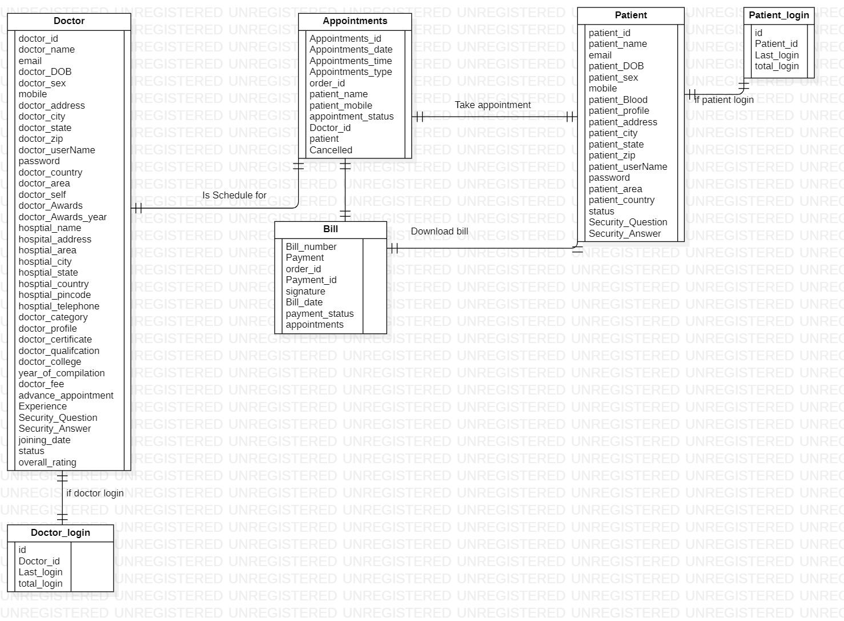

**ER Figure No.: - 3**

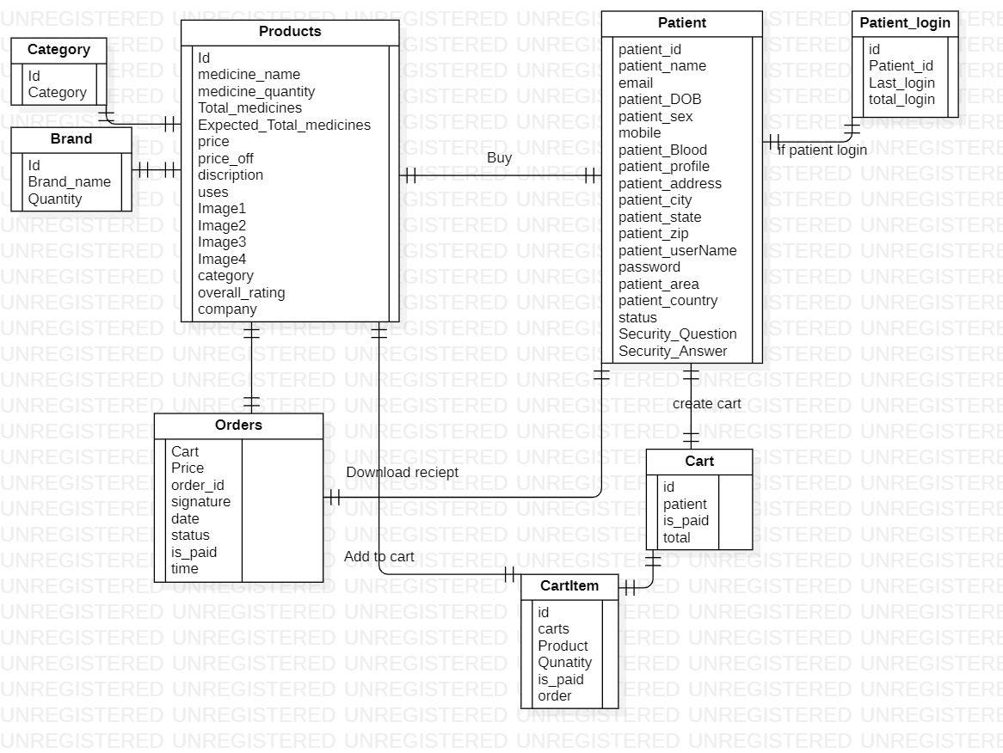

**ER Figure No.: - 4**

1. **Flow Chart:**

Flowcharts are nothing but a graphic symbol of truths or a system for better graphical understanding of project. It denotes step-by-step solutions to a problem, set of rules, or method. it's a far more figurative way of representing steps that can be preferred with help of maximum beginner programmers to understand computer technological know-how procedures, n causal to problem-solving inside procedure. A flow chart is image of stacks that shows how technology developments with present. since a flowchart is a graphical design of a procedure, it is easy to understand system.

* + **Flow chart’s shapes & description:**

|  |  |  |
| --- | --- | --- |
| Name | shapes | Meaning |
| Procedure |  | Procedure or action a] step |
| Flow line |  | direction of procedure flow |
| Start / terminator |  | Start or end point of procedure flow |
| Decision |  | Denote a decision-making point |
| Connector |  | Inspection point |
| Inventory |  | Raw material storage |
| Inventory |  | Finished goods storage |
| Preparation |  | Initial setup & or preparation steps before start of procedure flow |
| Alternate procedure |  | Shows a flow which is an alternative to normal flow |
| Flow line (dashed) |  | alternate flow direction of data flow |
|  |  |  |

* **Flow chart of Drmedizone:**

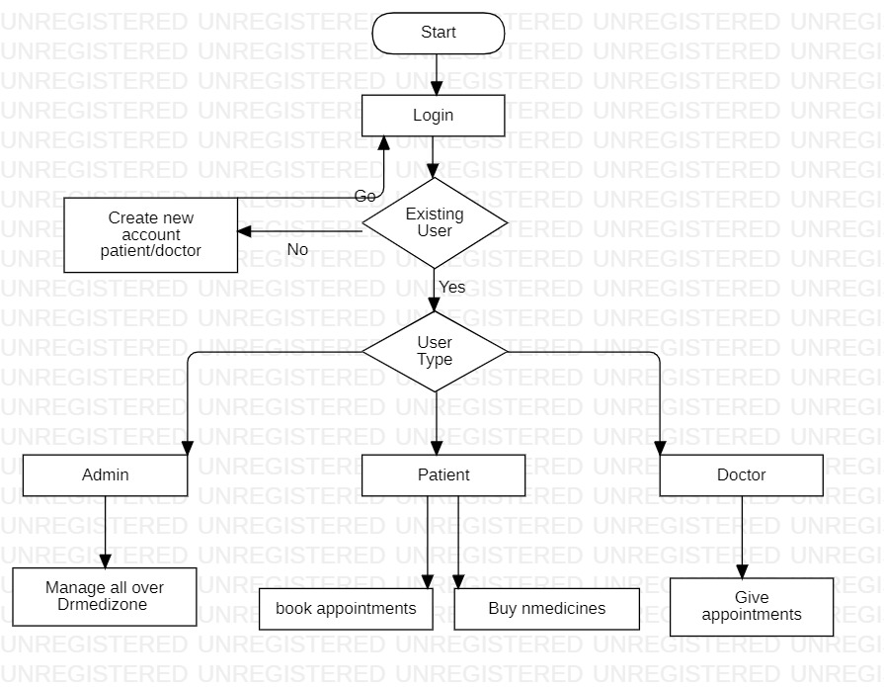

**Flow Chart Figure No.: - 1**

1. **Activity Diagram:**

Activity Diagram help you visualize flow of effort from one activity to next. It put importance on condition of flow in which it occurs. flow can be serial or similar, & to agreement with such kinds of flows, activity diagram has come up with a fork, join, etc.

**Activity diagram can be used for:**

* Displaying effort flow by using activities.
* Displaying business necessities.
* High level understanding of system’s functionalities.
* Examining professional necessities at a future stage.
  + **Activity diagram’s shapes & description:**

|  |  |  |
| --- | --- | --- |
| Name | shape | Meaning |
| Start node |  | initial state has not yet been used or modified by  activity. An activity diagram starts with this step. |
| Action state |  | A step in which a user or software performs a specific task. It denot  actions taken during this phase of software system. |
| Control flow |  | Connectors between two states or two actions to show flow. Shows order of execution. Also known as roads. |
| Decision |  | A conditional node or decision-node is one where multiple options are existing. Or re are two or more situations that can be measured at a software system point |
| Fork |  | point from which two concurrent or parallel procedurees start or start or procedure. It generally contains one input but may or may not have one output. |
| Join |  | A connection is where two results of concurrent activities add up to form one result. When concatenating, re is more than one input, but only one output is got. Two activities yield two results & one result is obtained. |
| End state |  | This is last stage of UML activity diagram. This is where activity ends in a software system ends. |

* + **Activity diagram for doctor appointment Booking:**

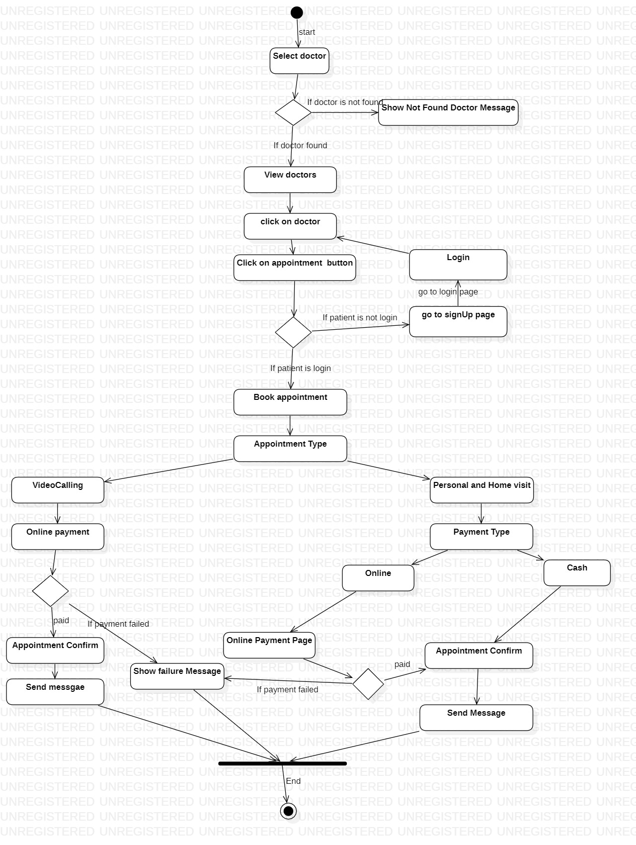

**Activity Figure No.: - 1**

* + **Activity diagram for Buy Medicines:**

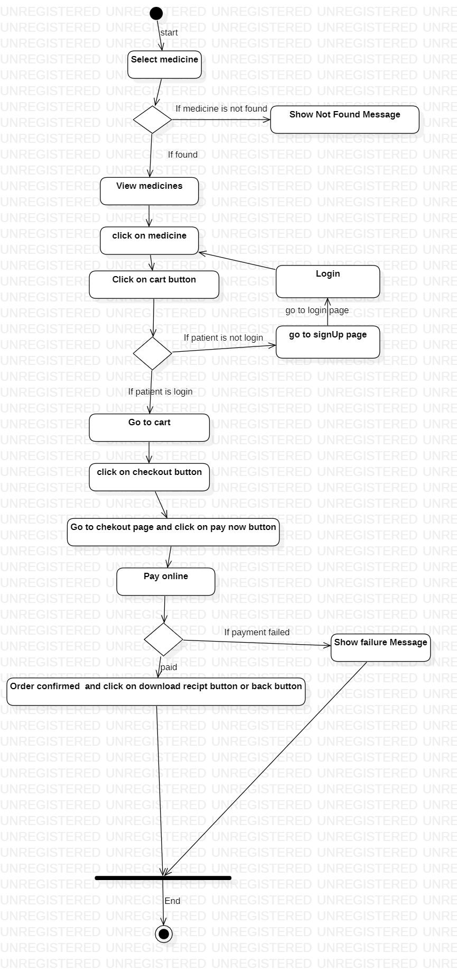

**Activity Figure No.: - 2**

* + **Activity diagram for book Lab Test:**

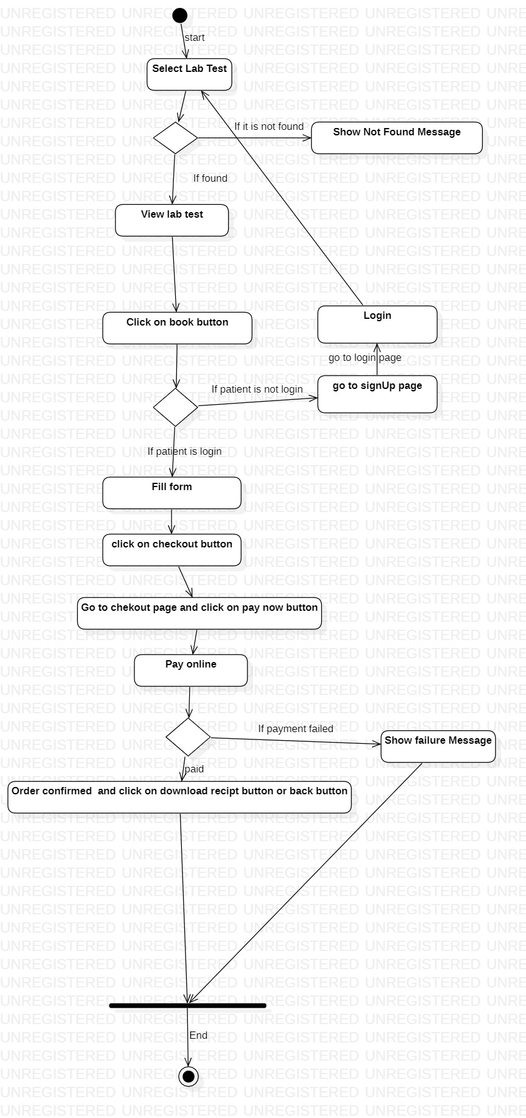

**Activity Figure No.: - 3**

* + **Activity diagram for login:**

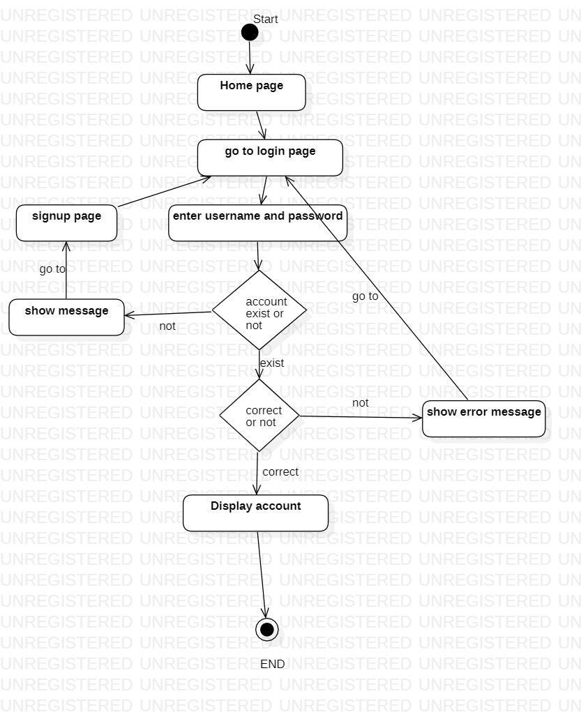

**Activity Figure No.: - 4**

* + **Activity diagram for registration:**

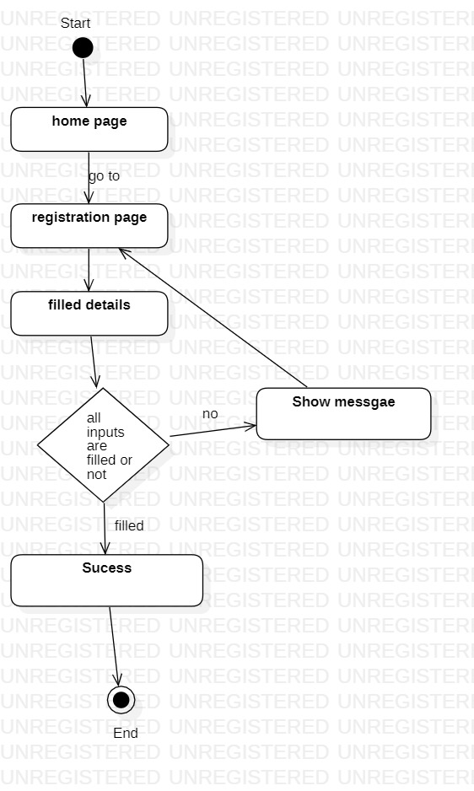

**Activity Figure No.: - 5**

1. **Data flow diagram (DFD):**

DFD is contraction for data-flow-Diagram. breath of records of a device or a development is denoted by using DFD. It also gives awareness into inputs & outputs of each object & method itself. DFD does not have manage float & no loops or decision rules are gift. particular operations depending at form of records can be defined with help of a flowchart. data go with flow Diagram can be denoted in many tactics. DFD goes to based-evaluation displaying tools. information float diagrams are very famous due to fact y help us to visualise primary steps & records concerned in software systems.

**Levels of DFD diagrams: -**

* + 0-Level (context) DFD
  + 1-Level DFD
  + 2-Level DFD
  + **Zero level (context) diagram:**

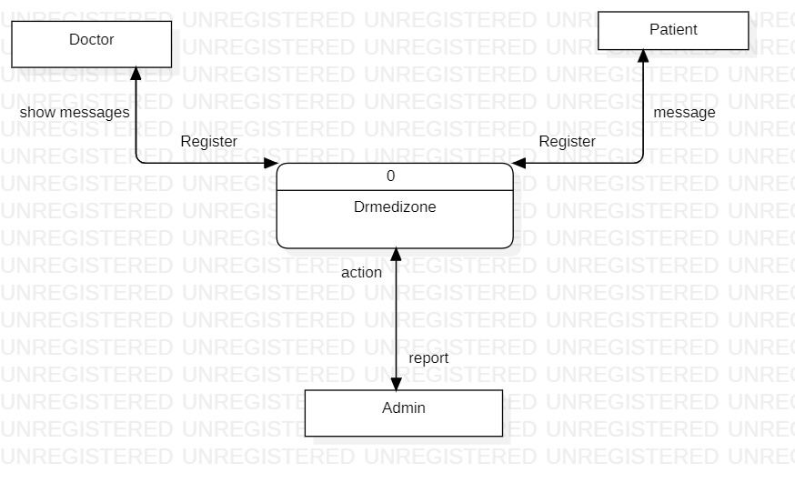

**DFD Figure No.: - 1**

* + - * **First Level Data Flow Diagram (DFD):**

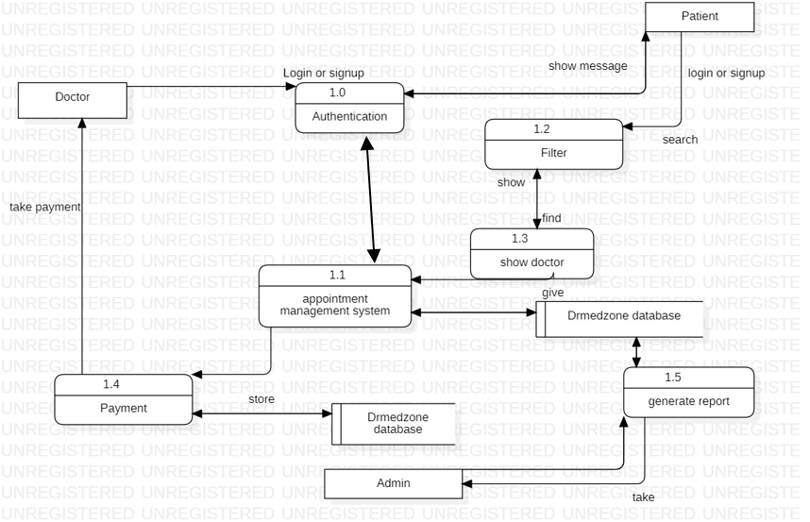

**DFD Figure No.: - 2**

* + **Second Level Data Flow Diagram (DFD):**

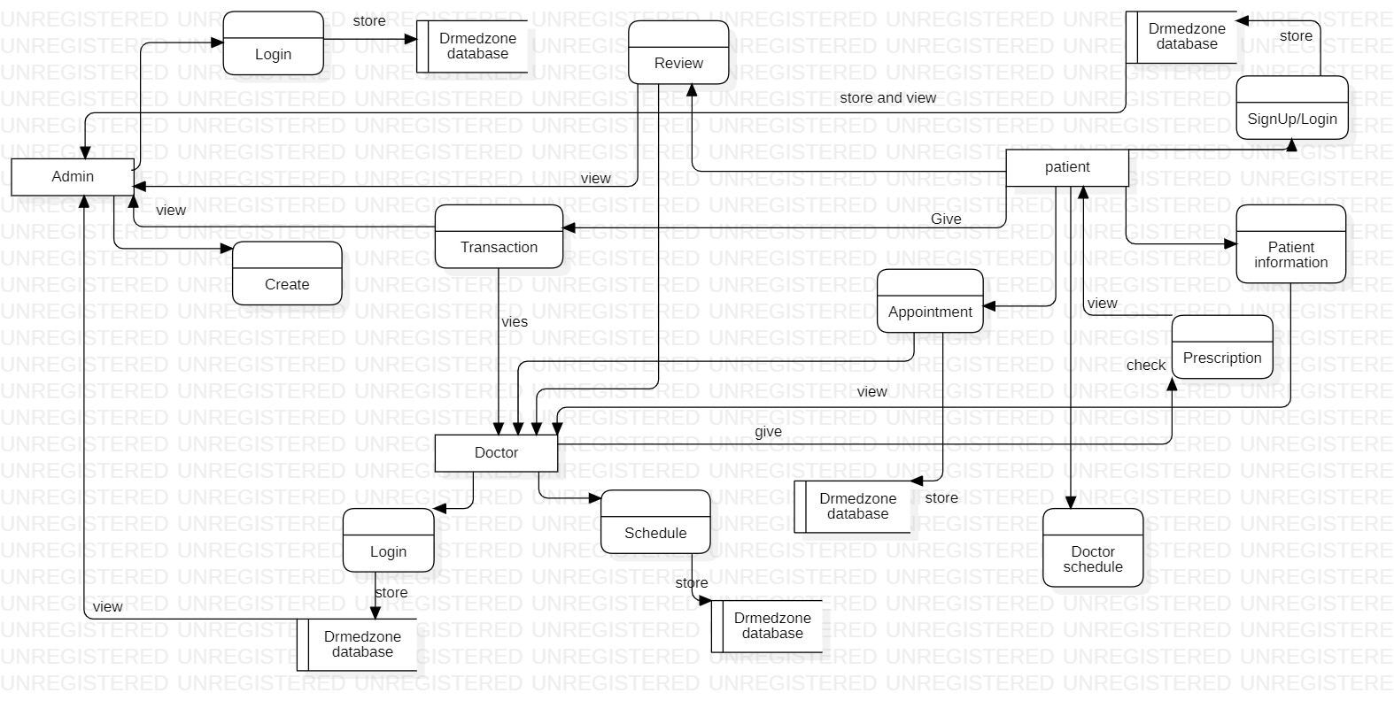

**DFD Figure No.: - 3**

1. **Use-Case Diagram:**

Use-Case diagram shows a fixed of Use-Cases, or actors, for a gadget & relationships among m. encompass dating Delivers more capability not exact within base Use-Case. It does not display order in which stairs are achieved to reap goal of each Use-Case. Use-Case figure are used to reveal active behaviour of system. It summarizes functionality of machine with aid of consisting of use instances, actors & relationships. model tasks, services, & features required by using your utility's structures/subsystems. It suggests excessive-level functionality of machine & additionally suggests how customers engage with it.

* + A simple & entire Use-Case diagram must be clarified.
  + A Use-Case diagram should constitute maximum vital interplay among more than one interaction.
  + at least one module of a machine has to be denoted by means of Use-Case diagram.
  + If Use-Case diagram is huge & greater complex, n it has to be drawn greater generalized.
  + **Use-Case diagram for doctor:**

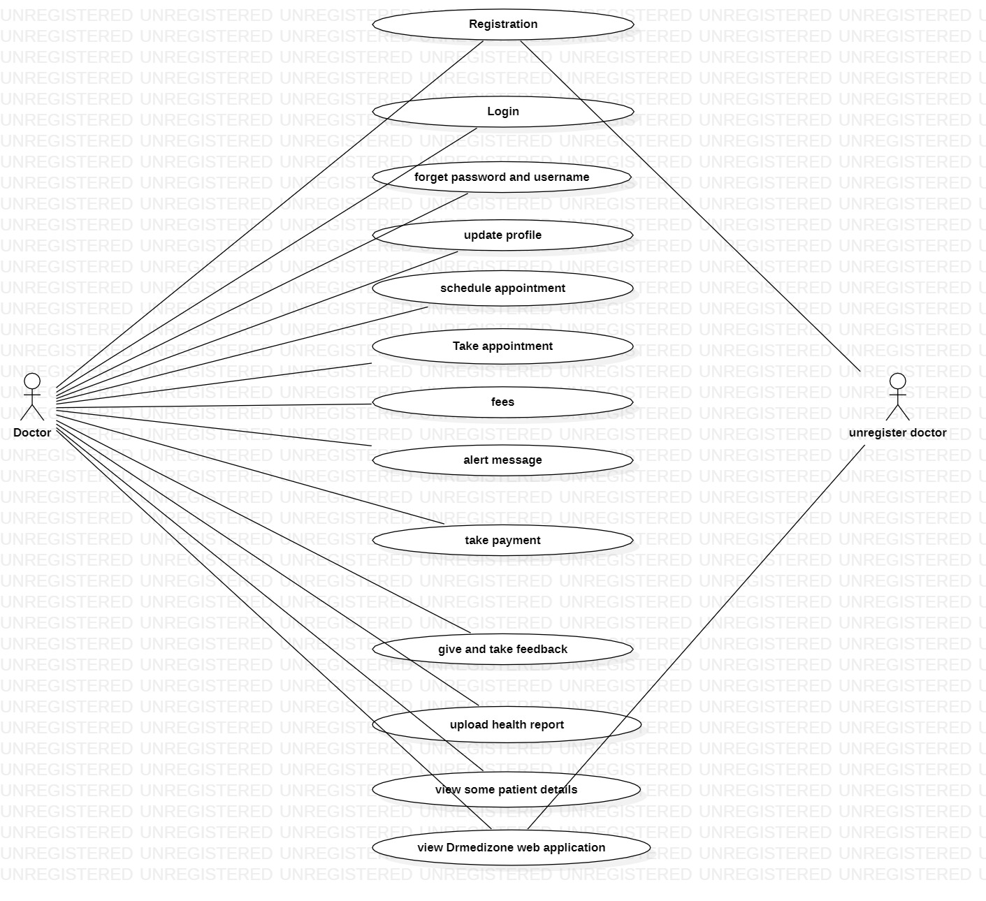

**Use-Case Figure No.: - 1**

* + **Use-Case diagram for admin:**

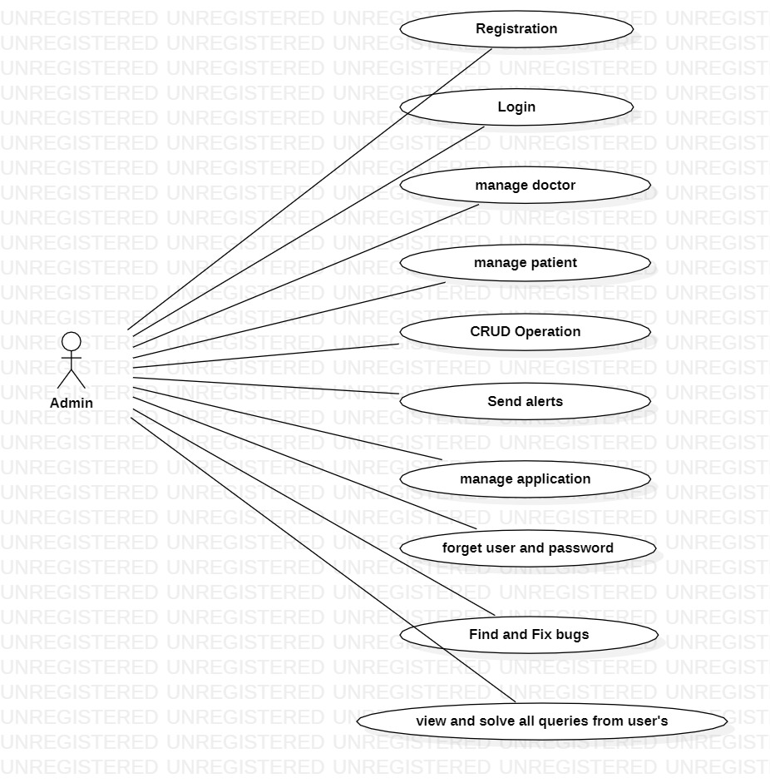

**Use-Case Figure No.: - 2**

1. **Sequence Diagram:**

Sequence diagram denote go with movement of messages within device & is also called as a case diagram. It helps in imagining some dynamic possibilities. It denotes verbal exchange among any two helps as a time ordered series of activities, such that those lifelines took module on run time. In UML, lifeline is denoted by way of a vertical bar, while message glide is denoted over a perpendicular dotted line that spreads across lowest of page. It includes repetitions as well as branched.

* + **Representations of a Sequence Diagram:**

**Lifeline:**

A man or woman participant inside series diagram is denoted via a lifeline. it's far positioned at pinnacle of diagram.

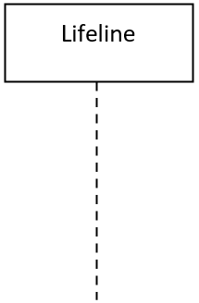

**Actor:**

A character played by means of an entity that relates with situation is called as an actor.



**Activation:**

It a is denoted by a thin rectangle on lifeline structure. Defines term in which procedure is completed with help of detail, so top & lowest of rectangle are related to start & finish time.

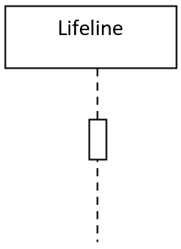

**Note:**

Notice is possibility to attach many comments to a detail. It basically contains useful information for modellers.

* + **Sequence diagram for login:**

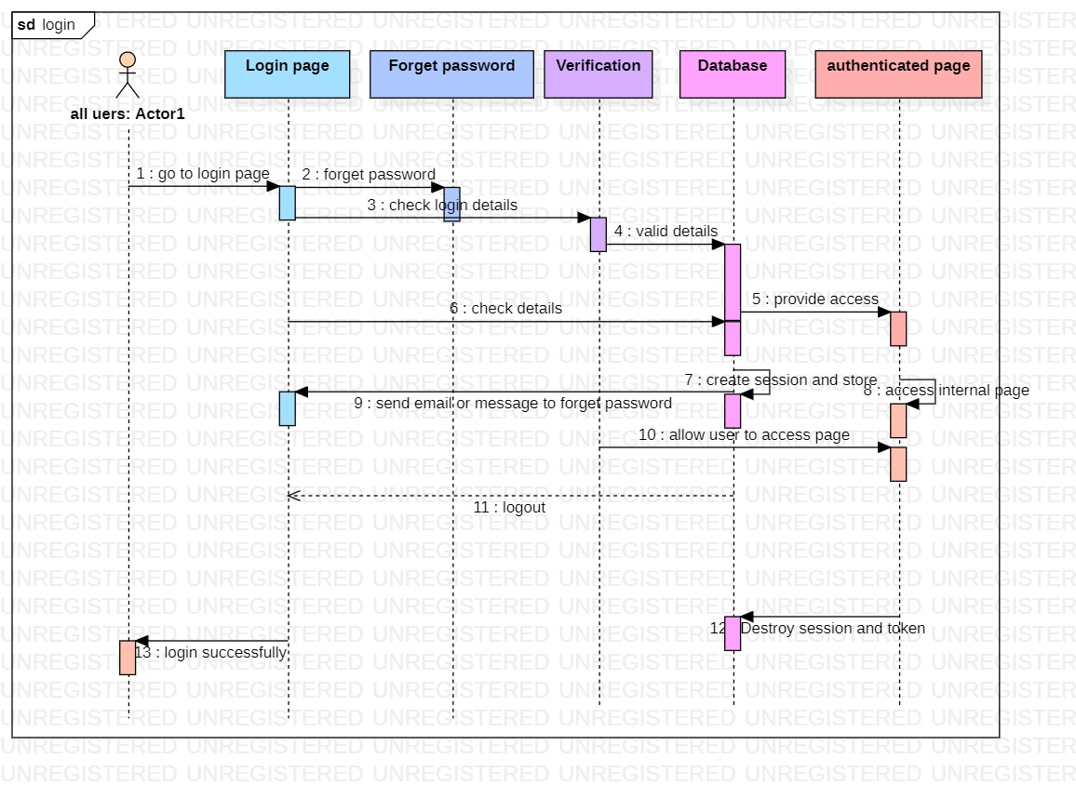

**Sequence Figure No.: - 1**

1. **Class diagram:**

When manipulative a structure or software program, developers will frequently use class figures to plan out what structure will appearance similar in still form. These diagrams consent them to figure out what classes they necessity, their functionality, & their associations with or system essentials - specifically or classes, procedures, attributes, & objects.

**benefit of class diagram:**

* Class diagrams are simple, fast to read, & gives a logic of orientation.
* y is basis for creating systems.
* y provides detailed vision into building of your project
* Create complete charts that highlight code required to be programmed & executed to defined structure.
* Provide an implementation-independent explanation of type used in a project that is later passed on to its apparatuses.

**Class notation:**

* + - Class Name:
    - name of class is always shown in first sector. It is required information.
    - Class Attributes:
    - Attributes are shown in after-class name sector.
    - attributes types are show after colon
    - Attributes are values that define a class.
    - Class Methods:
    - Operations are show in third sector. y is facilities class Delivers.
    - return type of a method is show after colon symbol at end of method name.
    - return types of methods parameters are show after colon.

**Class visibility:**

symbol before an features & procedures name in a class represent distinguishability of points & procedures. Visibility signs are used to determine availability of information contained in classes

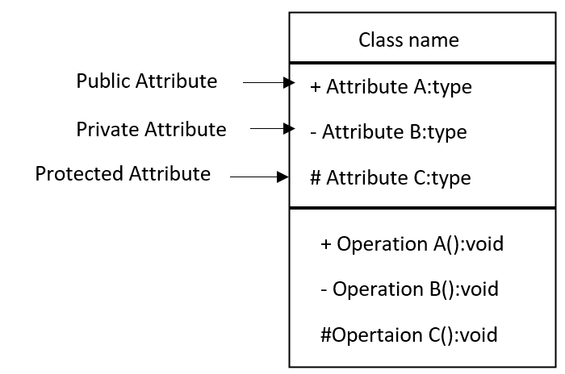

* **Class diagram of Appointment system:**

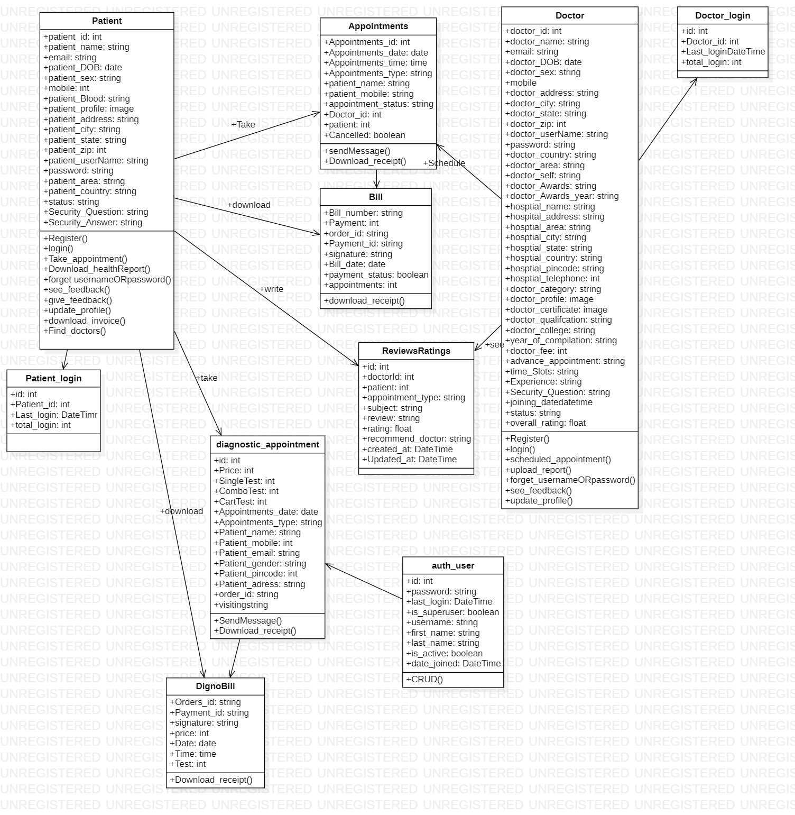

**Class Figure No.: - 1**

* **Class diagram of order medicine system:**

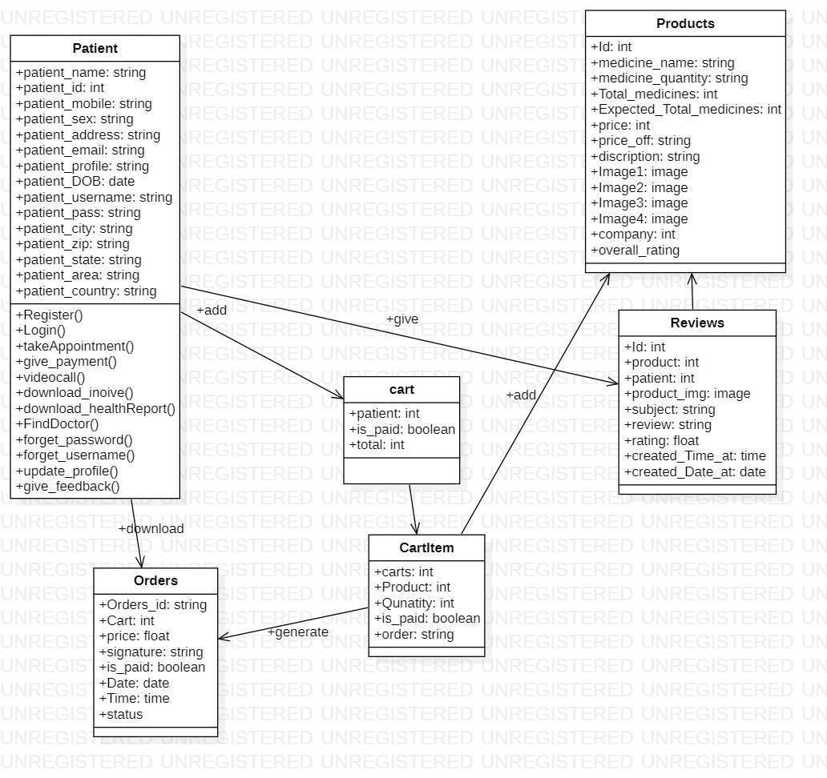

**Class Figure No.: - 2**

1. **List of tables with attributes & constraints:**

* **Patient table:**

|  |  |  |  |
| --- | --- | --- | --- |
| Serial number | Column name | Data types | Constraints |
| 1 | patient | int | Primary Key |
| 2 | patient_name | VarChar(50) | Not null |
| 3 | email | VarChar(50) | Not null |
| 4 | patient_sex | VarChar(10) | Not null |
| 5 | mobile | Int | Not null |
| 6 | patient_profile | Image | Not null |
| 7 | patient_address | VarChar(200) | Not null |
| 8 | patient_area | VarChar(50) | Not null |
| 9 | patient_city | VarChar(50) | Not null |
| 10 | patient_state | VarChar(50) | Not null |
| 11 | patient_country | VarChar(50) | Not null |
| 12 | patient_username | VarChar(50) | Not null |
| 13 | password | VarChar(100) | Not null |
| 14 | patient_zip | Int | Not null |
| 15 | patient_DOB | DATE | Not null |
| 16 | patient_Blood | VarChar(50) | Not null |
| 17 | status | VarChar(30) | Not null |
| 18 | Security_Question | VarChar(500) | Not null |
| 19 | Security_Answer | VarChar(500) | Not null |

* **Doctor Table:**

|  |  |  |  |
| --- | --- | --- | --- |
| Serial number | Column name | Data types | Constraints |
| 1 | doctor_id | Int | Primary Key |
| 2 | doctor_name | VarChar(50) | Not null |
| 3 | email | VarChar(50) | Not null |
| 4 | doctor_DOB | Date | Not null |
| 5 | doctor_sex | VarChar(10) | Not null |
| 6 | mobile | Int | Not null |
| 7 | doctor_address | VarChar(200) | Not null |
| 8 | doctor_city | VarChar(50) | Not null |
| 9 | doctor_state | VarChar(50) | Not null |
| 10 | doctor_zip | Int | Not null |
| 11 | doctor_username | VarChar(50) | Not null |
| 12 | password | VarChar(100) | Not null |
| 13 | doctor_country | VarChar(100) | Not null |
| 14 | doctor_area | VarChar(100) | Not null |
| 15 | doctor_self | VarChar(max) | Not null |
| 16 | hospital_address | VarChar(100) | Not null |
| 17 | hospital_area | VarChar(100) | Not null |
| 18 | hospital_pincode | VarChar(60) | Not null |
| 19 | hospital_city | VarChar(100) | Not null |
| 20 | hospital_telephone | Int | Not null |
| 21 | doctor_category | VarChar(50) | Not null |
| 22 | doctor_profile | Image | Not null |
| 23 | doctor_certificate | Image | Not null |
| 24 | doctor_qualification | VarChar(100) | Not null |
| 25 | doctor_fee | int | Not null |
| 26 | advanced_appointment | int | Not null |
| 27 | status | VarChar(50) | Not null |
| 28 | doctor_Awards | VarChar(100) | Not null |
| 29 | doctor_Awards_year | VarChar(100) | Not null |
| 30 | hosptial_name | VarChar(100) | Not null |
| 31 | hosptial_state | VarChar(100) | Not null |
| 32 | hosptial_country | VarChar(100) | Not null |
| 33 | doctor_college | VarChar(100) | Not null |
| 34 | year_of_compilation | VarChar(100) | Not null |
| 35 | time_Slots | VarChar(1000) | Not null |
| 36 | Experience | Int | Not null |
| 37 | Security_Answer | VarChar(500) | Not null |
| 38 | Security_Question | VarChar(500) | Not null |
| 39 | joining_date | Date | Not null |
| 40 | overall_rating | Float | Not null |
|  |  |  |  |

* **Doctor login table:**

|  |  |  |  |
| --- | --- | --- | --- |
| Serial number | Column name | Data type | Constraints |
| 1 | id | int | Primary Key |
| 3 | Doctor_id | Int | Florigen Key |
| 4 | total_login | Int | Not null |
| 5 | last_login | Date | Not null |

* **Patient login table:**

|  |  |  |  |
| --- | --- | --- | --- |
| Serial number | Column name | Data type | Constraints |
| 1 | id | int | Primary Key |
| 2 | Patient _id | Int | Foreign Key |
| 6 | total_login | Int | Not null |
| 7 | last_login | Date | Not null |

* **Appointment Table:**

|  |  |  |  |
| --- | --- | --- | --- |
| Serial number | Column name | Data types | Constraints |
| 1 | Appointments_id | int | Primary Key |
| 2 | Appointments_date | Date | Not null |
| 3 | Appointments_time | Time | Not null |
| 4 | Appointments_type | VarChar(60) | Not null |
| 5 | Doctor_id | int | Foreign Key |
| 6 | Doctor_name | VarChar(60) | Not null |
| 7 | Patient | int | Foreign Key |
| 8 | patient_name | VarChar(100) | Not null |
| 9 | order_id | VarChar(100) | Not null |
| 10 | appointment_status | VarChar(30) | Not null |
| 11 | patient_mobile | VarChar(100) | Not null |
| 12 | Cancelled | Boolean | Not null |

* **Auth_user table:**

|  |  |  |  |
| --- | --- | --- | --- |
| Serial number | Column name | Data types | Constraints |
| 1 | id | int | Primary Key |
| 2 | password | VarChar(60) | Not null |
| 3 | last_login | DateTime | Not null |
| 4 | is_superuser | Boolean | Not null |
| 5 | username | VarChar(60) | Not null |
| 6 | first_name | VarChar(60) | Not null |
| 7 | last_name | VarChar(60) | Not null |
| 8 | email | VarChar(60) | Not null |
| 9 | is_staff | Boolean | Not null |
| 10 | is_active | Boolean | Not null |
| 11 | date_joined | DateTime | Not null |

* **QNA Table:**

|  |  |  |  |
| --- | --- | --- | --- |
| Serial number | Column name | Data types | Constraints |
| 1 | id | int | Primary Key |
| 2 | Question | VarChar(500) | Not null |
| 3 | Answer | VarChar(500) | Not null |
| 4 | Email | Email | Not null |
| 5 | complete | Boolean | Not null |
| 6 | patient | Int | Foreign Key |

* **diagnostic_test_list**

|  |  |  |  |
| --- | --- | --- | --- |
| Serial number | Column name | Data types | Constraints |
| 1 | id | int | Primary Key |
| 2 | name | VarChar(100) | Not null |
| 3 | price | Int | Not null |
| 4 | Who_should_book_this_checkup | VarChar(max) | null |
| 5 | What_preparation_is_needed_for_this_Checkup | VarChar(max) | null |
| 6 | Age_Group | VarChar(100) | Not null |
| 7 | Gender | VarChar(200) | Not null |
| 8 | image | Image | Not null |
| 9 | Home_visit | Boolean | Not null |

* **diagnostic_test_list**

|  |  |  |  |
| --- | --- | --- | --- |
| Serial number | Column name | Data types | Constraints |
| 1 | id | int | Primary Key |
| 2 | name | VarChar(100) | Not null |
| 3 | price | Int | Not null |
| 4 | Who_should_book_this_checkup | VarChar(max) | null |
| 5 | What_preparation_is_needed_for_this_Checkup | VarChar(max) | null |
| 6 | Age_Group | VarChar(200) | Not null |
| 7 | Gender | VarChar(200) | Not null |
| 8 | image | Image | Not null |
| 9 | details | VarChar(max) | Not null |

* **dignostic_test_cart Table**

|  |  |  |  |
| --- | --- | --- | --- |
| Serial number | Column name | Data types | Constraints |
| 1 | id | Int | Primary Key |
| 2 | patient | Int | Foreign Key |

* **dignostic_test_cartItems Table**

|  |  |  |  |
| --- | --- | --- | --- |
| Serial number | Column name | Data types | Constraints |
| 1 | id | Int | Primary Key |
| 2 | carts | Int | Foreign Key |
| 3 | Tests | Int | Foreign Key |
| 4 | order | VarChar(500) | Not null |
| 5 | is_paid | Boolean | Not null |

* **diagnostic_appointment Table**

|  |  |  |  |
| --- | --- | --- | --- |
| Serial number | Column name | Data types | Constraints |
| 1 | id | int | Primary Key |
| 2 | patient | Int | Foreign Key |
| 3 | Price | Int | Not null |
| 4 | SingleTest | Int | Foreign Key |
| 5 | ComboTest | Int | Foreign Key |
| 6 | CartTest | Int | Foreign Key |
| 7 | Appointments_date | Date | Not null |
| 8 | Appointments_type | VarChar(100) | Not null |
| 9 | Patient_name | VarChar(100) | Not null |
| 10 | Patient_mobile | Int | Not null |
| 11 | Patient_email | Email | Not null |
| 12 | Patient_gender | VarChar(100) | Not null |
| 13 | Patient_pincode | Int | Not null |
| 14 | Patient_adress | VarChar(300) | Not null |
| 15 | order_id | VarChar(100) | Not null |
| 16 | visiting | VarChar(100) | Not null |
|  |  |  |  |

* **DignoBill Table**

|  |  |  |  |
| --- | --- | --- | --- |
| Serial number | Column name | Data types | Constraints |
| 1 | Orders_id | VarChar(500) | Primary Key |
| 2 | Payment_id | VarChar(100) | null |
| 3 | signature | VarChar(500) | null |
| 4 | price | float | Not null |
| 5 | Date | Date | Not null |
| 6 | Time | Time | Not null |
| 7 | Test | int | Foreign Key |
|  |  |  |  |

* **ReviewsRatings Table**

|  |  |  |  |
| --- | --- | --- | --- |
| Serial number | Column name | Data types | Constraints |
| 1 | id | Int | Primary Key |
| 2 | Payment_id | VarChar(100) | Not null |
| 3 | appointment_type | VarChar(100) | Not null |
| 4 | health_concern | VarChar(100) | Not null |
| 5 | subject | VarChar(100) | Not null |
| 6 | review | VarChar(max) | Not null |
| 7 | rating | Float | Not null |
| 8 | recommend_doctor | VarChar(50) | Not null |
| 9 | created_at | DateTime | Not null |
| 10 | Updated_at | DateTime | Not null |
| 11 | doctorId | Int | Foreign Key |
| 12 | patient | int | Foreign Key |

* **Projects Table**

|  |  |  |  |
| --- | --- | --- | --- |
| Serial number | Column name | Data types | Constraints |
| 1 | Id | Int | Primary Key |
| 2 | medicine_name | VarChar(200) | Not null |
| 3 | medicine_quantity | VarChar(200) | Not null |
| 4 | Total_medicines | Int | Not null |
| 5 | Expected_Total_medicines | Int | Not null |
| 6 | price_off | VarChar(200) | Not null |
| 7 | discription | VarChar(1000) | Not null |
| 8 | price | Float | Not null |
| 9 | uses | VarChar(500) | Not null |
| 10 | Image1 | Image | Not null |
| 11 | Image2 | Image | Not null |
| 12 | Image3 | Image | Not null |
| 13 | Image4 | Image | Not null |
| 14 | category | int | Foreign Key |
| 15 | company | Int | Foreign Key |
| 16 | overall_rating | Float | Not null |

* **Category Table:**

|  |  |  |  |
| --- | --- | --- | --- |
| Serial number | Column name | Data types | Constraints |
| 1 | id | Int | Primary Key |
| 2 | Category | VarChar(200) | Not null |

* **Brand Table**

|  |  |  |  |
| --- | --- | --- | --- |
| Serial number | Column name | Data types | Constraints |
| 1 | Id | Int | Primary Key |
| 2 | Brand_name | VarChar(200) | Not null |
| 3 | Quantity | Int | Not null |

* **Cart Table**

|  |  |  |  |
| --- | --- | --- | --- |
| Serial number | Column name | Data types | Constraints |
| 1 | id | Int | Primary Key |
| 2 | patient | Int | Foreign Key |
| 3 | is_paid | Boolean | Not null |
| 4 | total | Int | Not null |

* **CartItem Table**

|  |  |  |  |
| --- | --- | --- | --- |
| Serial number | Column name | Data types | Constraints |
| 1 | id | Int | Primary Key |
| 2 | carts | Int | Foreign Key |
| 3 | Project | Int | Foreign Key |
| 4 | Qunatity | Int | Not null |
| 5 | is_paid | Boolean | Not null |
| 6 | order | VarChar(500) | Not null |

* **Orders Table**

|  |  |  |  |
| --- | --- | --- | --- |
| Serial number | Column name | Data types | Constraints |
| 1 | Orders_id | VarChar(500) | Primary Key |
| 2 | carts | Int | Foreign Key |
| 3 | price | Int | Not null |
| 4 | signature | Int | Not null |
| 5 | is_paid | Boolean | Not null |
| 6 | Date | Date | Not null |
| 7 | Time | Time | Not null |
| 8 | status | VarChar(50) | Not null |

* **Wishlist Table**

|  |  |  |  |
| --- | --- | --- | --- |
| Serial number | Column name | Data types | Constraints |
| 1 | id | Int | Primary Key |
| 2 | patient | Int | Foreign Key |
| 3 | total | Int | Not null |

* **wishlistItem Table**

|  |  |  |  |
| --- | --- | --- | --- |
| Serial number | Column name | Data types | Constraints |
| 1 | id | Int | Primary Key |
| 2 | WishlistProject | Int | Foreign Key |
| 3 | Project | Int | Foreign Key |

* **Bill Table:**

|  |  |  |  |
| --- | --- | --- | --- |
| Serial number | Column name | Data types | Constraints |
| 1 | Bill_number | VarChar(60) | Primary Key |
| 2 | Payment | Int | Not null |
| 3 | order_id | VarChar(60) | Not null |
| 4 | Payment_id | VarChar(60) | Not null |
| 5 | signature | VarChar(60) | Not null |
| 6 | Bill_date | DateTime | Not null |
| 7 | appointments | Int | Foreign Key |

1. **Test Cases:**

|  |  |  |  |
| --- | --- | --- | --- |
| System Name: - | Drmedizone | | |
| Module code: - | **Dr_001** | | |
| Pass | 0 | **Pending:-** | 20 |
| Fail | 0 | **Number of test case:-** | 20 |

|  |  |  |  |  |
| --- | --- | --- | --- | --- |
| Test case Id | Test case | Expected Output | Actual Output | Result |
| Dr_001L1 | Correct Username & password | Redirect on profile page |  |  |
| Dr_001L2 | Correct Username & Invalid password | Show error message:-  Password is invalid. |  |  |
| Dr_001L3 | Invalid Username &  Correct password | Show error message:-  Username is invalid. |  |  |
| Dr_001L4 | Invalid Username &  Invalid password | Show error message:-  Username & password are invalid. | . |  |
| Dr_001L5 | Username input box is empty &  Correct password | Show error message:-  Please enter username |  |  |
| Dr_001L6 | Correct Username & password input box is empty | Show error message:-  Please enter password |  |  |
| Dr_001L7 | Username & password input boxes both are empty | Show error message:-  Please enter username & password |  |  |
| Dr_001L8 | Input boxes are empty | Show error message:- Enter all necessary details are required |  |  |
| Dr_001L9 | Click submit button | Submit form & show message:-  Submitted successfully |  |  |
| Dr_001L10 | If doctor schedule is busy | Show message:-  Doctor is not available |  |  |
| Dr_001L11 | Search doctor by name | Show list of all related name of doctors |  |  |
| Dr_001L12 | Search doctor by categories | Show list of all related category of doctors |  |  |
| Dr_001L13 | Search doctor by fees | Show list of all related doctors |  |  |
| Dr_001L14 | Upload health report | Show message:-Upload successfully |  |  |
| Dr_001L15 | Download health report | Show message:-download successfully |  |  |
| Dr_001L16 | Doctor is not found | Show message:- Doctor is not found |  |  |
| Dr_001L17 | Click get appointment button | Open appointment form |  |  |
| Dr_001L18 | Click doctor button | Show list of all doctors |  |  |
| Dr_001L19 | Click get appointment button but patient is not login | Open login form |  |  |
| Dr_001L20 | Click on doctor profile | Show all doctor details |  |  |

**Chapter 5 – Implementation & Testing**

1. **Model used**

* **Incremental Model**

incremental model is used when necessities for basic project are understood.

Several deliverables are defined independently & effort flow is linear. repeat again

in nature & increasingly focus on practical projects.

1. **Details of tools & technologies used:**
2. **Details of tools:**
   * **VS Code:**

It is free-&-open source application. VS Code has many features, including support for multiple programming languages, code debugging, debugging, & Git integration. re is also a robust extension market where users can download & install extensions to enhance editor's functionality. It has a user friendly UI with customizable mes & settings. It has supports integrated terminal functionality that allows users to run commands & execute code in editor. It also has a live support feature that agrees to manage in real time. Overall, it is a versatile & prevailing code editor suitable for an inclusive range of programming problems.

* + **MySQL Workbench :**

It is a UI for database plan & management tool. It Delivers a GUI for create & modify database structures, as well as managing data & queries. MySQL Workbench supports several database management systems, including MySQL, MariaDB, & or RDBMS systems. It also has a built-in editor with syntax & auto-completion features. MySQL Workbench offers database backup & allows users to easily backup & restore databases. It has a user-friendly UI with customizable themes & settings. Overall, MySQL Workbench is a powerful database design & management tool suitable for both new & experienced database administrators.

1. **Details of technologies:**

* **HTML/CSS:**

HTML is a markup language used to create structure & content of web pages. CSS is a styling language used to control presentation & layout of web pages. HTML uses tags to define different types of content, such as headers, paragraphs, & images. HTML & CSS exertion to make attractive & functional Web-application s. HTML, CSS are used for presentation of Web-application .

* **Bootstrap:**

Bootstrap is a frontend development framework for building responsive Web-application. Bootstrap includes pre-built HTML & CSS templates as well as JavaScript plugins to speed up development. Bootstrap uses a mesh framework to easily make flexible & responsive layouts for Web-application. Bootstrap includes many UI apparatuses such as buttons, views, tables, & navigation menus to help create a Web-application . Bootstrap is free to use.

* **Python:**

It's simple to read, develop, & maintain python. it's a high level language. Data analysis, Python, web development, artificial intelligence, etc. Because Python is platform unaffected & is well-matched with an extensive range of OS, with Windows, macOS, & Linux, it is utilised for a widespread variety of applications. Since it is interpreted language, no coding is required for its operation. Python emphasizes programmed readability with simple syntax. Functional & object oriented programming is available.

* **Django Framework:**

To make Web-applications with Python, use high-level web framework Django. Django uses MVC architectural model to break down tasks in small portions. For mutual Web-application-development tasks like authentication, routing, & database admin, Django comes with a tonne of built-in tools. ORM framework is used by Django to make affording with databases simpler.

* **MySQL:**

Data may be stored, managed, & retrieved using MySQL, an open source RDBMS. Many-programming-languages are compatible with MySQL, which is mutually used for online applications. MySQL performs CRUD procedures & data interaction via Structured Query Language. Windows, macOS, & Linux are just a few of many operating systems on which MySQL may be used. With features like encryption, access control, MySQL is quite safe.

1. **Details for hardware used:**

|  |  |
| --- | --- |
| Apparatuses | Hardware Used |
| Procedure or | Intel(R) Core(TM) i5-10300H CPU @ 2.50GHz 2.50 GHz |
| RAM | 8.00 GB |
| System type | 64-bit operating system, x64-based procedure or |

1. **Source Code:**

**Snippets of Import statements of codes**

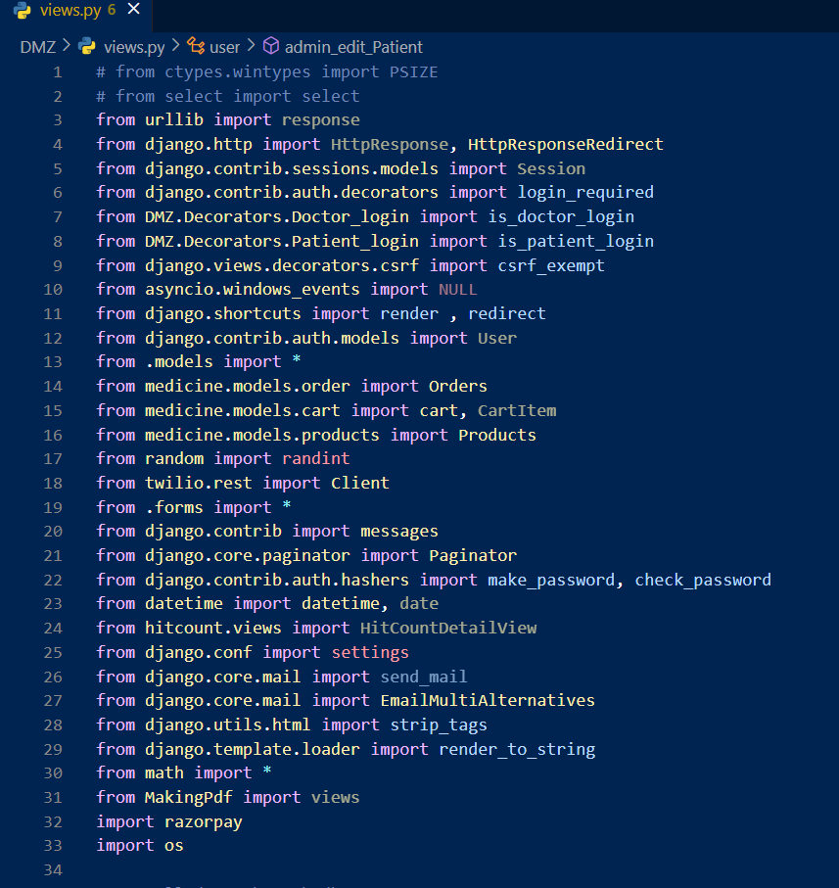

**Snippets code of send email messages & opt:**

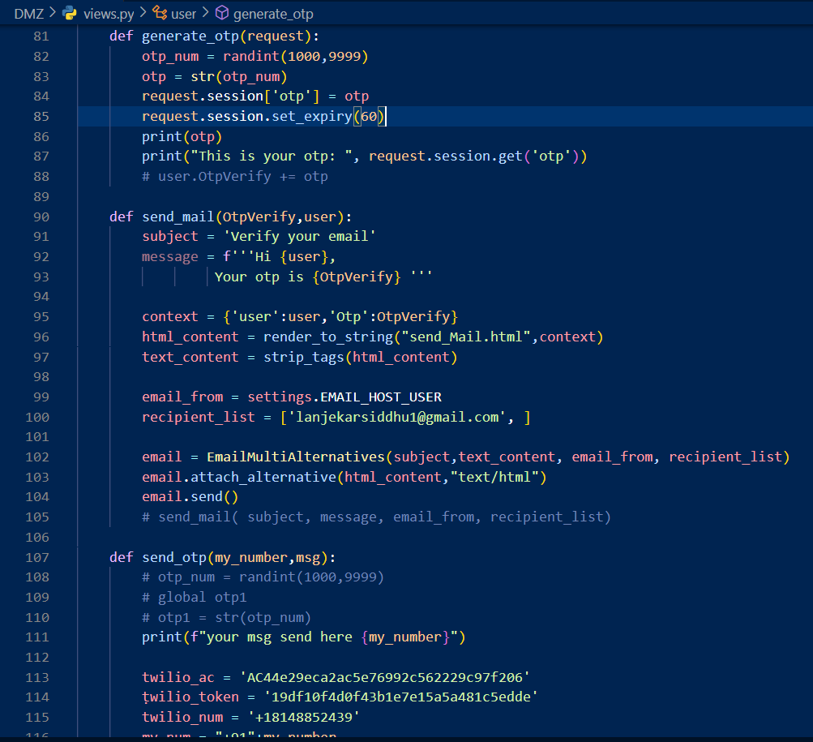

**Snippets of view.py file:**

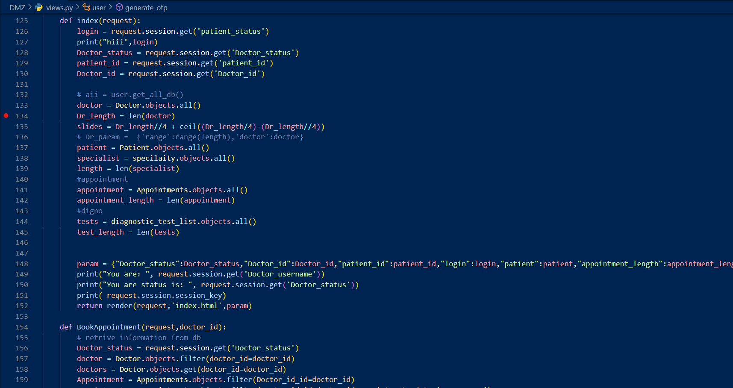

**Snippets code of Doctor Dashboard:**

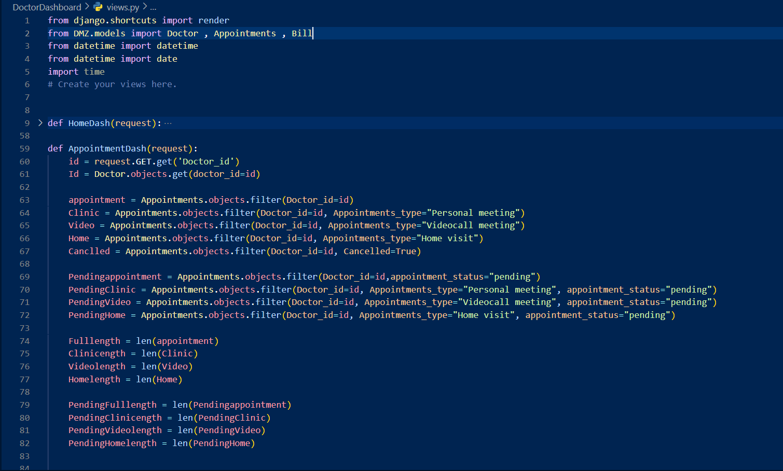

**Snippets code of patient dashboard:**

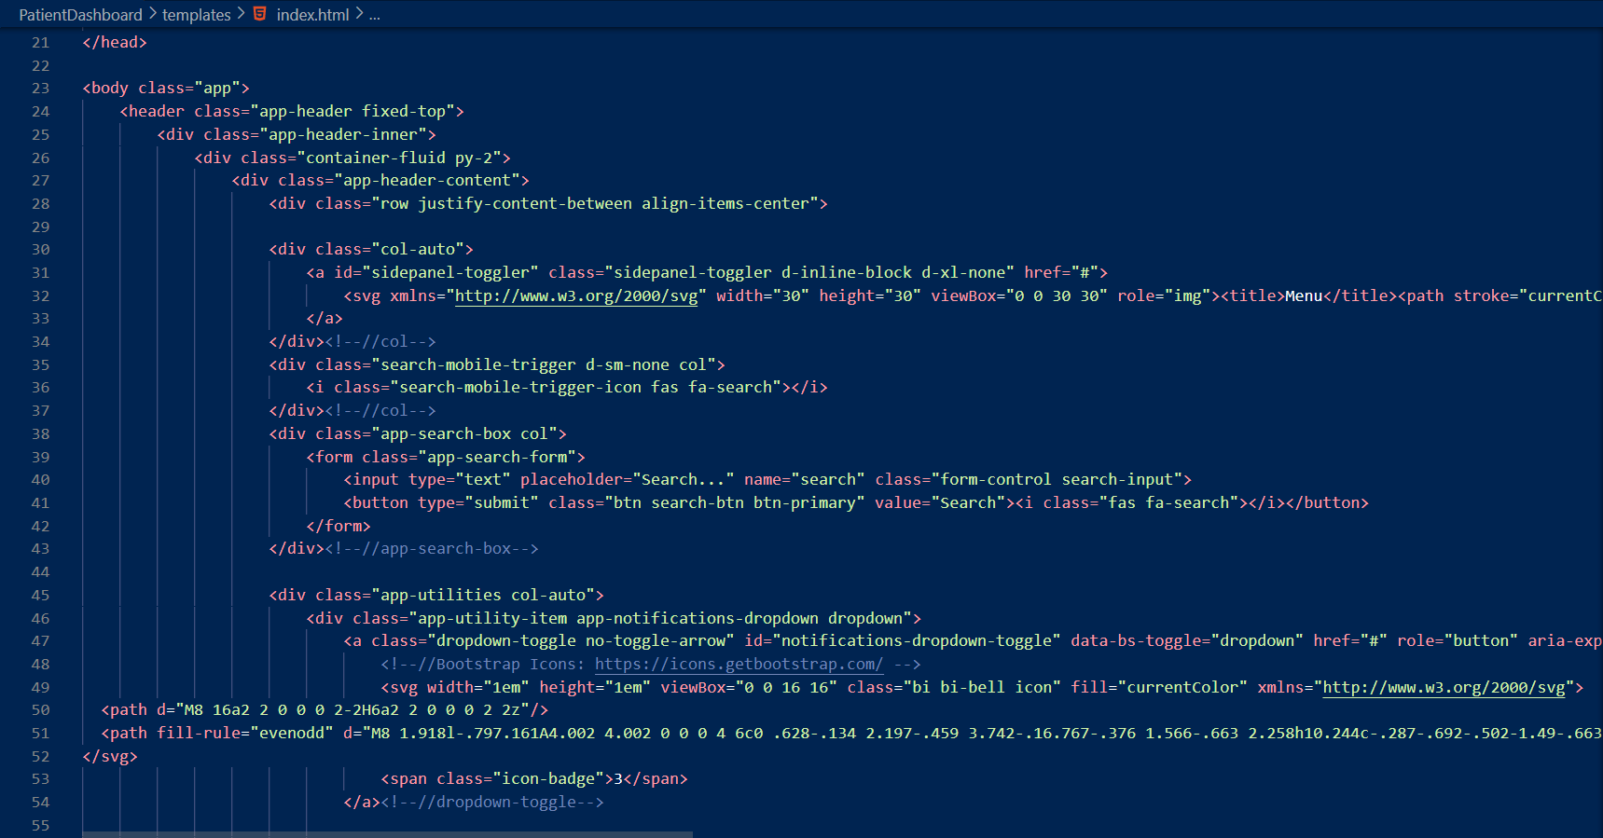

**Snippets code of admin dashboard:**

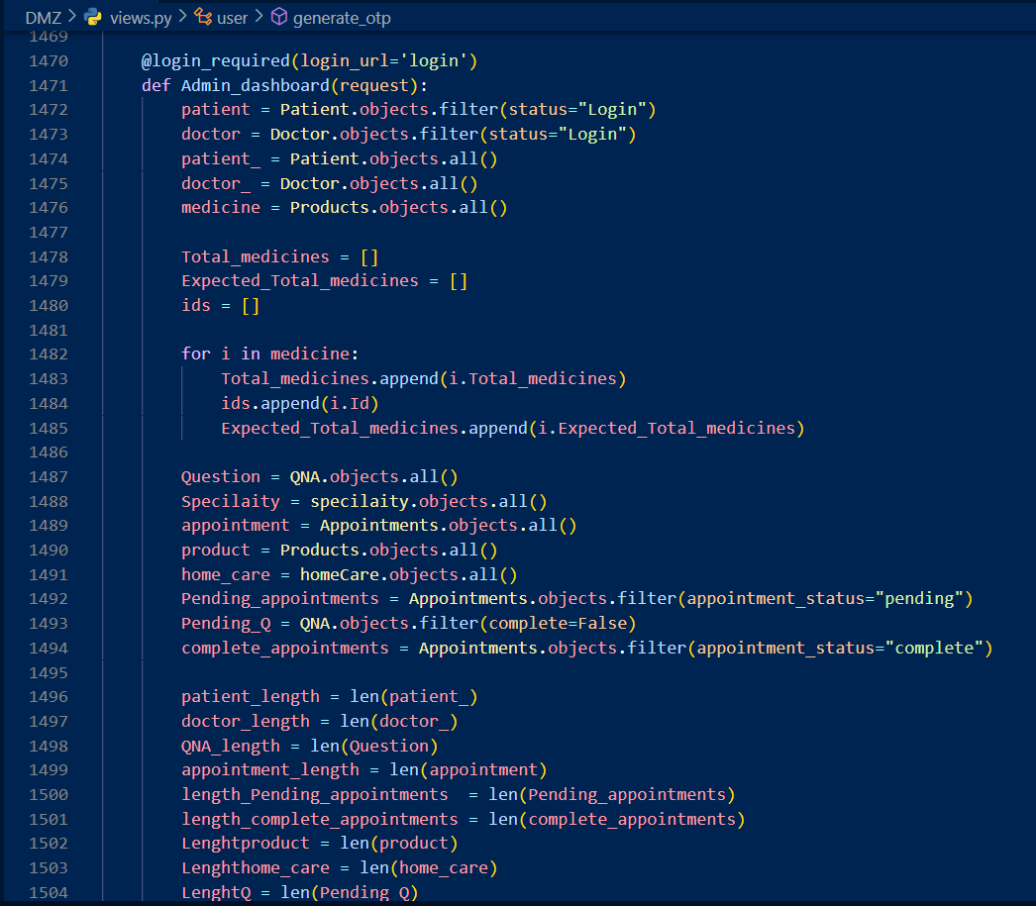

**Snippets code of generator & download code:**

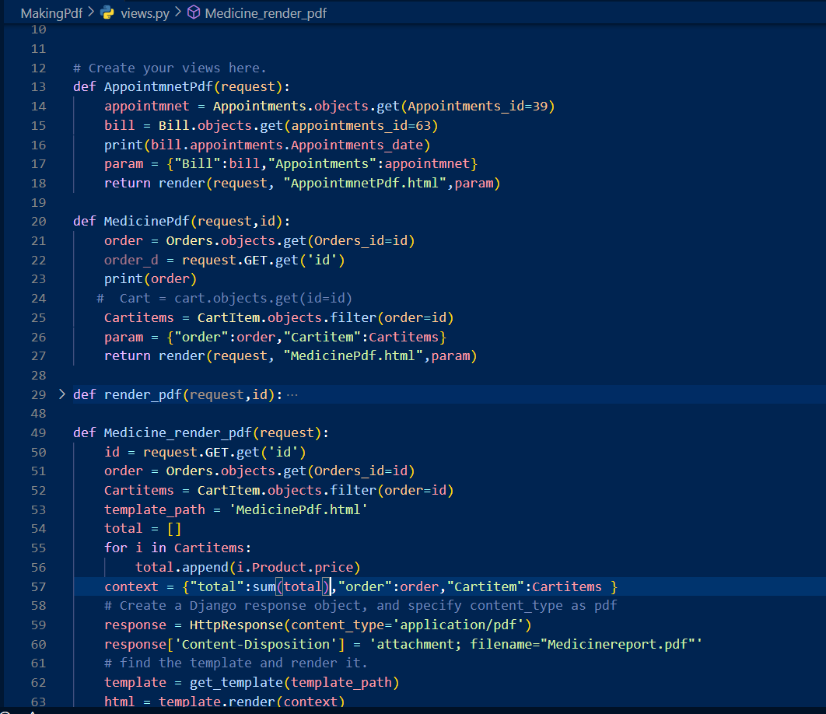

**Snippets of medicine part of code:**

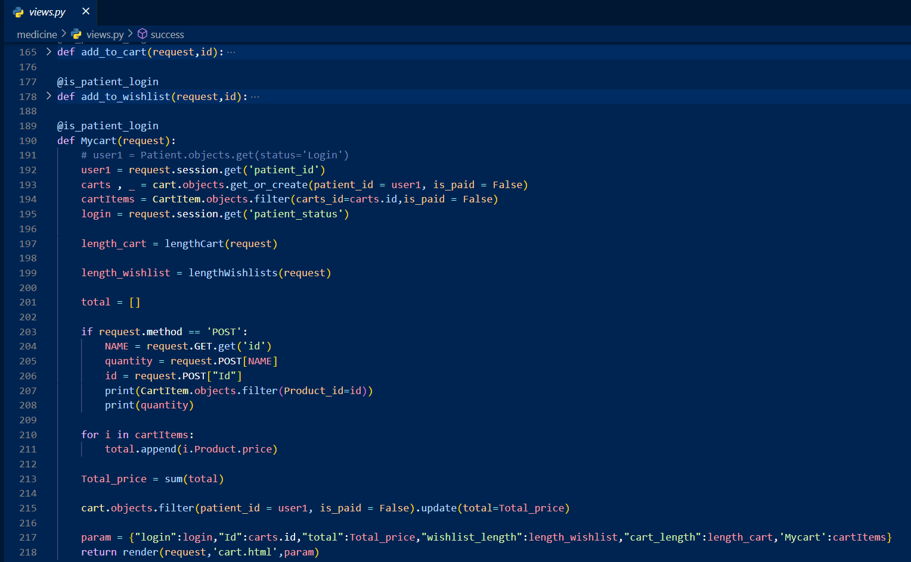

**Snippets of Routing code:**

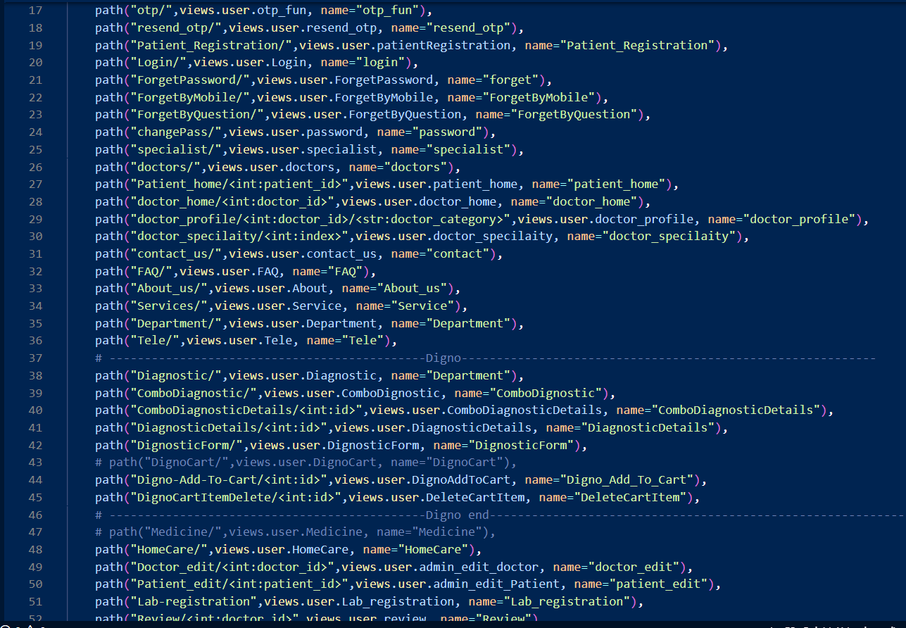

**Snippets of Database model code:-**

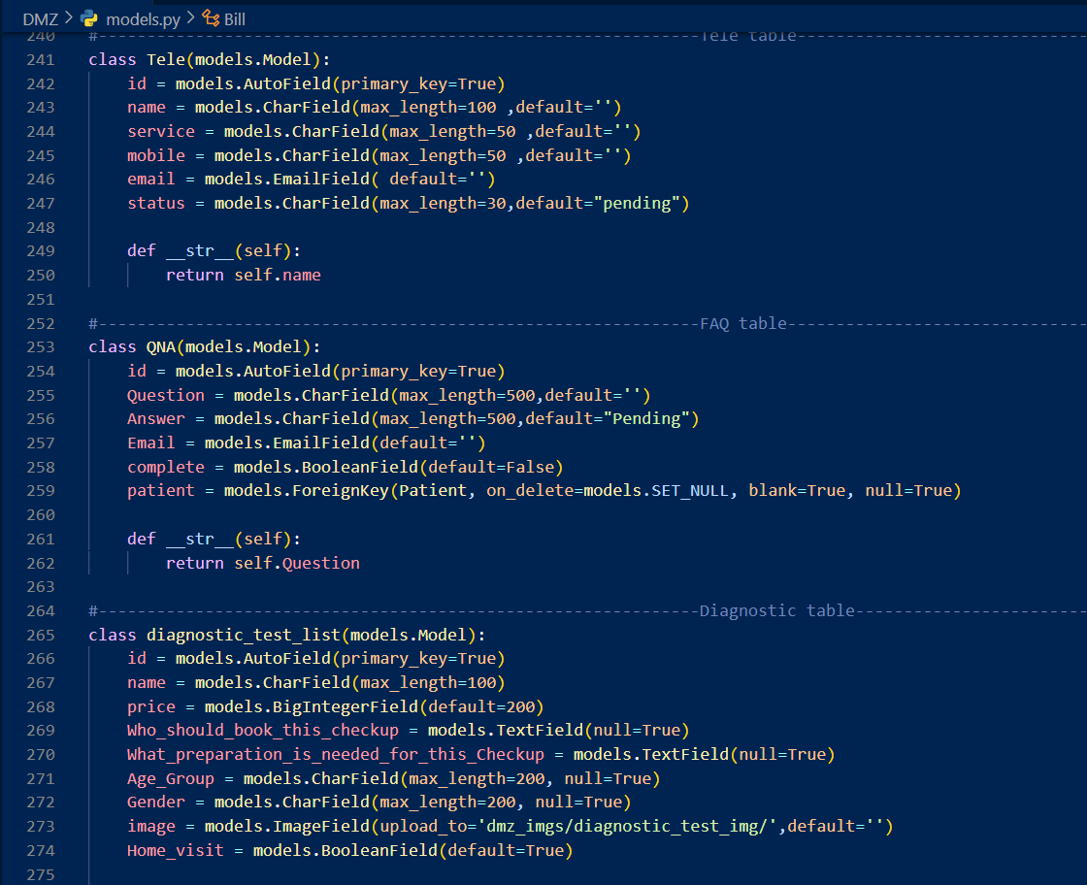

1. **Code Efficiency:**

It describes non-functional necessities such as code efficiency, reliability, speed, & procedure used to generate code for application or Web-application. It is correlated to effectiveness of code & rapidity of procedure Ing time. It is important to confirm high performance for . aim is to decrease source usage & time to completion while minimizing effort place danger. Evaluate quality of project using code function. It plays an important part in applications organized in high speed area where performance & scalability are critical. It is important that rules administer complex procedure.

I have used following procedure for maintain code efficiency for my project:

* Code that was redundant was removed.
* Will be using caching to load apparatuses faster & only when essential.
* Unnecessary packages were removed.
* Used reusable apparatuses. Have proper exception handling blocks.

**Chapter 6 – Testing**

1. **Testing Approach**

A new test form was written to evaluate features & functionality of Web-application. Different features & functions have different characteristics. We need to generate test data to make system reliable, safe, useful, effective & efficient. Software testing are used for assessing a software item to find discrepancies between specified input & expected output. It assesses superiority of project made. system needs to be tested to see if it is affecting properly. testing is done over all phases of change life-cycle. It is verification & validation approach (V&V Model).

* **Verification:**

Verification includes checking that project or procedure happens necessities & specifications. Validation is typically done through development to catch bugs or problems early. Validation can be completed using a variety of techniques, including experimentation, statistical analysis, & analysis. Validation approves that project or procedure is reliable, safe, & happens customer's needs. acknowledgment can help identify defects or problems that may cause problems in future. Validation helps improve superiority of project & decrease danger of failure.

* **Validation:**

project is made as per customer necessities. Testing goes h& in h& with execution to confirm that system efforts accurately & efficiently. most mutual type of testing is done by user who executed program. application that is developed should be valid. It is in this phase, all bugs & errors made in previous step of software development life-cycle are solved. System testing helps in uncovering weaknesses that were not detected in earlier phases of progress cycle. program is executed to find errors intentionally. This includes stress testing, boundary-value analysis etc. For persistence of testing, many test cases are generated.

Testing approves that project or procedure happens user needs & is fit for purpose. Many methods can be cast-off such as testing, user testing, usability testing & visual inspection. Testing approves that a project or procedure is user-friendly, effective, & efficient. Testing is essential to confirm that a project or procedure happens needs & wants of customer

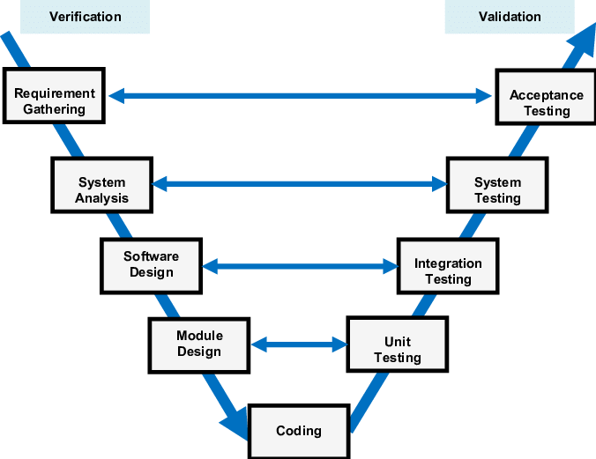

**Figure No. 6.1:- VV Model**

1. **Unit-testing:**

Unit-testing is a software testing procedure in which separate or section chunk of a software application are tested separately from rest of system to confirm y are effort properly. Unit-testing usually involves writing tests for a unit of code that covers all inputs & outputs, & n executing those tests to make definite rules behave as predictable. Unit-testing is a vital part of current software development because it helps confirm overall quality & reliability of final project. Unit-testing is method of testing separate or chunks of a software application to confirm y are effort correctly. This is done by collecting test data that examines how code behaves in different contexts. By doing this, developers can find & fix problems early in change cycle, resultant in improved & improved projects.

**Types of Unit-testing:**

* **Black-box-testing:**

Black-box-testing is a software testing technique. Its attentions on exterior behaviour of system & tests it against input & output. Testers are troubled with effort seen by end users, not with internal efforts of system. This approach helps identify inconsistencies between system behaviour & user necessities or expectations.

* **White box testing:**

Black-box-testing is a software testing technique. Its attentions on exterior behaviour of system & tests it against input & output. Testers are troubled with effort seen by end users, not with internal efforts of system. This approach helps identify inconsistencies between system behaviour & user necessities or expectations.

* **Grey box testing:**

Gray-box-testing is a software testing technique. It involves testing system with some knowledge of its inner effecting. Testers have limited access to inner chunk of system & use this info to produce more well-organized & actual test data. This approach will help identify problems that may arise due to impact of different chunk of system, such as integration problems. Gray-box-testing is beneficial for systems that are too complex to be completely tested using a standalone Black-box but do not have access to all functionality exclusive, such as checking white box.

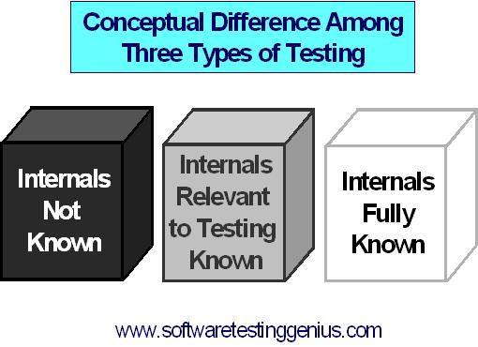

**Figure No. 6.1.1:- Types of Unit-testing**

1. **Integration Testing:**

It is type of testing where separate software program apparatuses are mutual & tested as an entire to confirm y effort well together. It involves testing how different apparatuses of system effort to perform intended function**.** In further words, integration testing is a method of confirmatory that different types of software application effort composed as likely & that system happens specified supplies & specific instructions. It's usually done after Unit-testing because it helps to catch matters initial in development procedure.

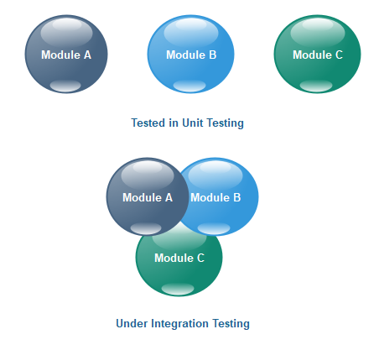

**Figure No. 6.1.2:- Integration testing**

* **Test Plan:**

A test plan is a text that defines test strategy, purpose, resources mandatory for testing test time, appraisal & delivery. Prepared software test situation is carefully evaluated rendering to defined procedure & evaluated by administrator. Test preparation is known as most important task in test implementation procedure.

re are following steps for testing:

* Analyse project
* Develop test-strategy
* Define test-strategy
* Define test-criteria
* Resource planning
* Plan test environment
* Test Deliverables
* **Test Cases:**

A test case is a set of actions or steps used to test where a software application, system, or functionality is at effort as expected. It is intended to switch right behaviour of software under certain conditions.

|  |  |  |  |
| --- | --- | --- | --- |
| System Name: - | Drmedizone | | |
| Module code: - | **Dr_001** | | |
| Pass | 20 | **Pending:-** | 0 |
| Fail | 0 | **Number of test case:-** | 20 |

|  |  |  |  |  |
| --- | --- | --- | --- | --- |
| Test case Id | Test case | Expected Output | Actual Output | Result |
| Dr_001L1 | Correct Username & password | Redirect on profile page | Redirect on profile page | pass |
| Dr_001L2 | Correct Username & Invalid password | Show error message:-  Password is invalid. | Show error message:-  Password is invalid. | pass |
| Dr_001L3 | Invalid Username &  Correct password | Show error message:-  Username is invalid. | Show error message:-  Username is invalid. | pass |
| Dr_001L4 | Invalid Username &  Invalid password | Show error message:-  Username & password are invalid. | Show error message:-  Username & password are invalid  . | pass |
| Dr_001L5 | Username input box is empty &  Correct password | Show error message:-  Please enter username | Show error message:-  Please enter username | pass |
| Dr_001L6 | Correct Username & password input box is empty | Show error message:-  Please enter password | Show error message:-  Please enter password | pass |
| Dr_001L7 | Username & password input boxes both are empty | Show error message:-  Please enter username & password | Show error message:-  Please enter username & password | pass |
| Dr_001L8 | Input boxes are empty | Show error message:- Enter all necessary details are required | Show error message:- Enter all necessary details are required | pass |
| Dr_001L9 | Click submit button | Submit form & show message:-  Submitted successfully | Submit form & show message:-  Submitted successfully | pass |
| Dr_001L10 | If doctor schedule is busy | Show message:-  Doctor is not available | Show message:-  Doctor is not available | pass |
| Dr_001L11 | Search doctor by name | Show list of all related name of doctors | Show list of all related name of doctors | pass |
| Dr_001L12 | Search doctor by categories | Show list of all related category of doctors | Show list of all related category of doctors | pass |
| Dr_001L13 | Search doctor by fees | Show list of all related doctors | Show list of all related doctors | pass |
| Dr_001L14 | Upload health report | Show message:-Upload successfully | Show message:-Upload successfully | pass |
| Dr_001L15 | Download health report | Show message:-download successfully | Show message:-download successfully | pass |
| Dr_001L16 | Doctor is not found | Show message:- Doctor is not found | Show message:- Doctor is not found | pass |
| Dr_001L17 | Click get appointment button | Open appointment form | Open appointment form | pass |
| Dr_001L18 | Click doctor button | Show list of all doctors | Show list of all doctors | pass |
| Dr_001L19 | Click get appointment button but patient is not login | Open login form | Open login form | pass |
| Dr_001L20 | Click on doctor profile | Show all doctor details | Show all doctor details | pass |

**Chapter 7 – User Interface**

**Home Page User Interface**

This UI is first page of Drmedizone Web-application. On this UI user can see doctors, specialist total count of doctors, specialist, appointments & lab test. Going to medicine & lab test page are available on this UI.

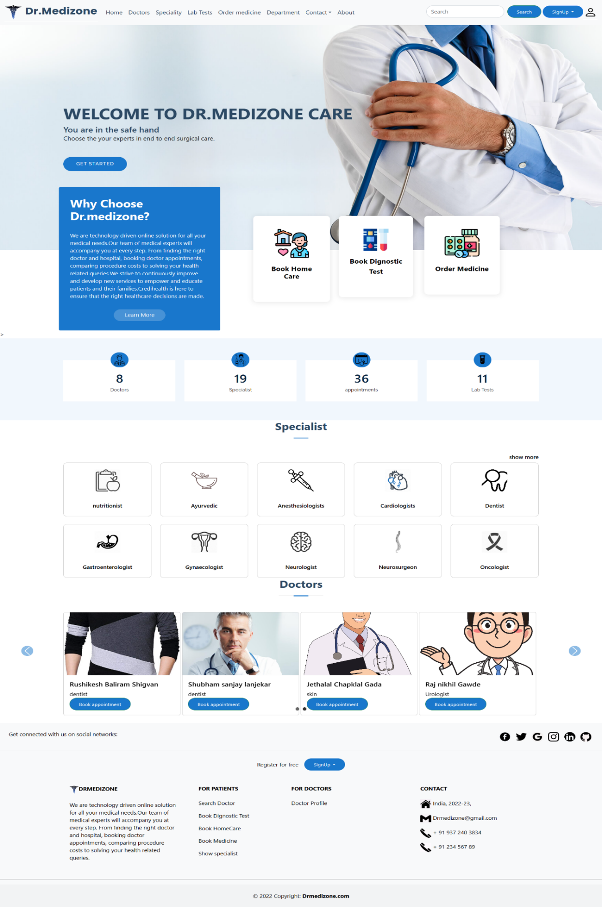

**Figure No. 7.1 :- Home Page User Interface**

**Specialist Page User Interface**

This UI page are especially available for patients. In this page user can see list of specialties of doctor.

With help of this UI user can filter specific specialties of doctors

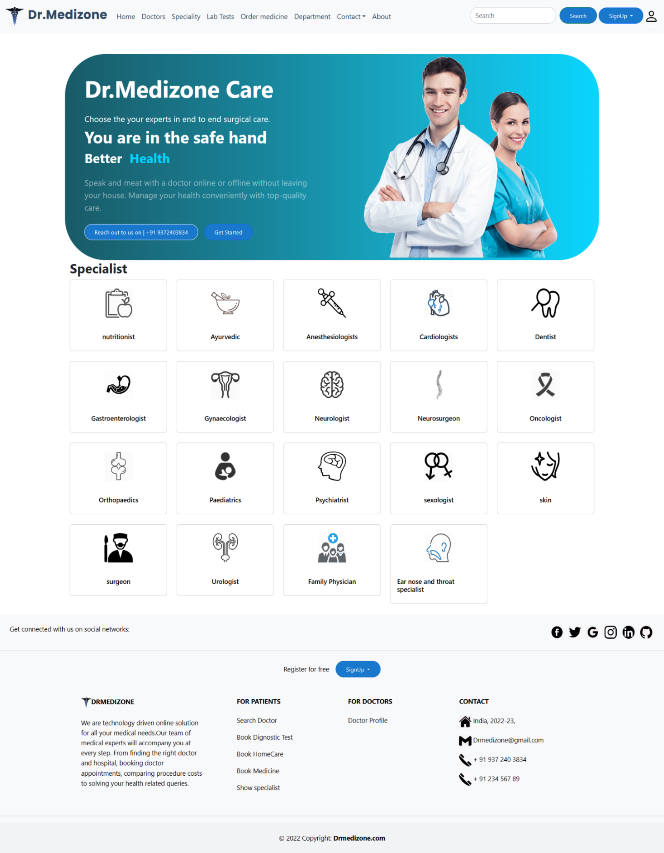

**Figure No. 7.2 :- Specialist Page User Interface**

**Doctor Detail Page User Interface**

This is single doctor detail page. In this page patient can see doctor’s details & see review & ratings of single doctor. If patient can login n patient book appointment & give review & rating. Patient can also see related specialist doctors.

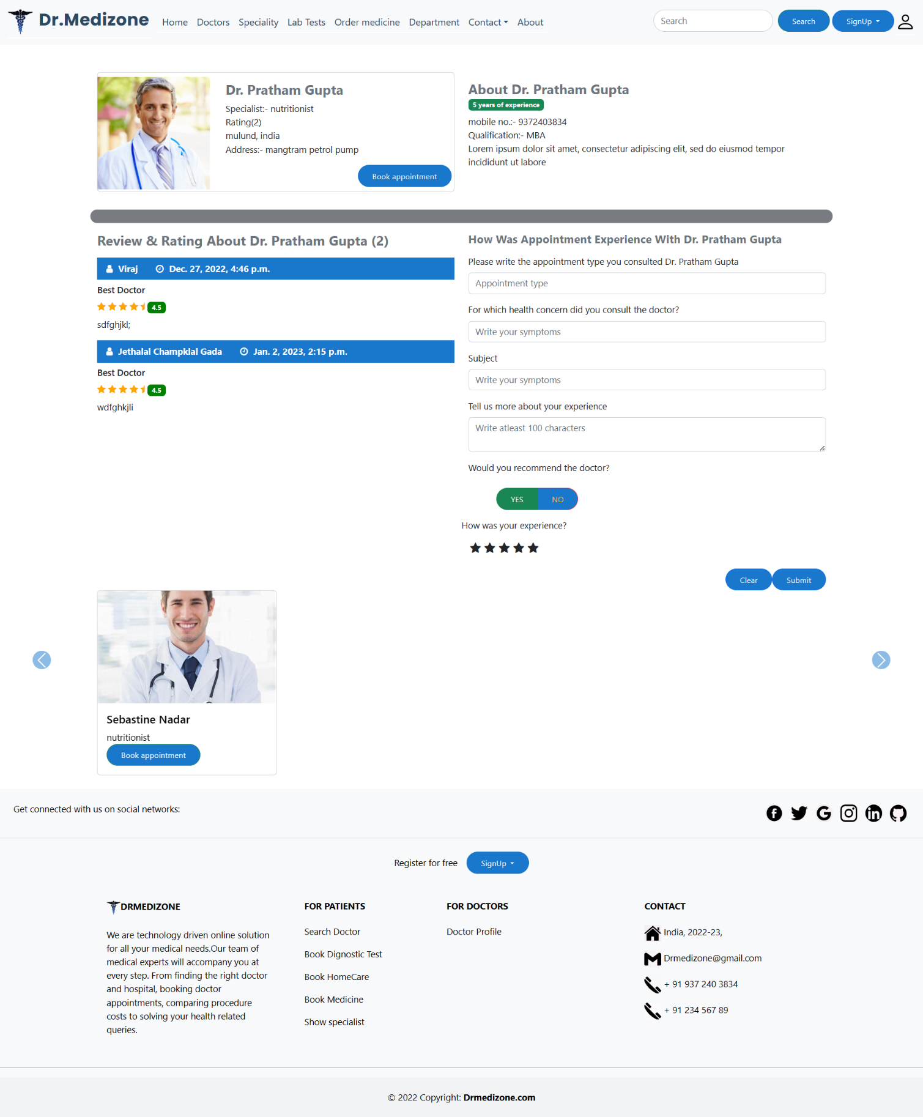

**Figure No. 7.3 :- Doctor Detail Page User Interface**

**Doctor’s Page User Interface**

In this UI patient can see all doctors here; With help of specialist & Rating patient can filter doctors. Patient can also search doctor by name. If patient can login n patient book appointment here.

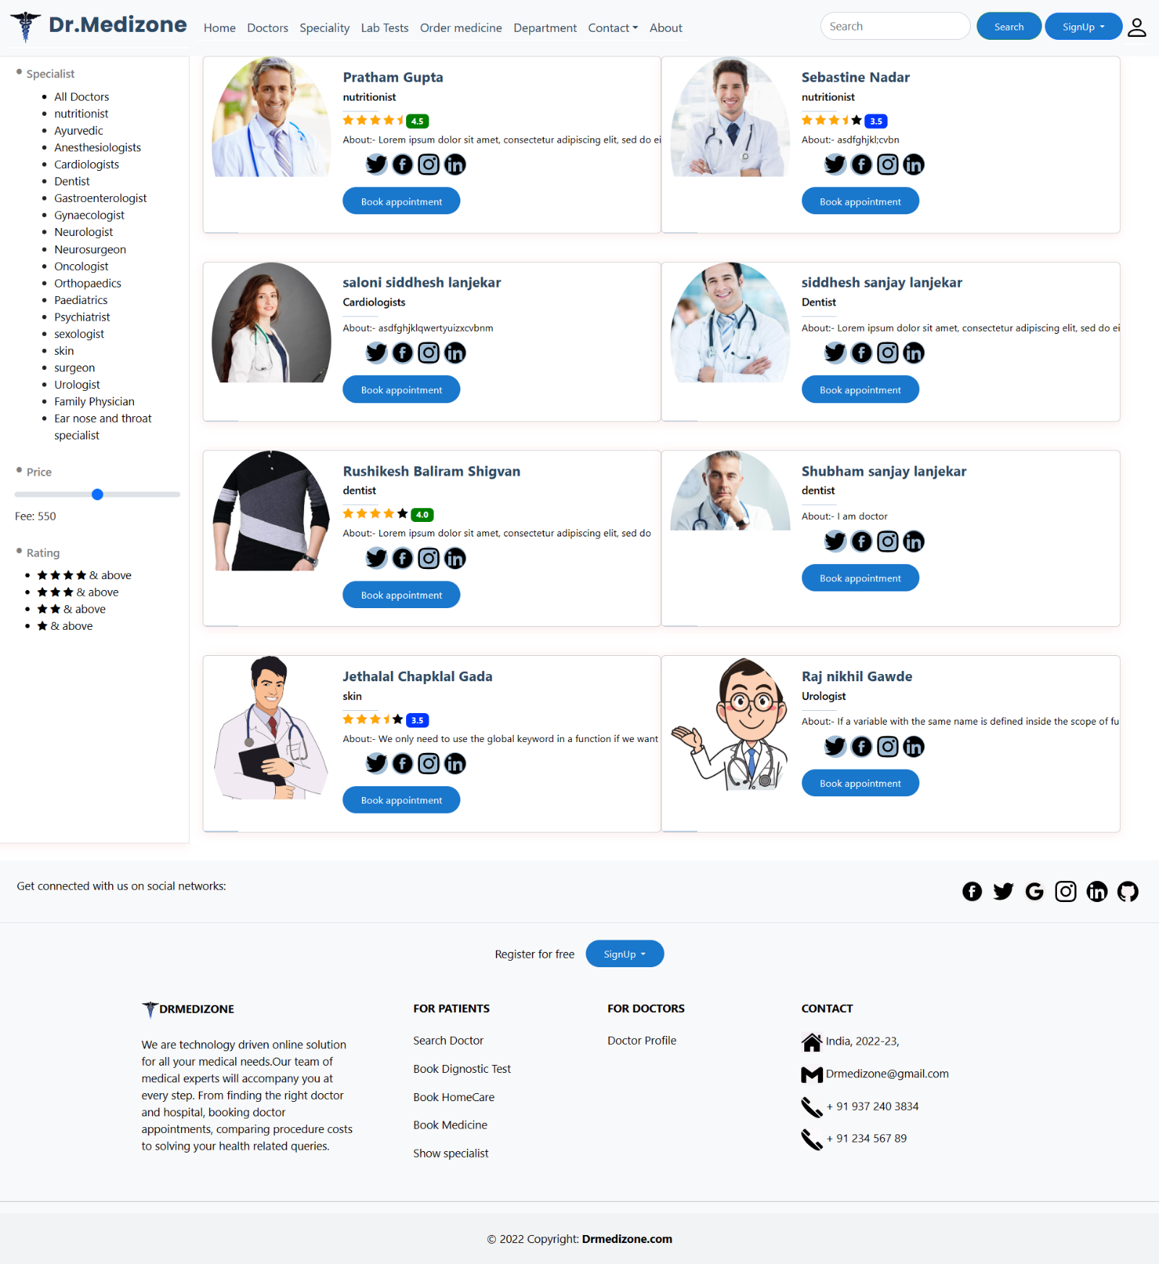

**Figure No. 7.4 :- Doctor’s Page User Interface**

**Filter Page On Doctor’s Page User Interface**

This is filter page based on specialists, star rating, search by names also; If patient can login n patient book appointment here.

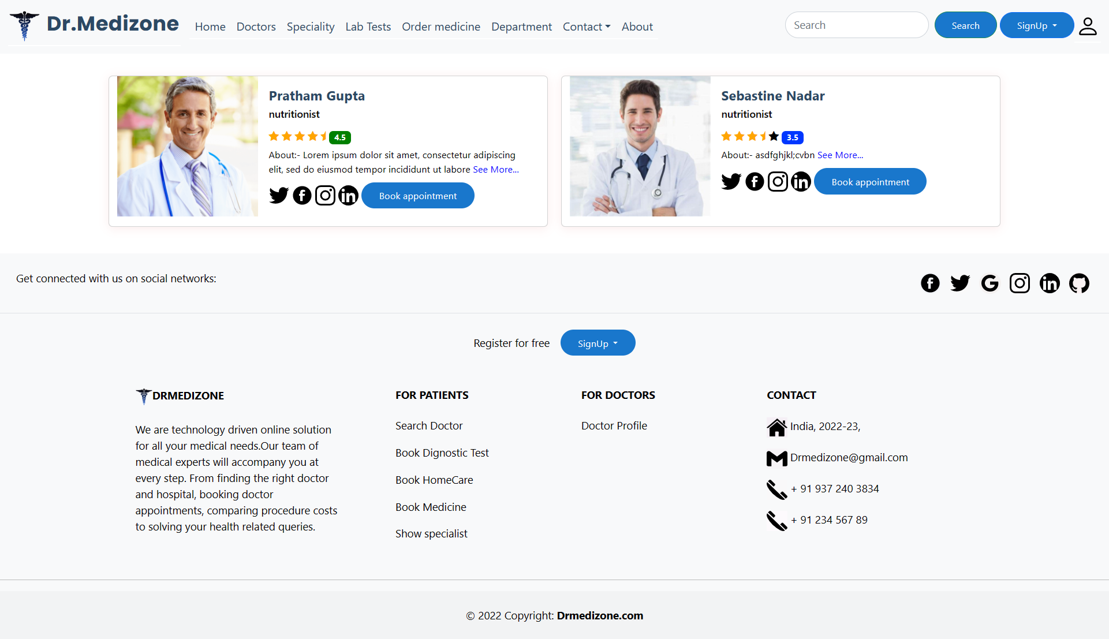

**Figure No. 7.5 :- Filter Page on Doctor’s Page User Interface**

**Filter Page On Doctor’s Page If Doctor Not Found User Interface**

This is filter page based on specialists, star rating, search by names also; if any doctors are not found so show message **“Doctor Not Found!!!”**

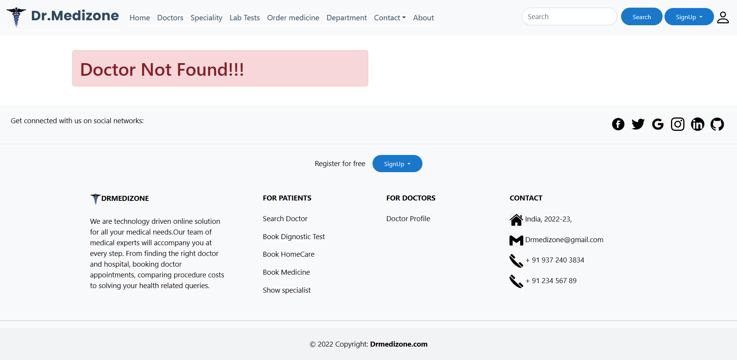

**Figure No. 7.6 :- Filter Page on Doctor’s Page If Doctor Not Found User Interface**

**Homecare Page User Interface**

In this UI you can take equipment on rent after filling given form; if patient can login n take equipment on rent if patient not login n redirect on login page. Patient can see or information.

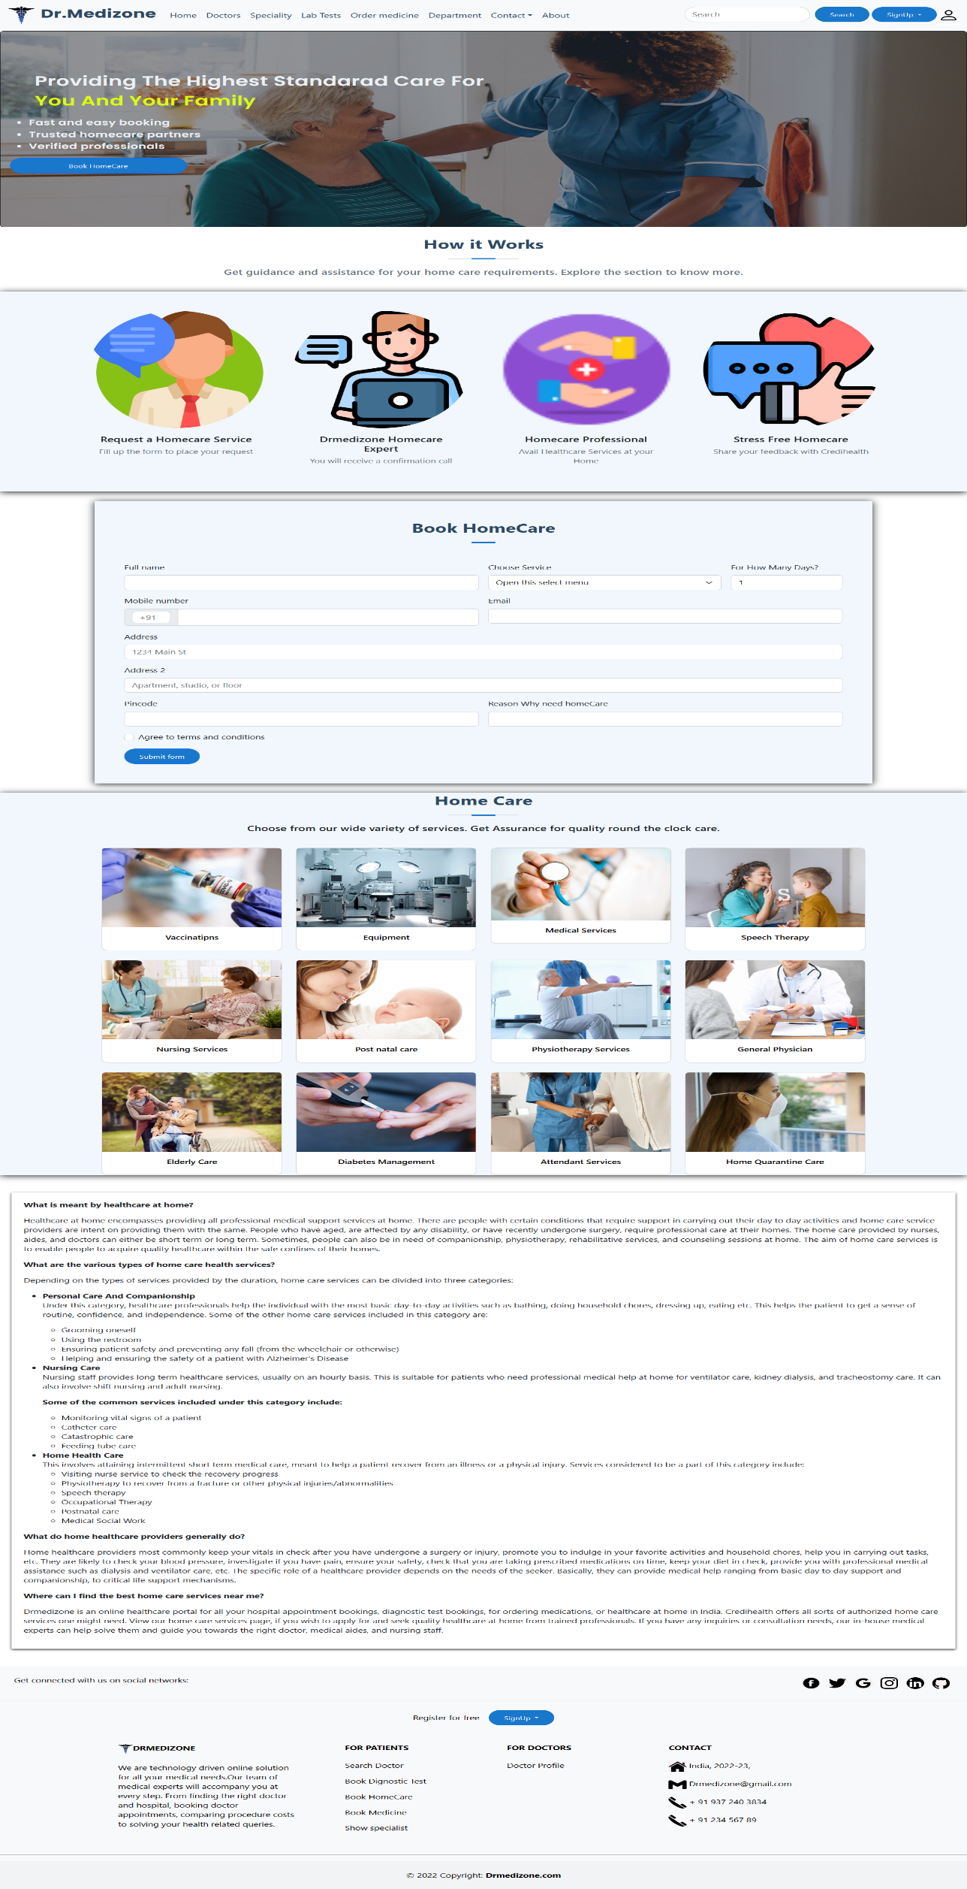

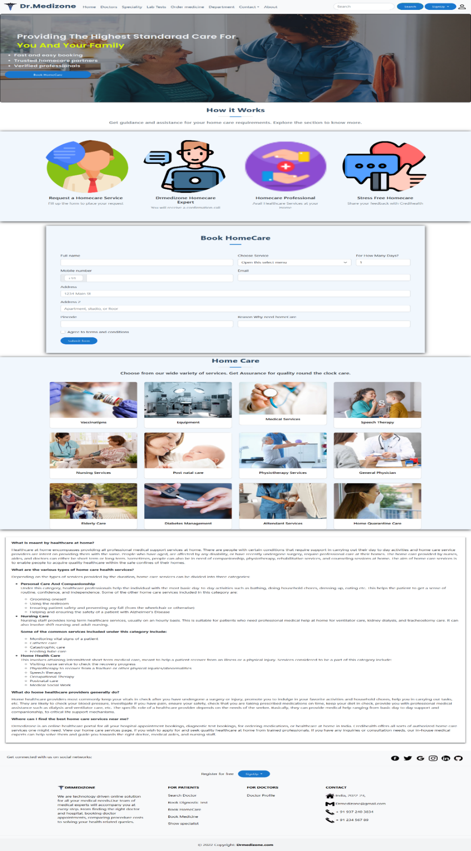

**Figure No. 7.7 :- Homecare Page User Interface**

**Lab Test Page User Interface**

This is Lab Test UI On this UI patient can see combo & single tests. User can see any test in detail if user click on specific test. If patient can login n single lab-tests are added into cart.

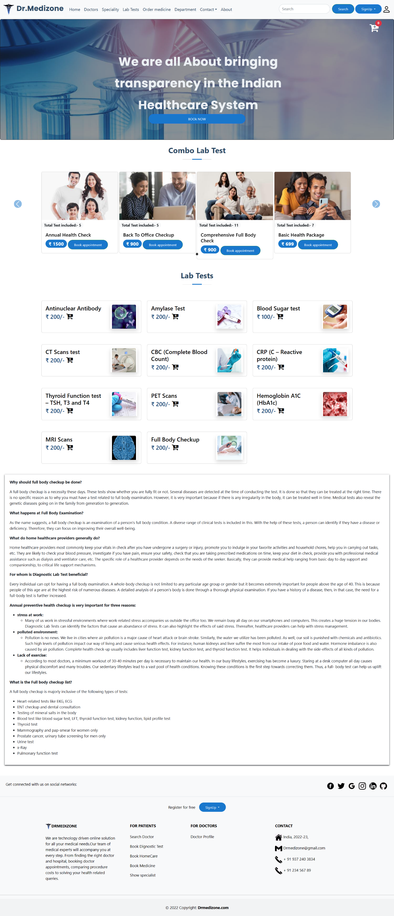

**Figure No. 7.8 :- Lab Test Page User Interface**

**Combo Package Detail Lab Test Page User Interface**

This is Combo Lab Test UI On this UI patient can see single combo test in details. If patient can login n get appointment for lab-tests.

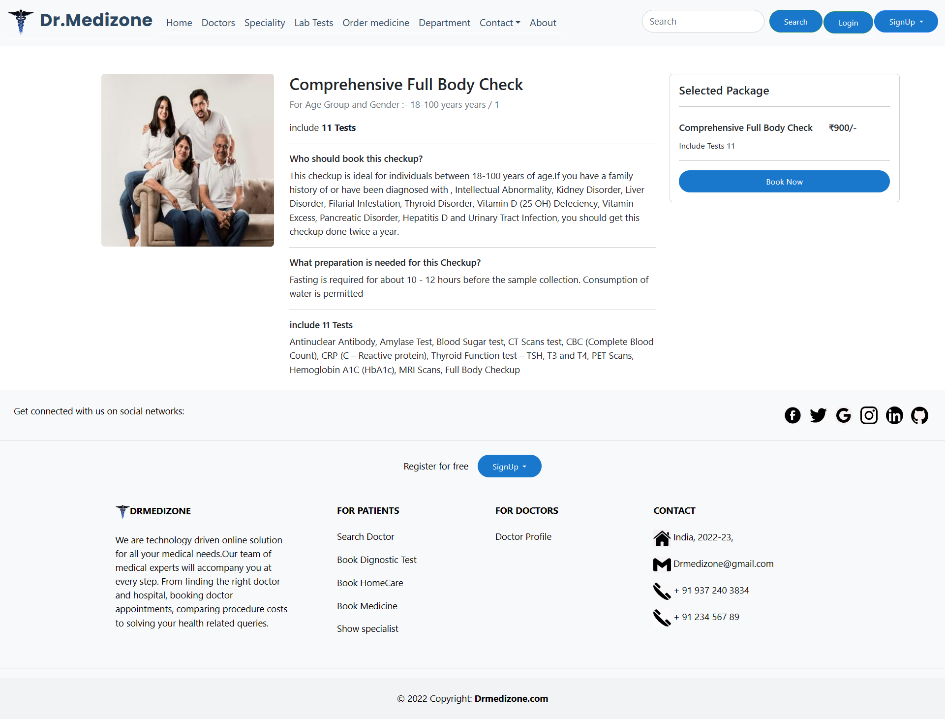

**Figure No. 7.9 :- Combo Package Detail Lab Test Page User Interface**

**Single Lab Test Detail Page User Interface**

This is single Lab Test UI On this UI patient can see single test in details. If patient can login n get appointment for lab-tests & single lab-tests are added into cart & remove test into cart also.

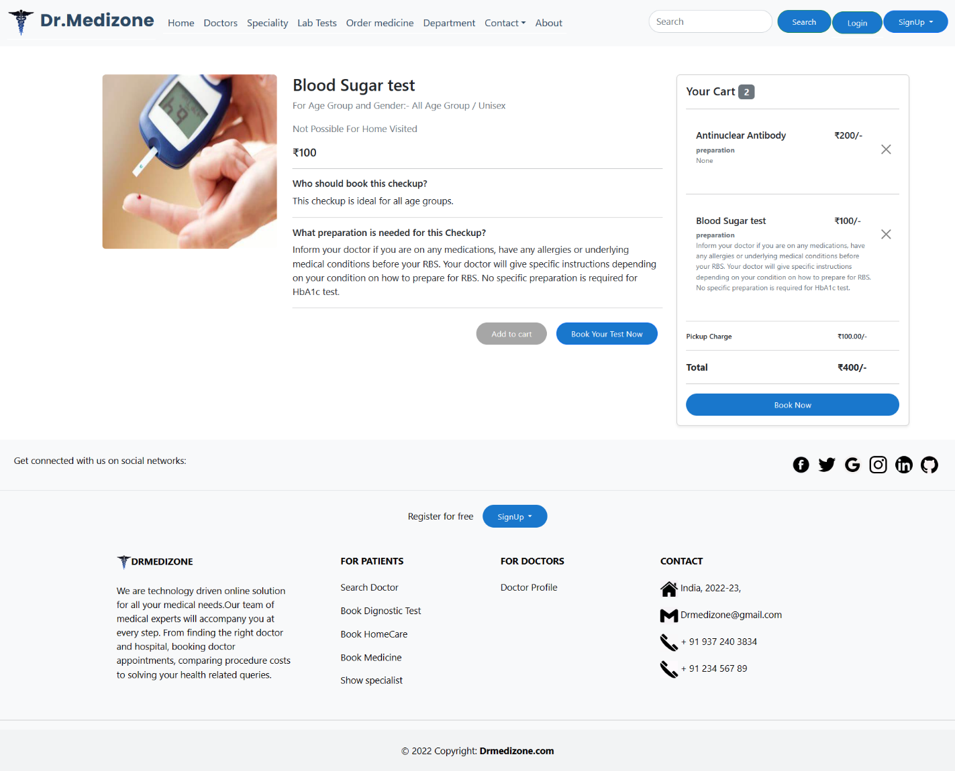

**Figure No. 7.10 :- Single Lab Test Detail Page User Interface**

**Contact Page User Interface**

This is Contact page UI. On this UI any user can contact with admin & give any message to admin. User can see location of admin office; for admin contact admin’s Phone number; Email address & Address are available.

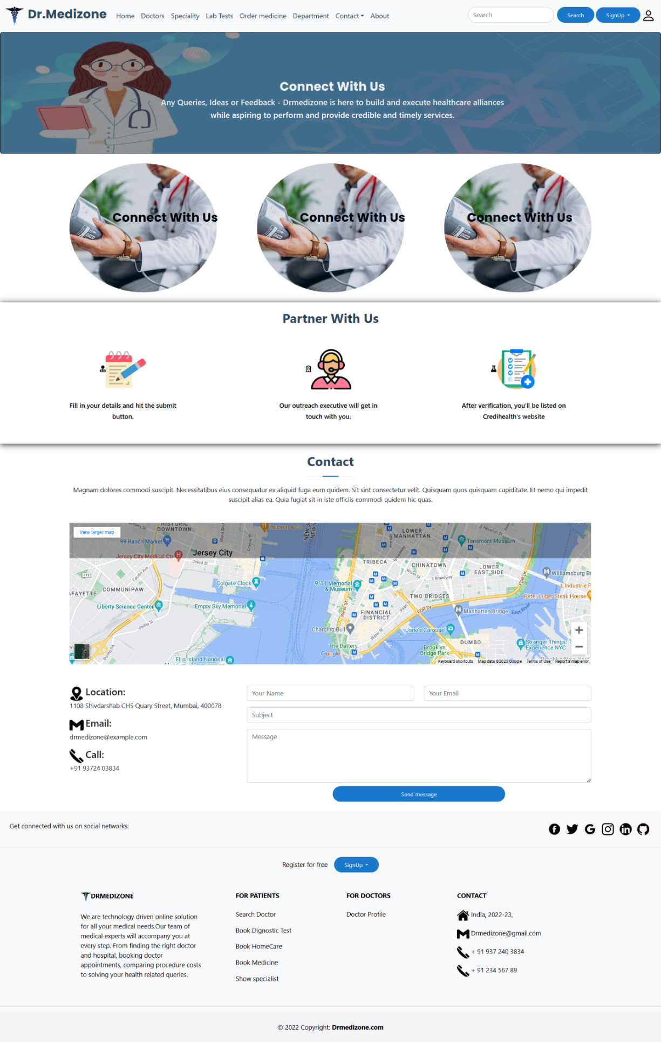

**Figure No. 7.11 :- Contact Page User Interface**

**FAQ Page User Interface**

This is FAQ page; with help of this page any user can ask any question to admin; & all user can see also or user’s question’s answer here. For using this page are not compulsory users are login

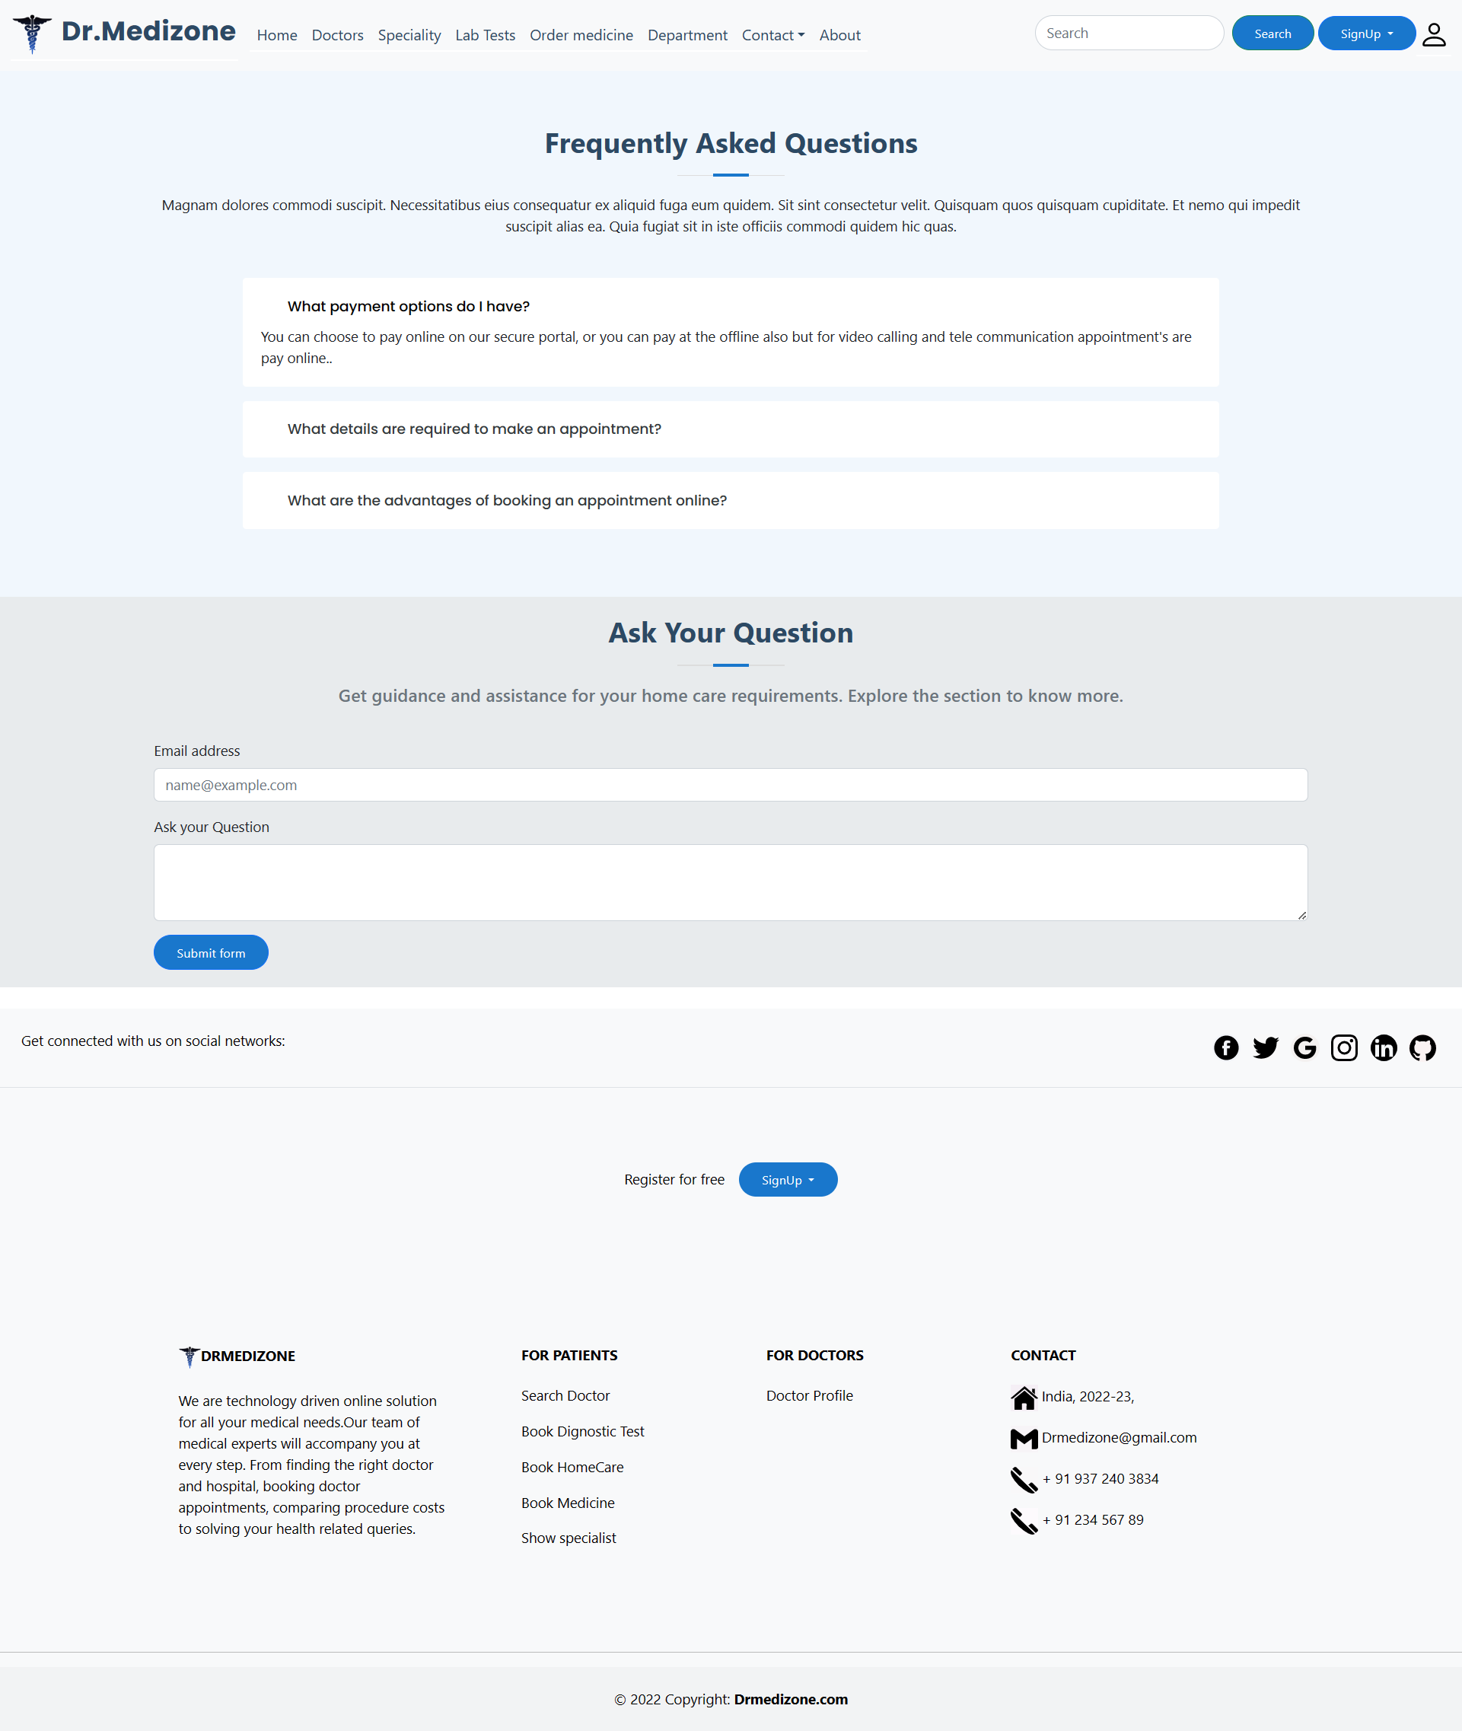

**Figure No. 7.12 :- FAQ Page User Interface**

**Lab Test Form Page User Interface**

This is Lab test form; Using this form patient can take appointment with online payment. All input fields are compulsory to fill for taking appointment. For coming to this page are compulsory to patients are login.

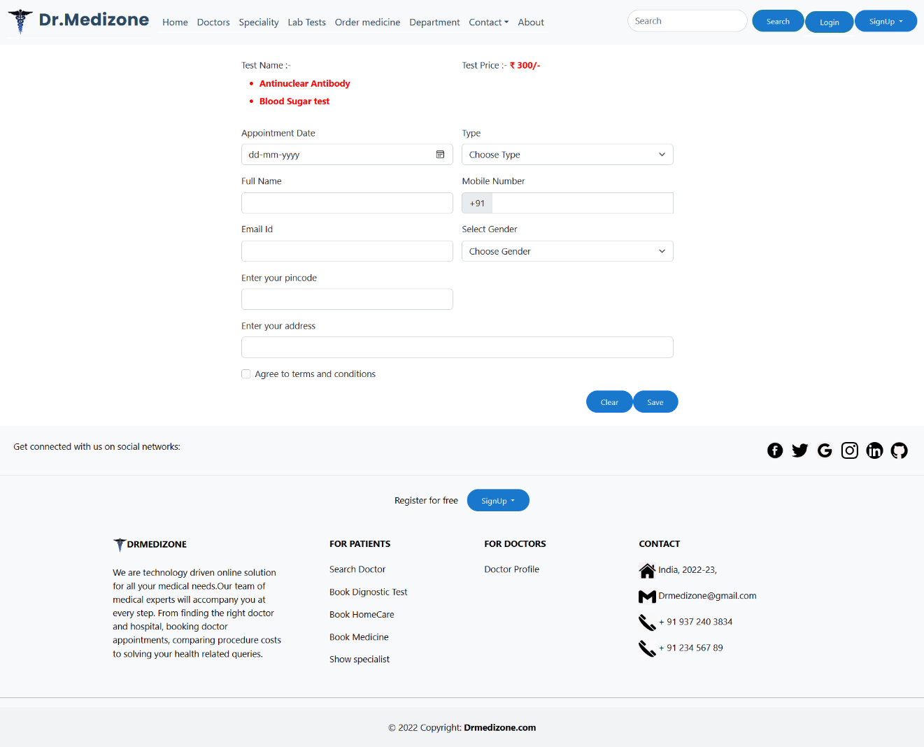

**Figure No. 7.13 :- Lab Test Form Page User Interface**

**Payment Welcome Page User Interface**

This is welcome page of payment gateway. After filling form patient go to this page for online payment. I use razorpay payment gateway.



**Figure No. 7.14 :- Payment Welcome Page User Interface**

**Payment Popup User Interface**

Following UI is a pop-up window of razorpay payment gateway; In this pop-up are many types of payment methods are available; ex. UPI, Card, Net-banking etc. using this pop-up window patient can paid appointment’s fees.

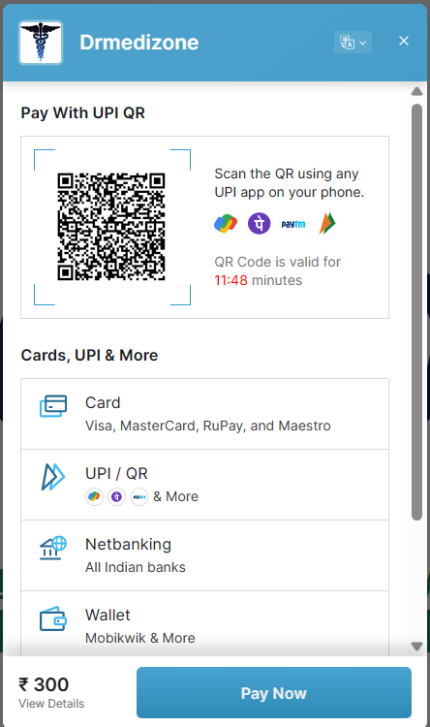

**Figure No. 7.15 :- Payment Popup User Interface**

**Thanks Page User Interface**

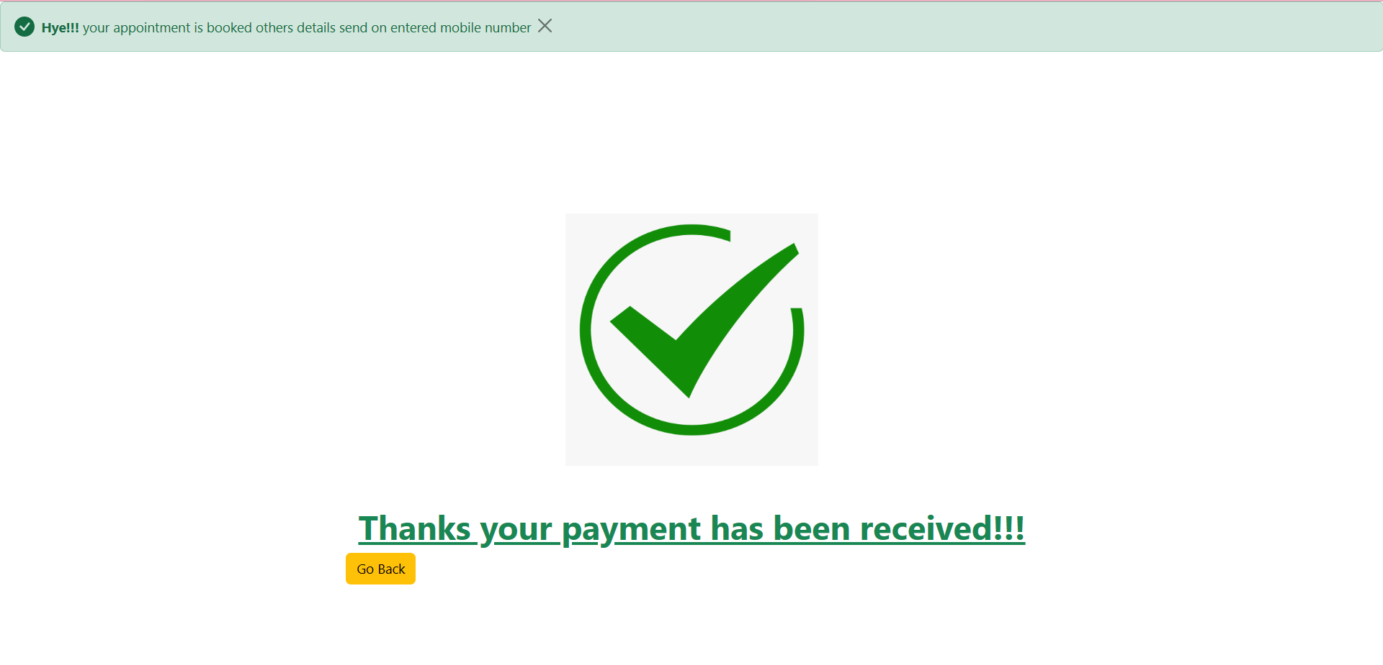

**Figure No. 7.16 :- Thanks Page User Interface**

**About Page User Interface**

This about page of Drmedizone Web-application; In this page give information of about project, our vision.

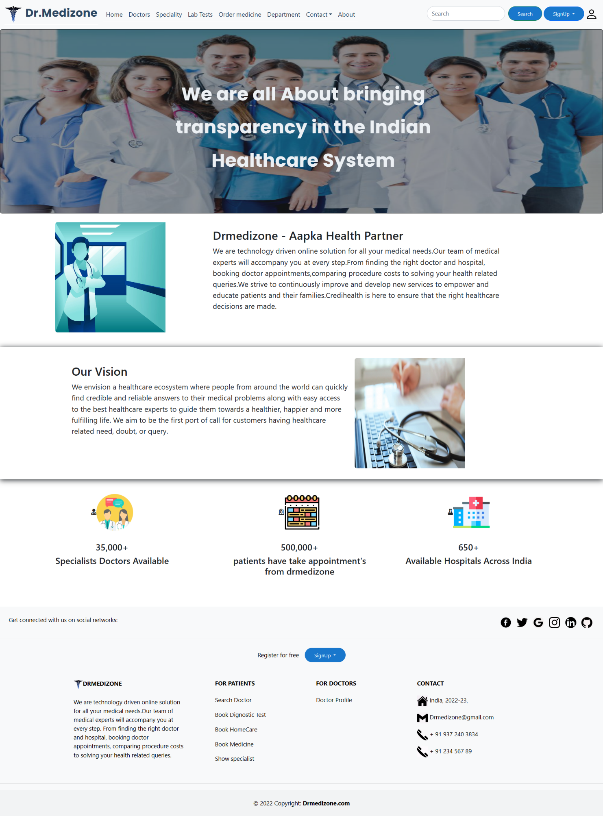

**Figure No. 7.17 :- About Page User Interface**

**Doctor Appointment Page User Interface**

This is doctor appointment page for coming this page a patient can login are compulsory. In this page are two types of methods are available one is Cash on Appointment & Online payment. Also, in this page rating system are also available.

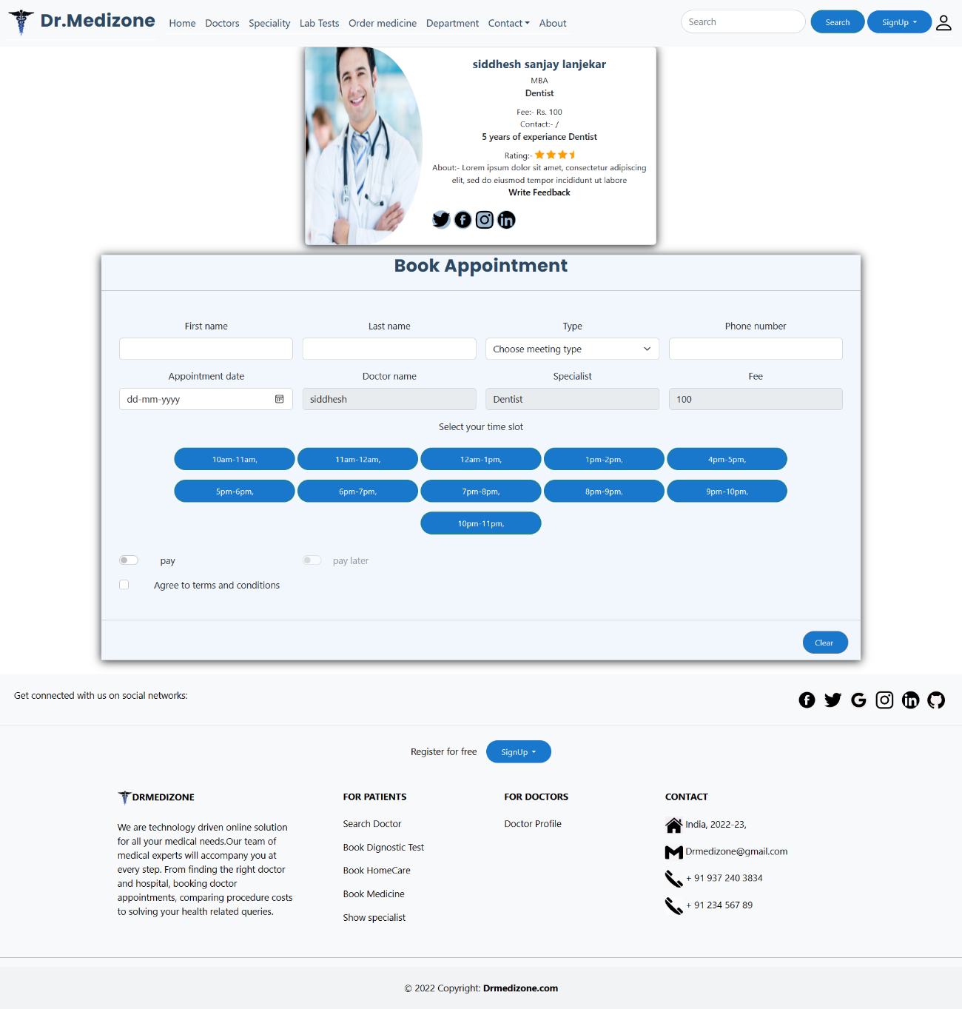

**Figure No. 7.18 :- Doctor Appointment Page User Interface**

**Appointment Receipt User Interface**

This is receipt of appointment system; download after successful taking appointment. In this receipt all appointment related information is available.

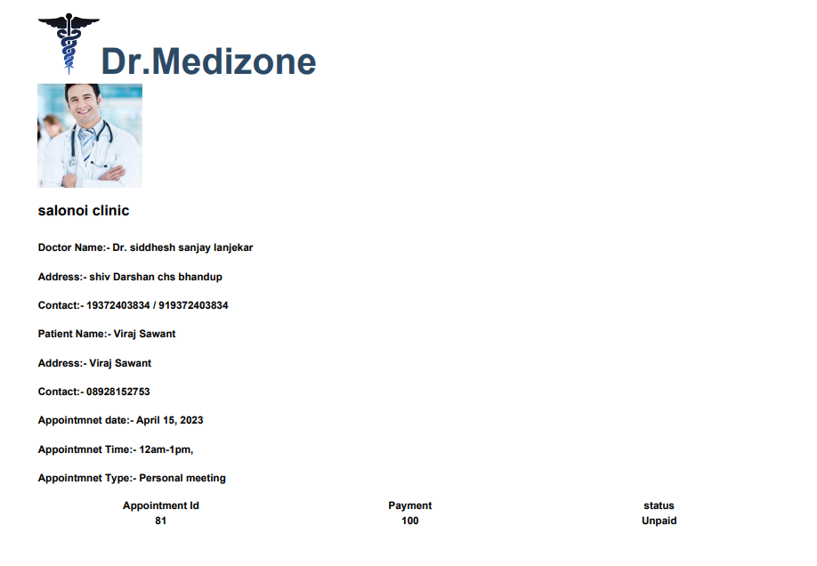

**Figure No. 7.19 :- Appointment Receipt User Interface**

**Admin Home Page User Interface**

This admin dashboard page where Admin view total appointments, total Doctors, total Patients, total medicine order etc. also view active doctors & patients list. Also, can view medicine quantity graph; Appointments pie char also can view by admin.

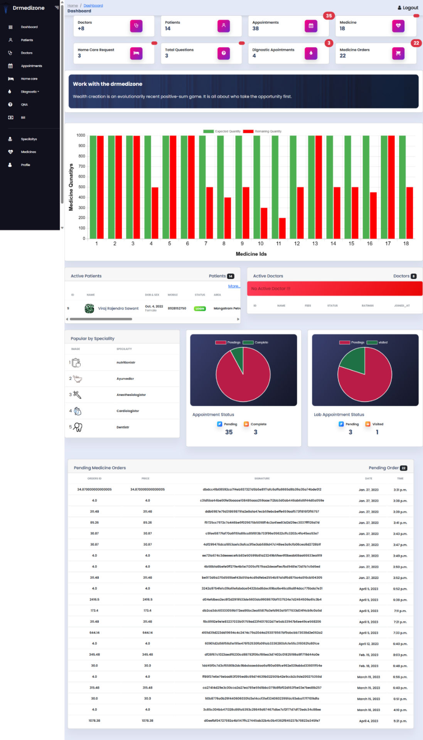

**Figure No. 7.20 :- Admin Home Page User Interface**

**Admin Patient Table User Interface**

Admin view all patient with details & login status also; Admin view also login details in table; admin also delete patient & edit patient details.

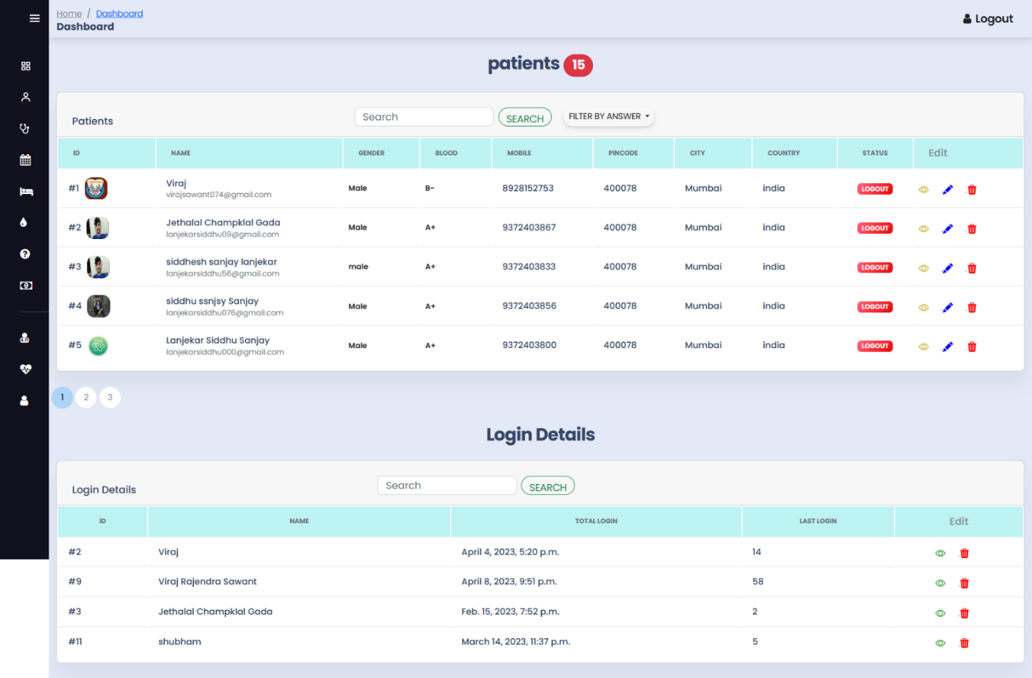

**Figure No. 7.21 :- Admin Patient Table User Interface**

**Admin Doctor Part User Interface**

Admin view all doctor with details & login status also; Admin view also login details in table; admin also delete patient & edit patient details.

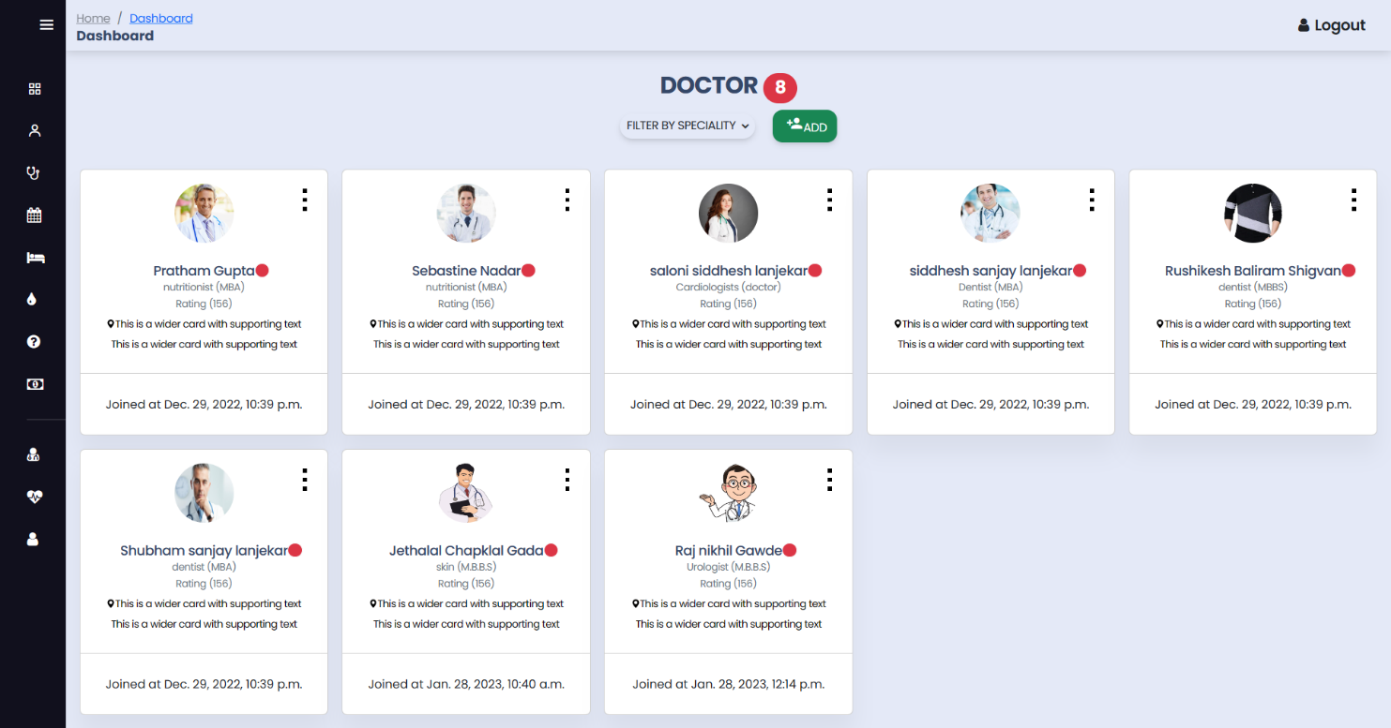

**Figure No. 7.22 :- Admin Doctor Part User Interface**

**Admin Doctor Appointment User Interface**

Admin view all appointments of a particular doctor & patient with schedule time & payment history.

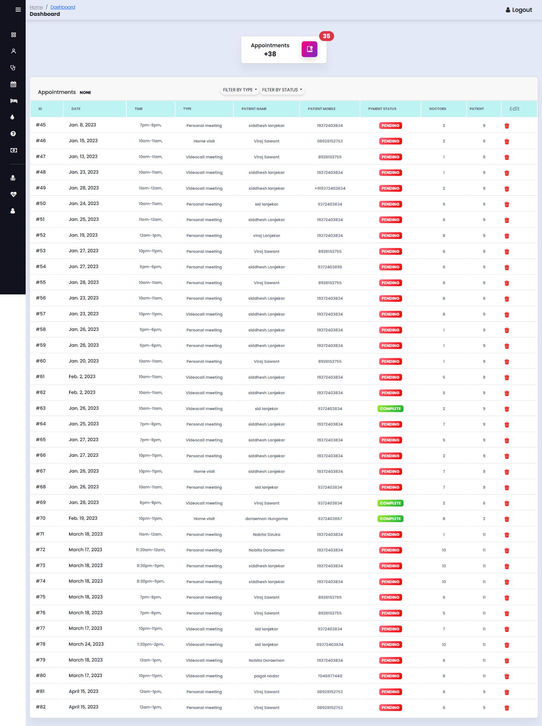

**Figure No. 7.23 :- Admin Doctor Appointment User Interface**

**Admin QNA User Interface**

This is admin QNA interface. User can ask any question, doubts; & admin can give answer of pending questions.

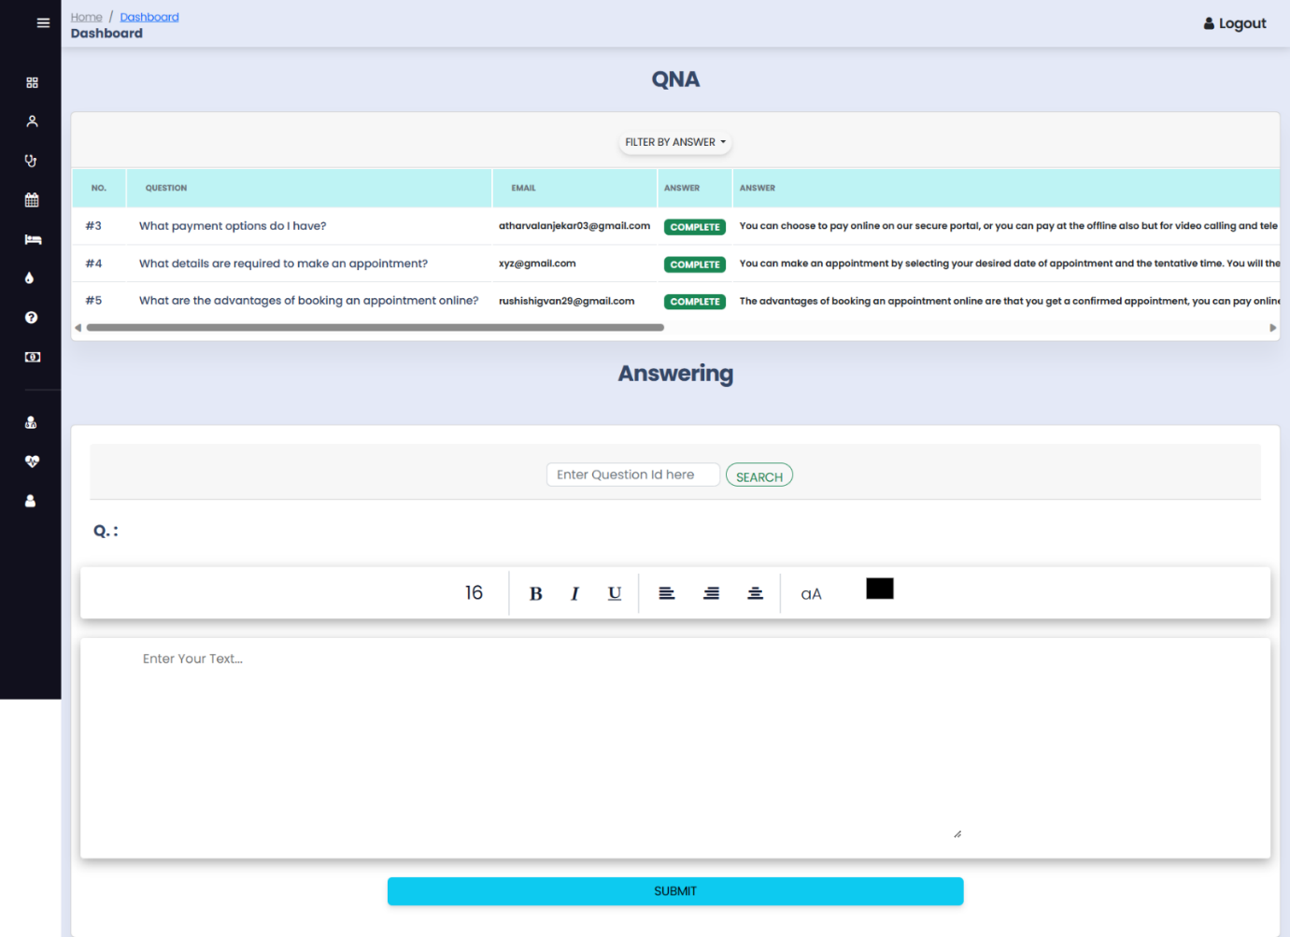

**Figure No. 7.24 :- Admin QNA User Interface**

**Admin Medicine User Interface**

Admin view medicine table & Admin can upload medicines with full details. Admin also perform CRUD actions.

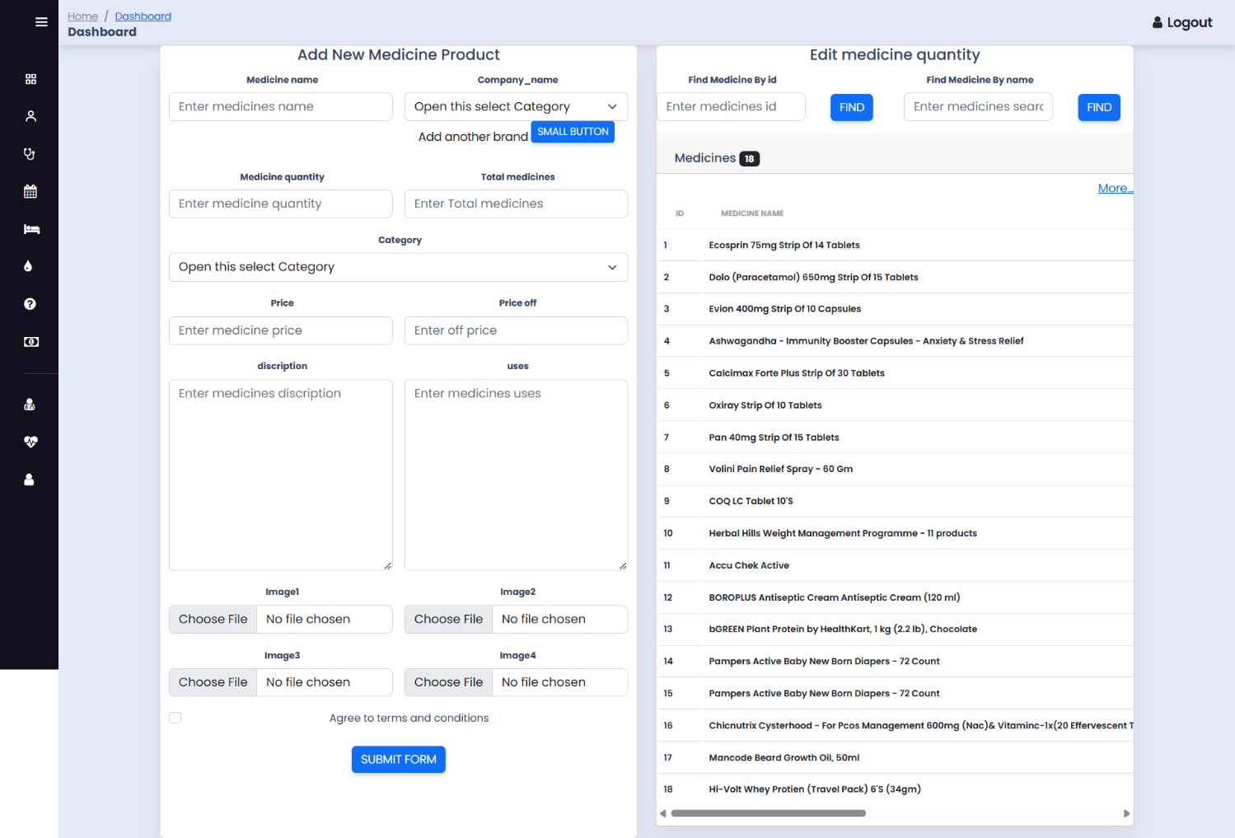

**Figure No. 7.25 :- Admin Medicine User Interface**

**Admin Lab Appointment User Interface**

Admin view all appointments of a particular lab test & patient with schedule date & visited history.

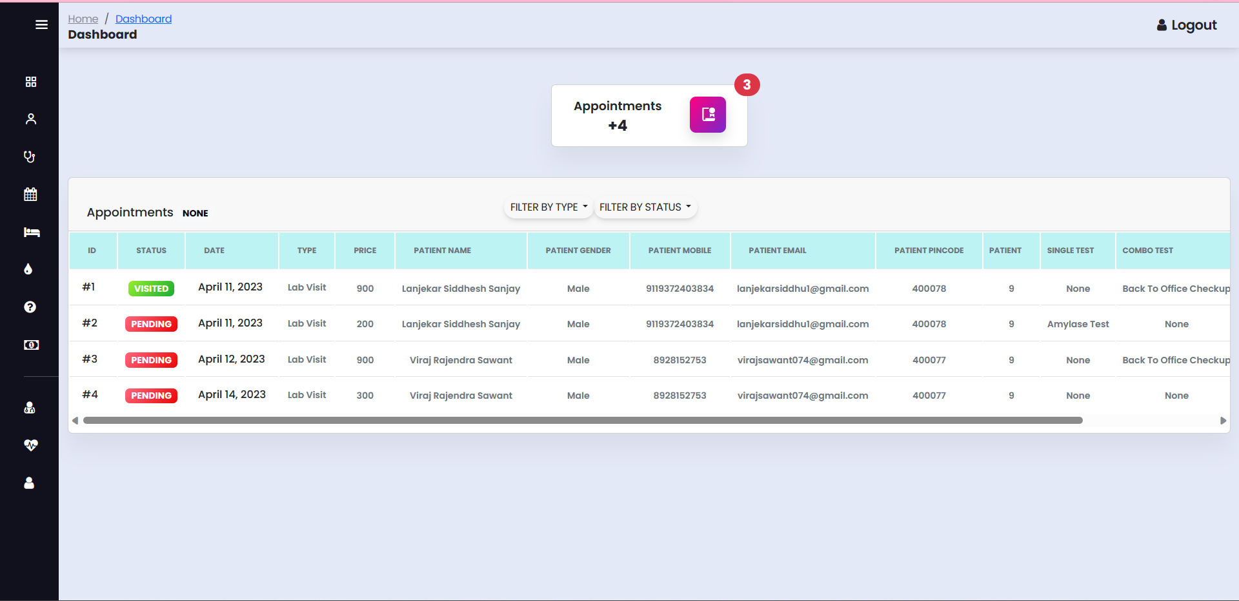

**Figure No. 7.26 :- Admin Lab Appointment User Interface**

**Admin Lab Test User Interface**

Admin is view all llab-tests with all details . Admin can Edit & delete Lab-tests.

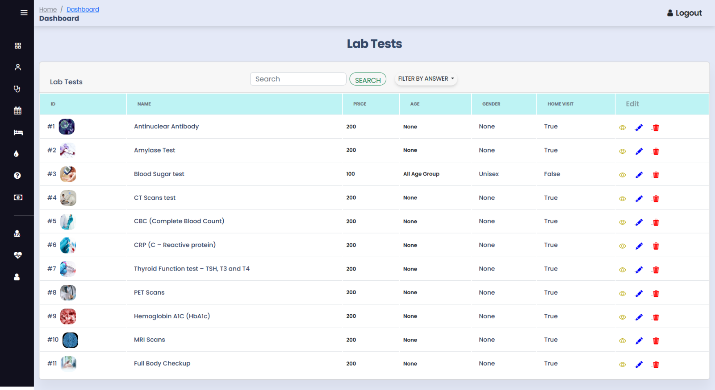

**Figure No. 7.27 :- Admin Lab Test User Interface**

**Admin Combo Lab Test Form User Interface**

Admin can create combo lab-tests with following form ; & adbjust price bestowing to admin.

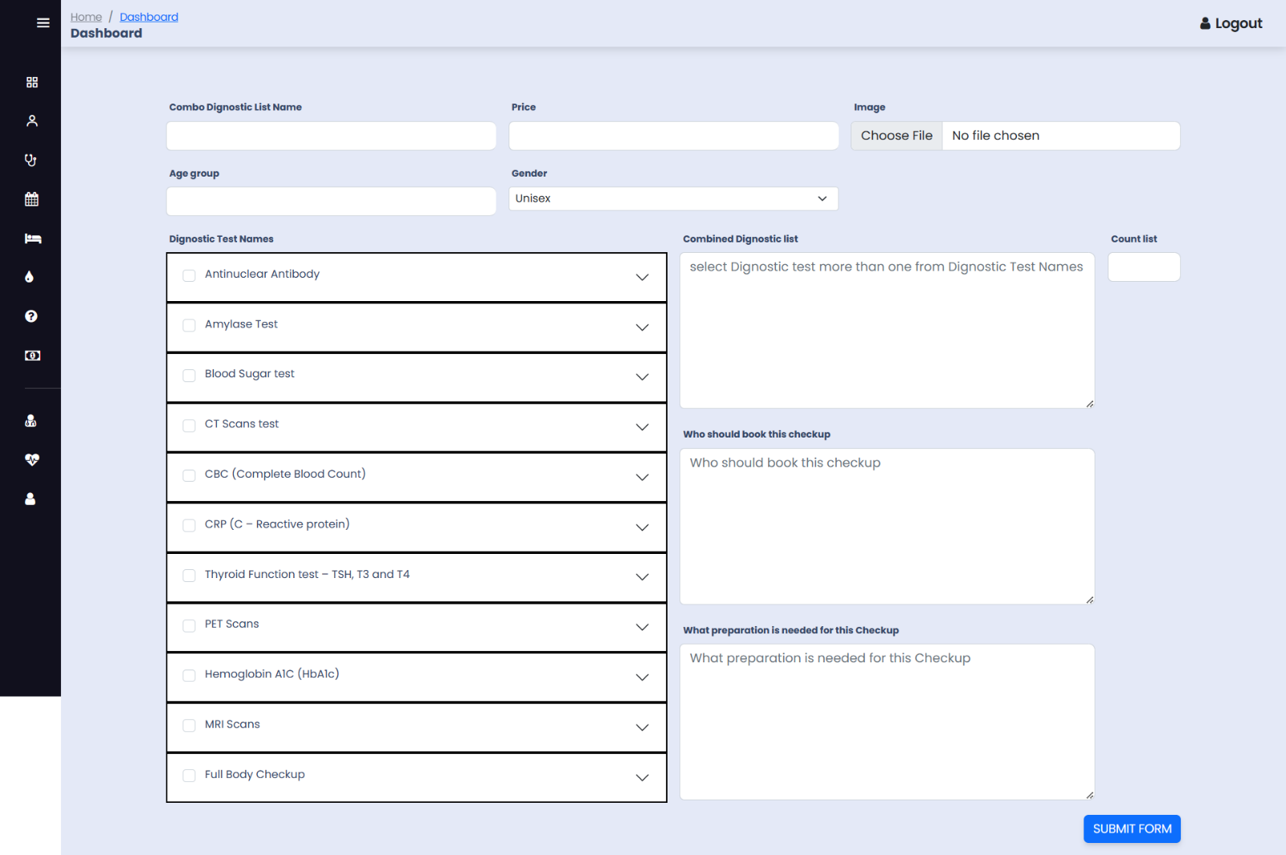

**Figure No. 7.28 :- Admin Combo Lab Test Form User Interface**

**Doctor Dashboard Home Page User Interface**

This is Doctor Dashboard Home page; In this page doctor view self-total appointments & total pending appointment also, doctor can view.

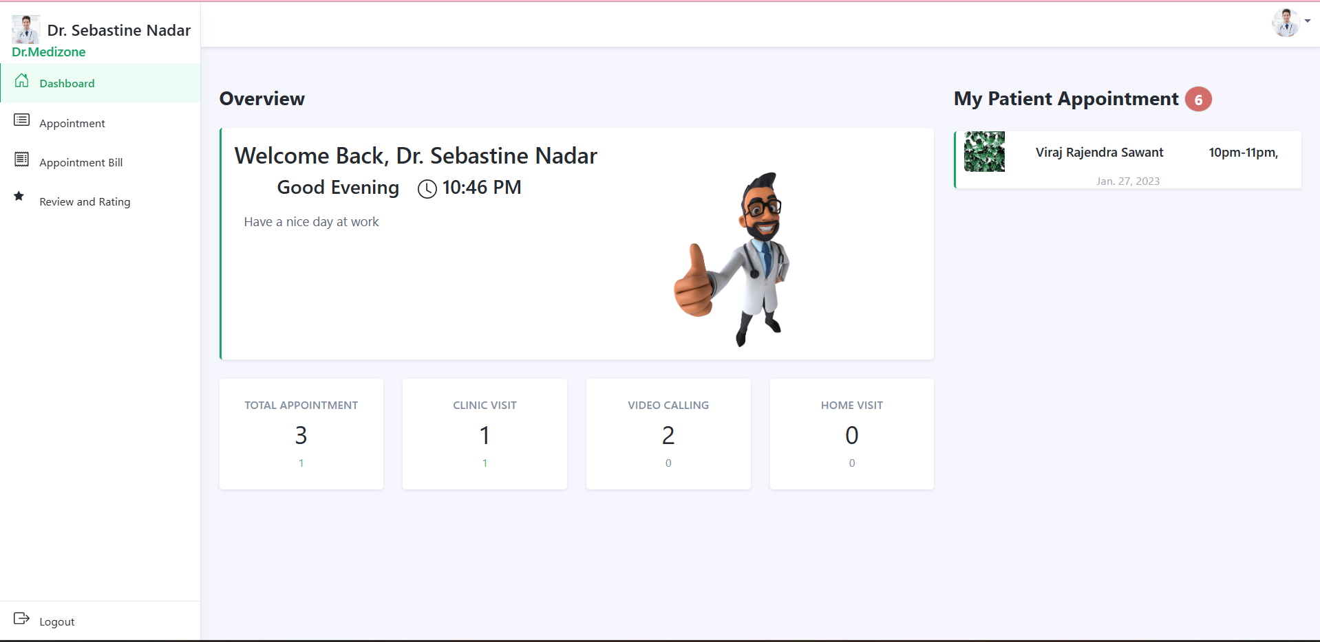

**Figure No. 7.29 :- Doctor Dashboard Home Page User Interface**

**Doctor Dashboard Appointments Page User Interface**

This appointment page; In this page doctors view appointment & appointment status; doctor can also reschedule appointment.

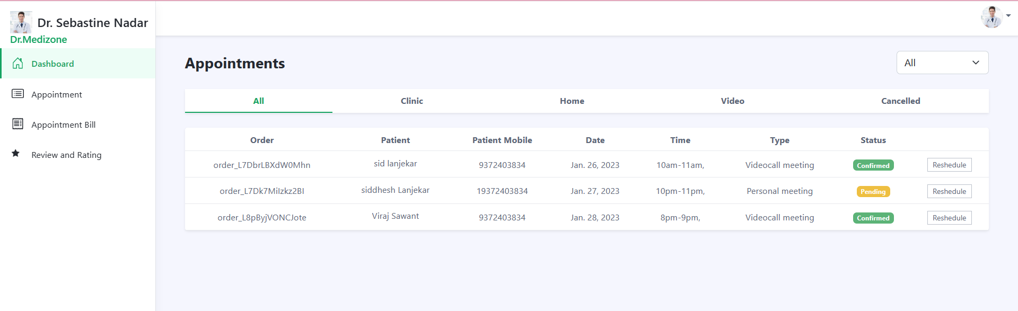

**Figure No. 7.30 :- Doctor Dashboard Appointments Page User Interface**

**Doctor Dashboard Appointments Bill Page User Interface**

This isppointment bill page; doctor can download receipt of ir appoinments & fillter also.

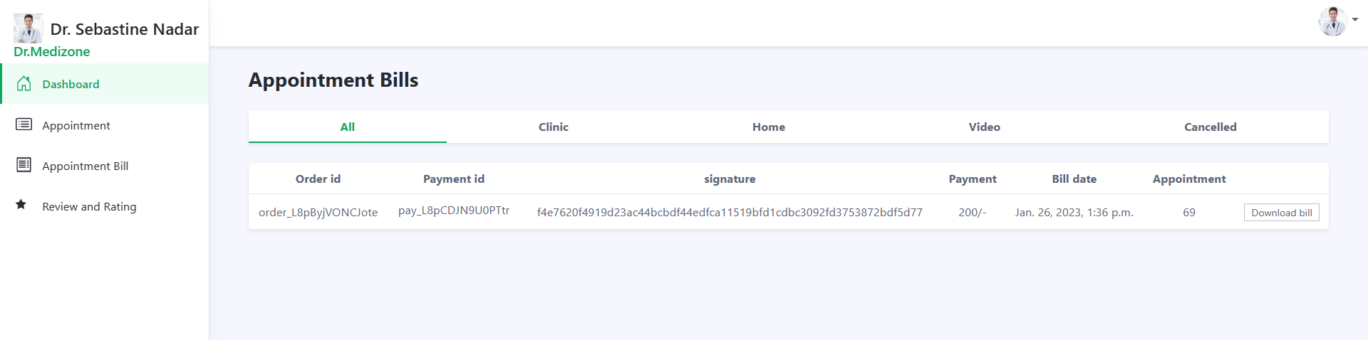

**Figure No. 7.31 :- Doctor Dashboard Appointments Bill Page User Interface**

**Doctor Dashboard Review & Rating Page User Interface**

This is review-rating page; In this page doctor view own ratings-reviews & patient also.

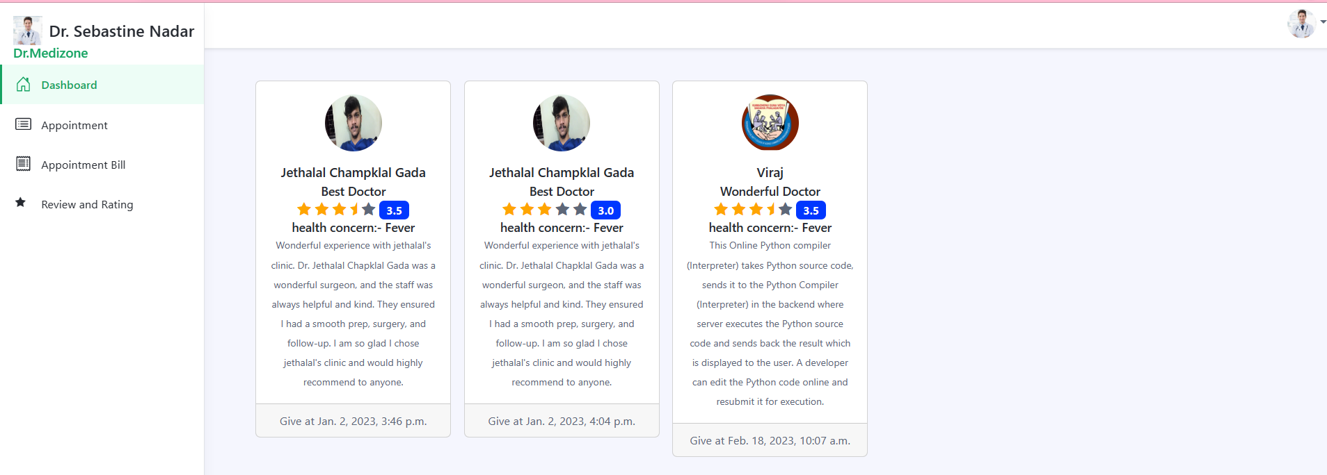

**Figure No. 7.32 :- Doctor Dashboard Review & Rating Page User Interface**

**Patient Dashboard Doctor Appointment Page User Interface**

Here Patients can see appointment list, prescription, billing & all related efforts in this

appointment system.

Here Patients can see appointment list, prescription, billing & all related efforts in this

appointment system.

Here Patients can see appointment list, prescription, billing & all related efforts in this

appointment system.

Here Patients can see doctor appointment list, Download appointment receipt, view appointment in details & all related efforts in this appointment system.

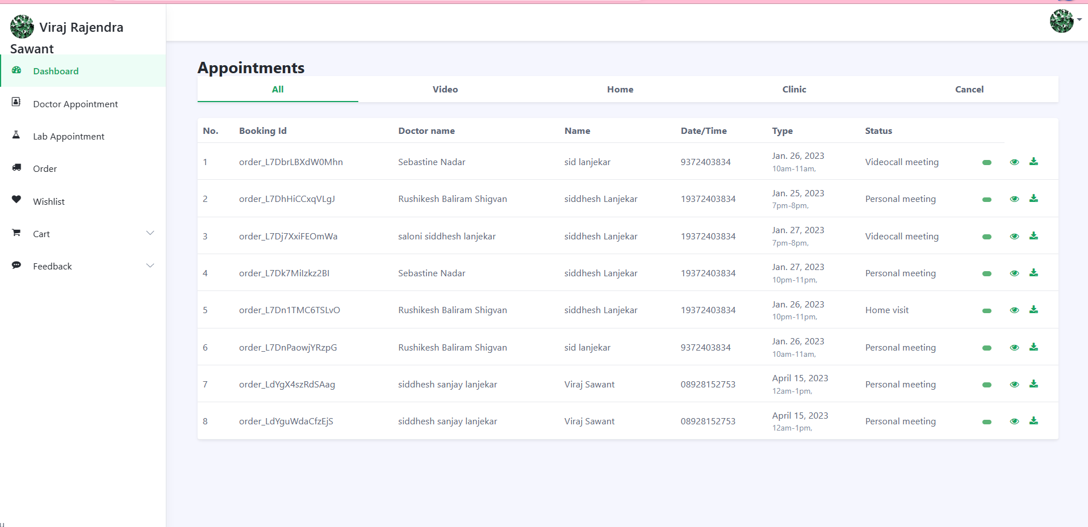

**Figure No. 7.33 :- Patient Dashboard Doctor Appointment Page User Interface**

**Patient Dashboard Lab Appointment Page User Interface**

Here Patients can see Lab appointment list, Download appointment receipt, view appointment in details & all related efforts in this appointment system.

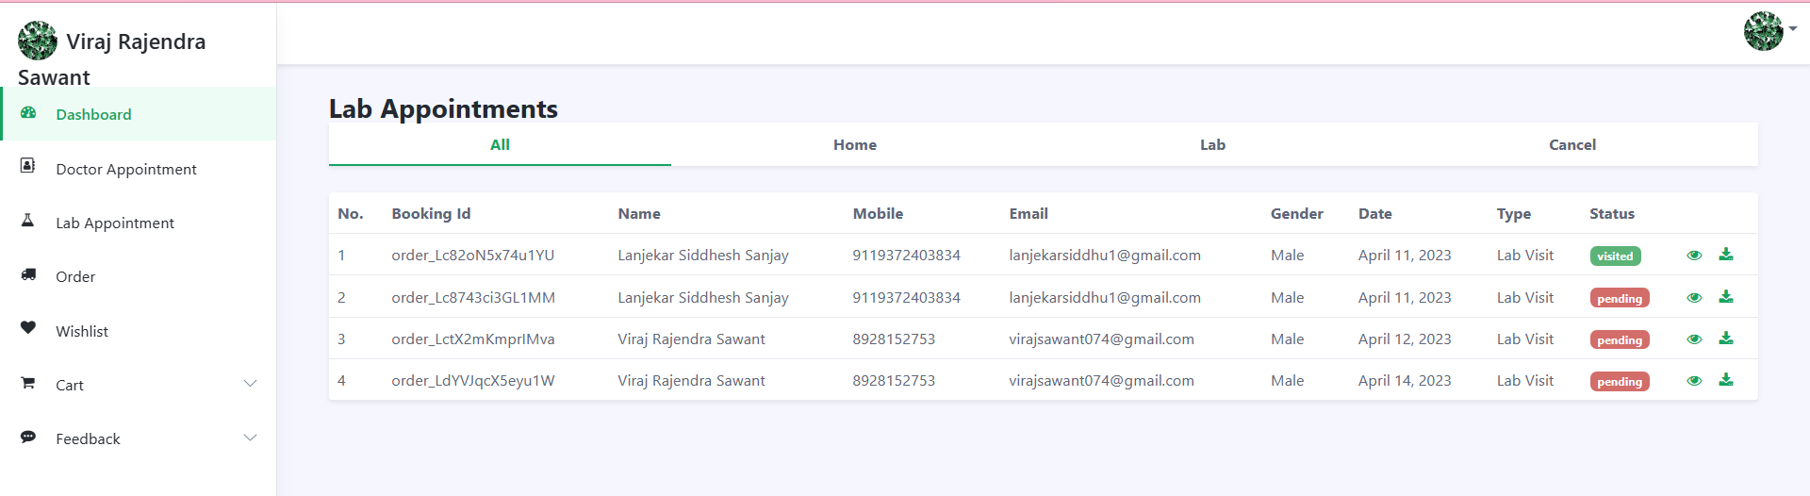

**Figure No. 7.34 :- Patient Dashboard Lab Appointment Page User Interface**

**Patient Dashboard Orders Page User Interface**

This is medicines order page; Patient can view own orders & status; patient can also download receipt of own orders

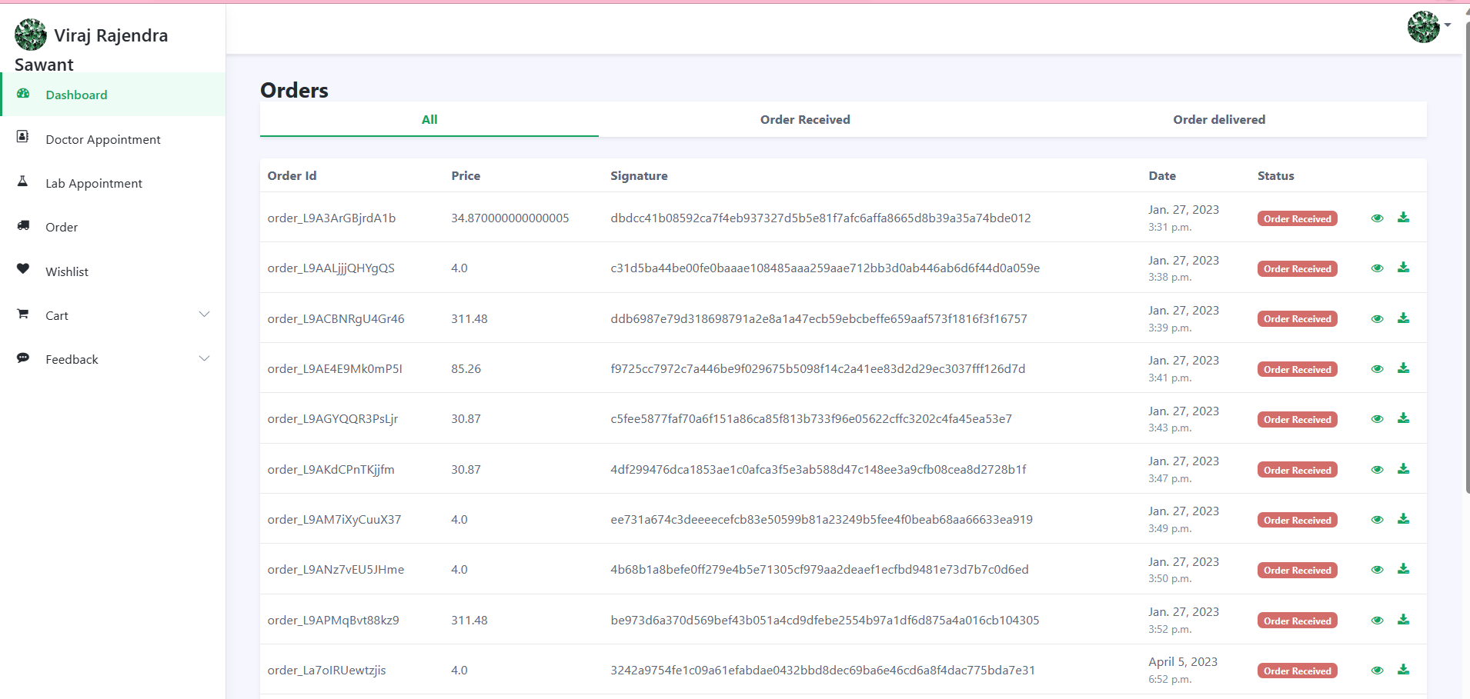

**Figure No. 7.35 :- Patient Dashboard Orders Page User Interface**

**Patient Dashboard Wishlist Page User Interface**

Patient can view his/her favourites medicines ; & Patient can unlike medicines.

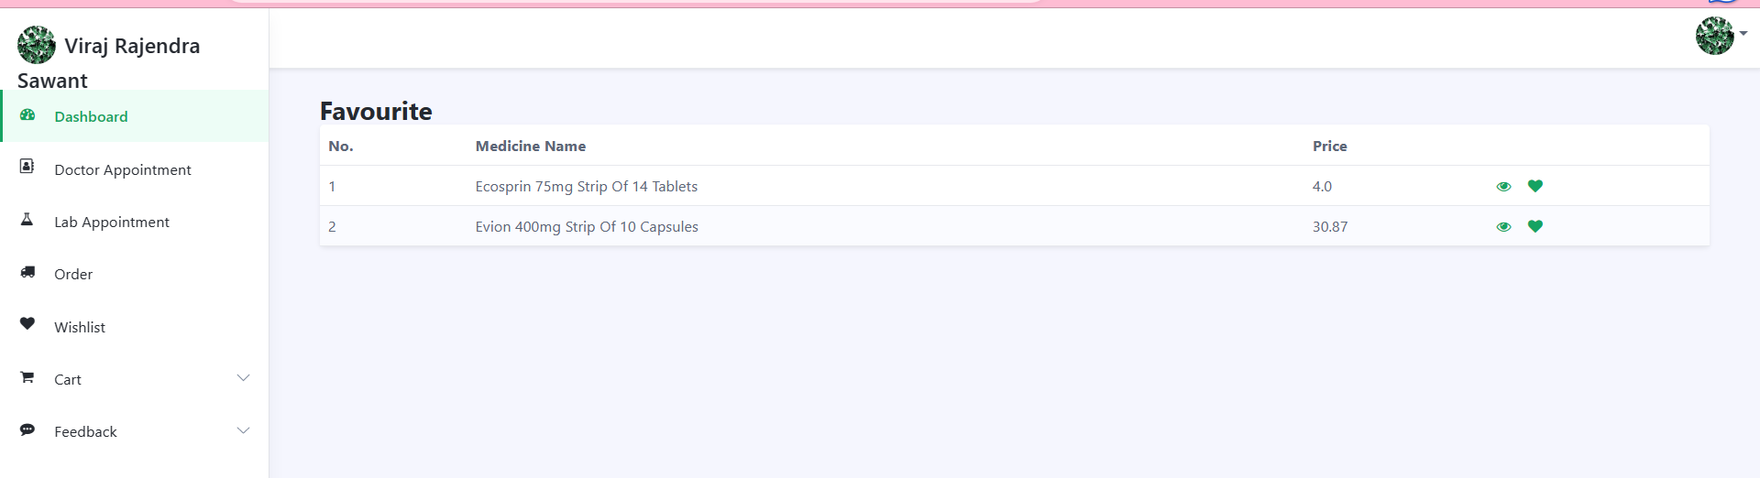

**Figure No. 7.36 :- Patient Dashboard Wishlist Page User Interface**

**Medicine Page User Interface**

This is Medicine home page; In this page patient can view medicines category vise; patient can add project in cart & In wishlist also.

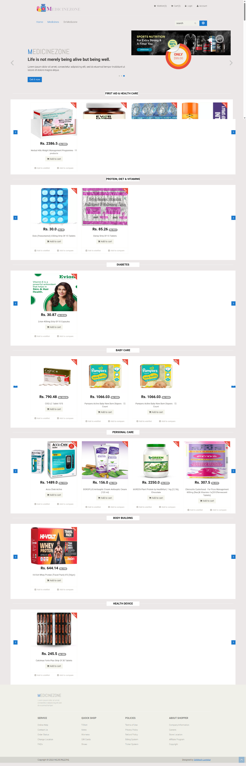

**Figure No. 7.37 :- Medicine Page User Interface**

**Medicine Project Page User Interface**

This is Medicine poduct page; In this page patient can filter medicines category vise & br& vise & star rating vise; patient can add project in cart & In wishlist also.

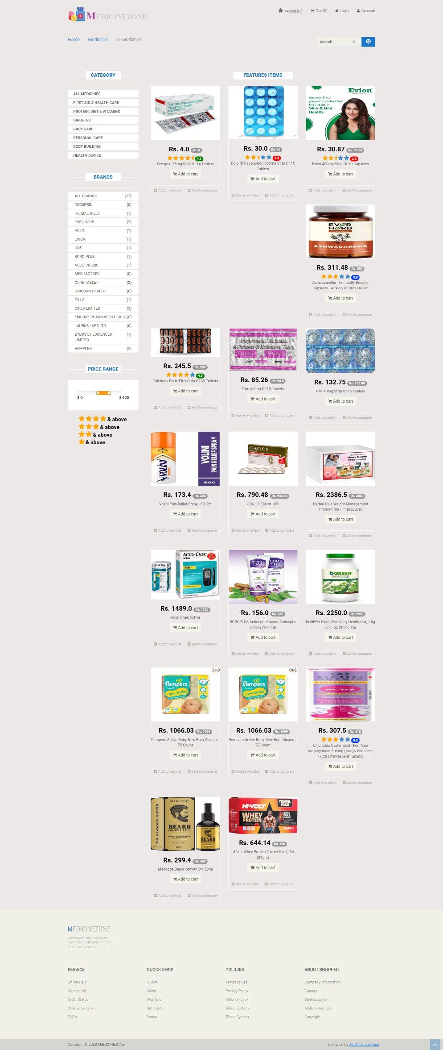

**Figure No. 7.38 :- Medicine Project Page User Interface**

**Medicine Project Detail Page User Interface**

This is medicine project detail page; in this page patient can view medicines in details. In this page patient can view ratings also. & give review & rating also if patient can login.

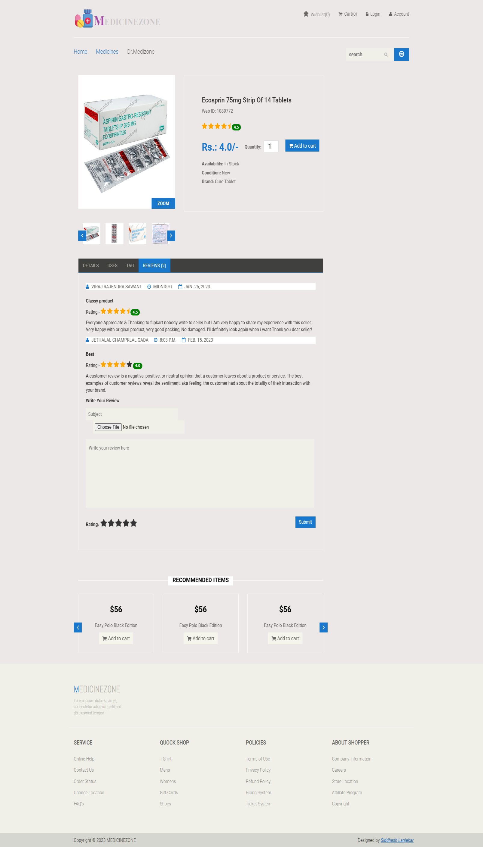

**Figure No. 7.39 :- Medicine Project Detail Page User Interface**

**Medicine Cart Page User Interface**

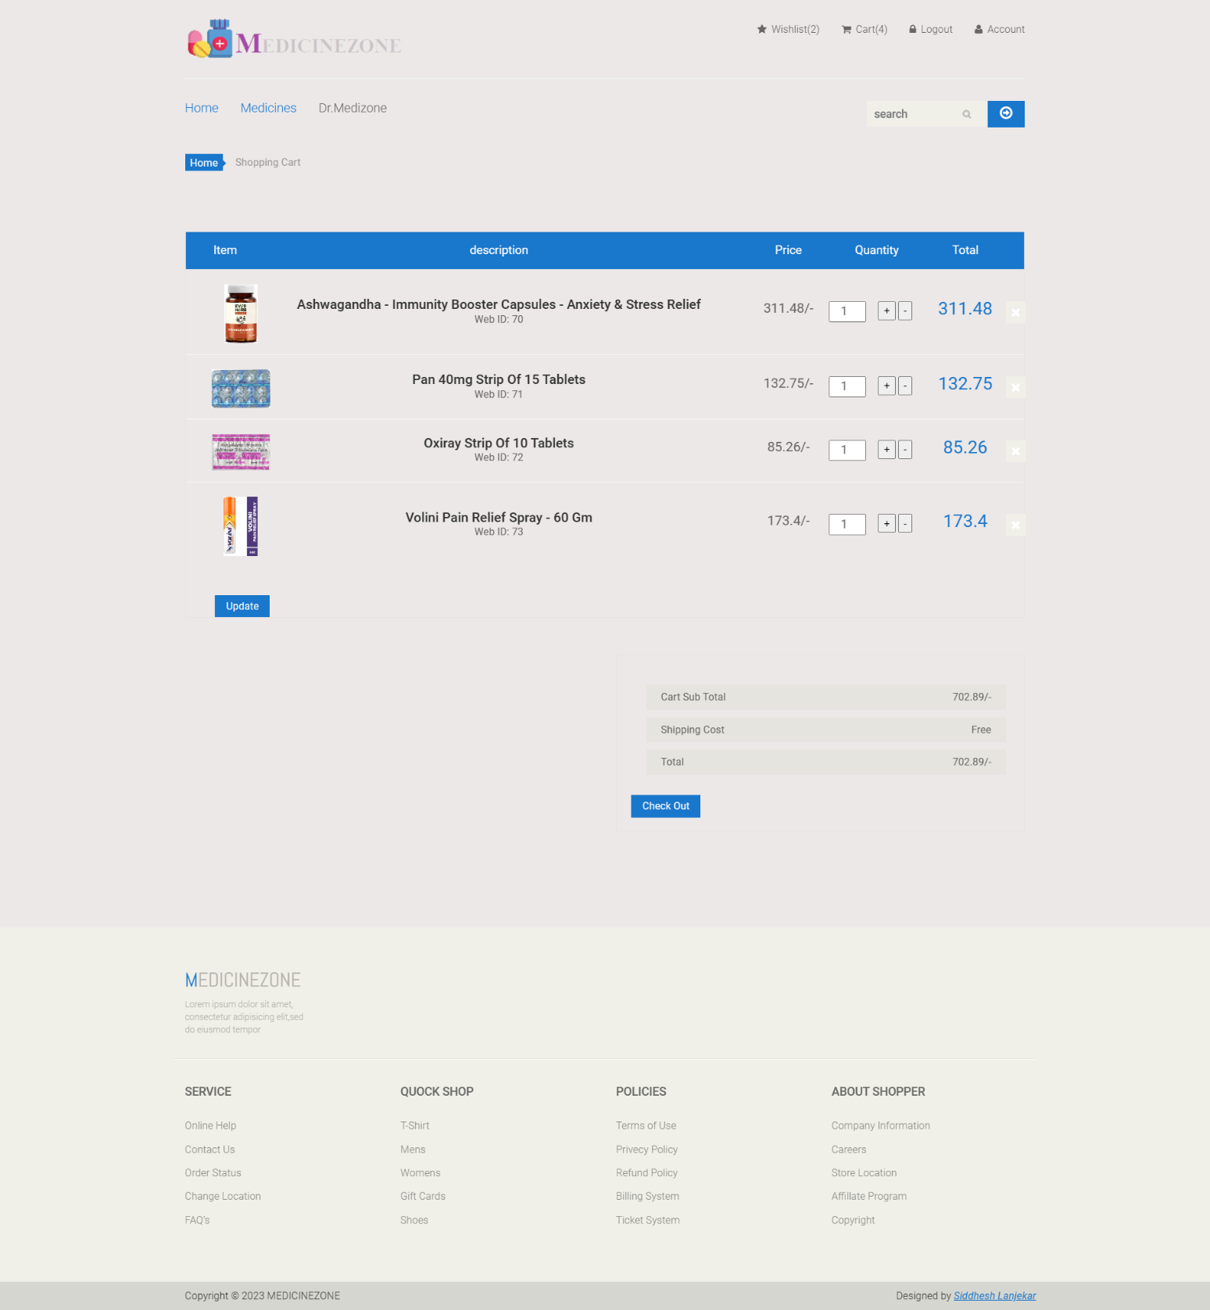

**Figure No. 7.40 :- Medicine Cart Page User Interface**

**Login Page User Interface**

This is login page; using this page admin, patient & doctors are login. After login users are use full project. If user is forgetting our password so click forget password & go to next procedures.

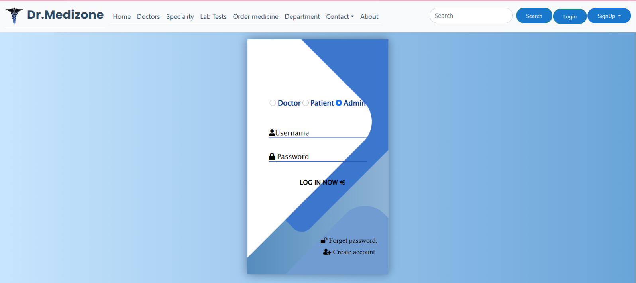

**Figure No. 7.41 :- Login Page User Interface**

**Doctor Registration Page User Interface**

Using this form a doctor is register self for using drmedizone Web-application & communicate- with patient; & grow over career.

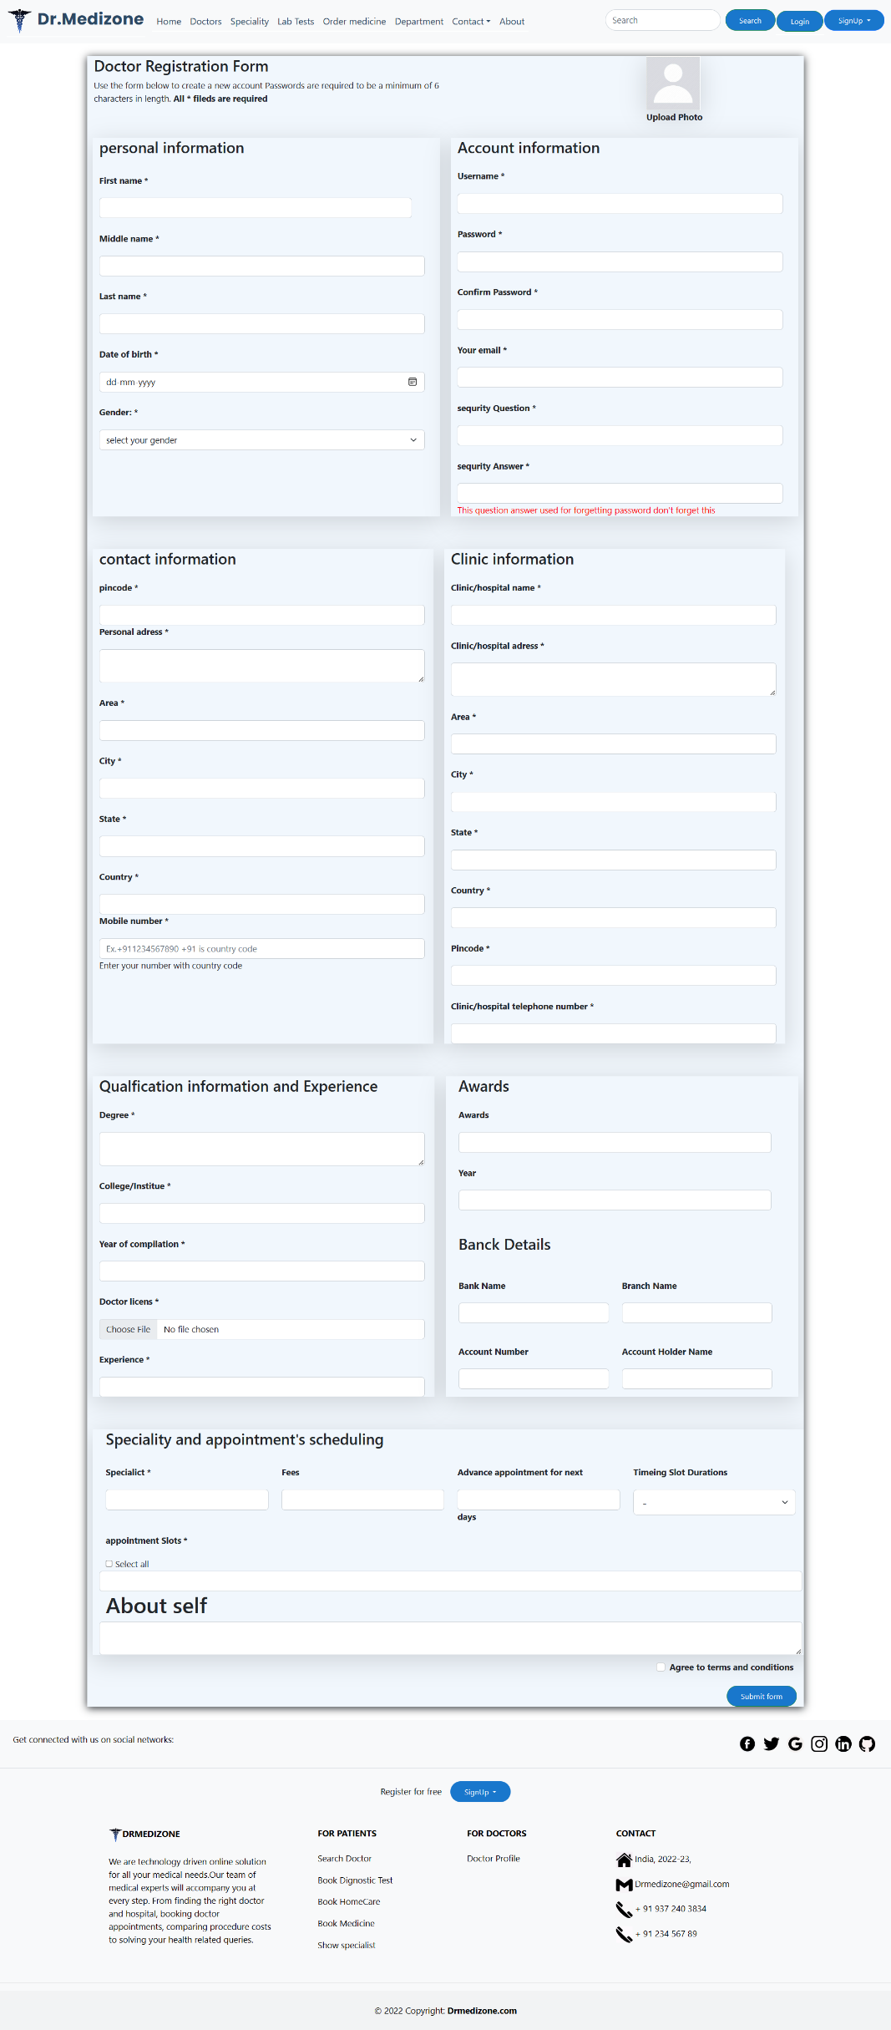

**Figure No. 7.42 :- Doctor Registration Page User Interface**

**Patient Registration Page User Interface**

Using this form a patient can register self for using drmedizone Web-application & interact with doctor; & take appointment with doctor as well as lab-tests; patient also buy medicine after registration.

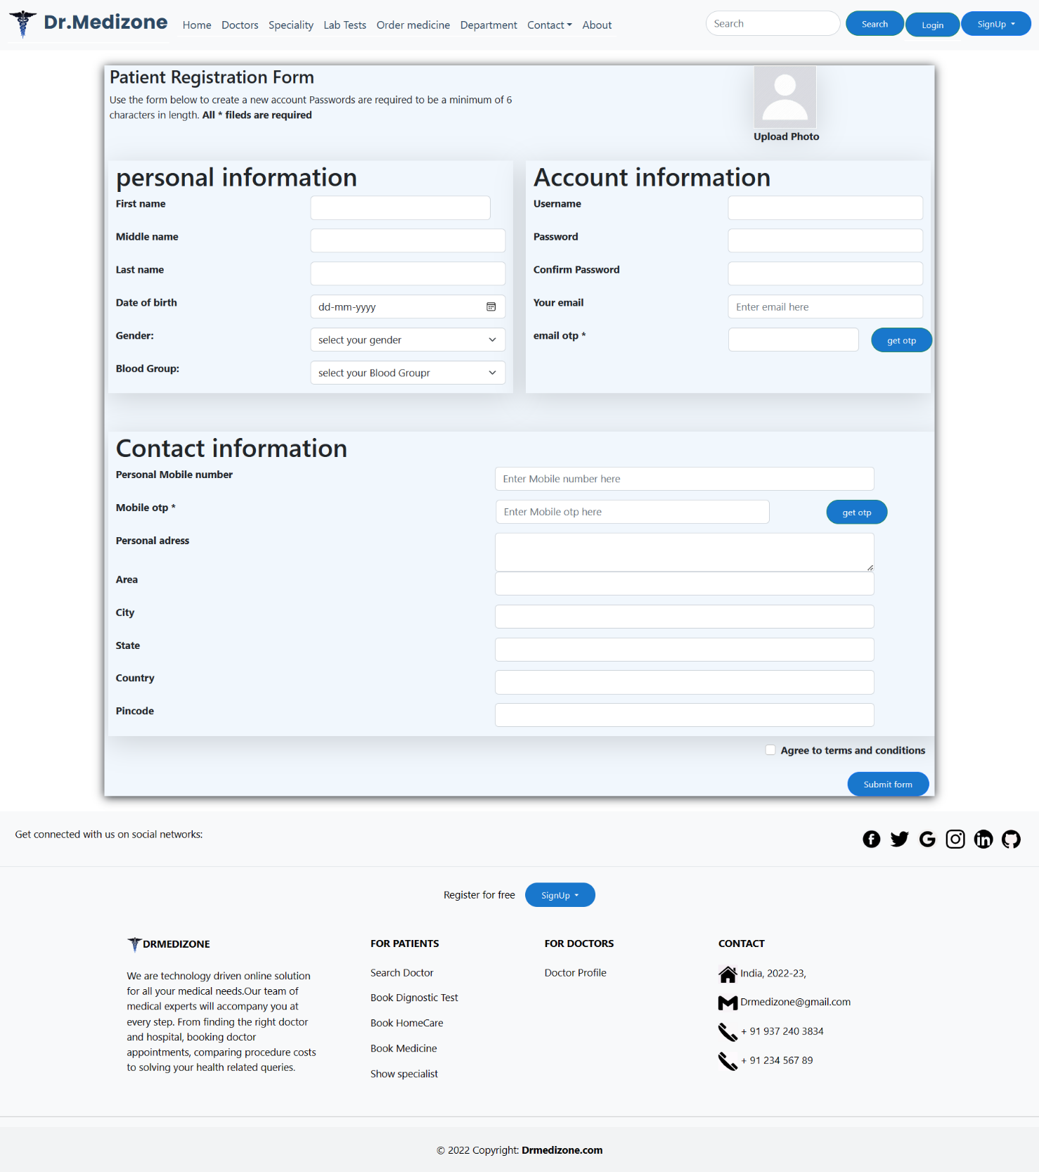

**Figure No. 7.43 :- Patient Registration Page User Interface**

**OTP verification Page User Interface**

This is OTP verification page for forgetting password of doctor & patient; This is one minute OTP page; after one minute OTP are discarded. If users are can’t enter OTP within one minute n resend option are visible for new OTP.

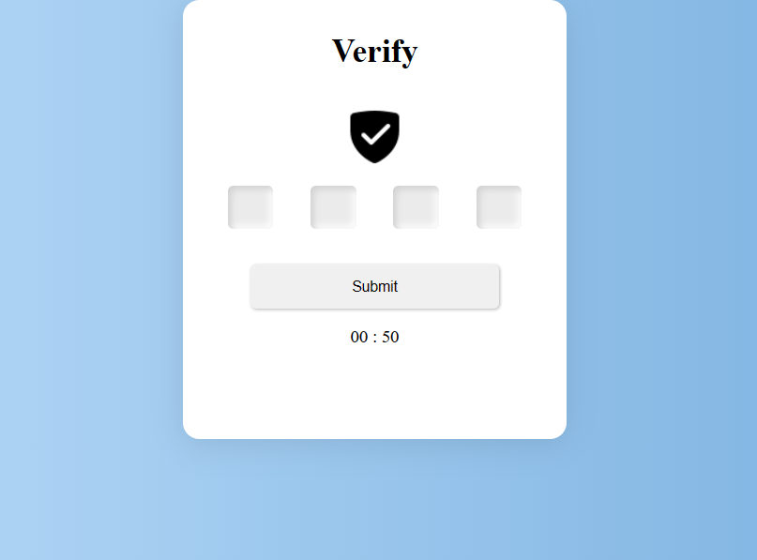

**Figure No. 7.44 :- OTP verification Page User Interface**

**Chapter 8 – Result & Discussion**

1. **Test report**

method of developing test cases can help you uncover problems in application's necessities or design. Case is established of conditions where tester can regulate where system happens necessities. re are possible bugs or holes in system, test belongings will help identify those bugs & can be solved using test cases. therefore, proper testing is required to expect minimal errors. Although 100% testing is impossible, we must provide as much as possible. So, we want to select right test.

**Test report must be:**

* + - **Detailed :** It should provide a detailed description of testing activity, which showcases testing performed on project. No abstract information is included in this document.
    - **Clear :**  info in test statement would have clarity.
    - **Standard :** It must follow a standard template.
    - **Specific :** Summarize document in clear & concise points.

1. **Project Information:**

|  |  |
| --- | --- |
| **Project Overview** | |
| Project | Appointment System |
| Name of project | Drmedizone |
| Project description | A platform for patient can book appointments & buy medicines; doctor scheduled appointments. |

|  |  |
| --- | --- |
| **Project Duration** | |
| Start date | 12/09/2022 |
| End date | 10/04/2023 |

**Chapter 9 – Conclusion**

Drmedizone is web-based system that stunned matter of reserve appointments giving to user’s choice. plan suggestions an actual answer where users can view many appointments slots existing & choice select date & time. With this system doctor can set schedule. Doctor can easily manage appointment procedure & monitor. With this system time can be saved doctor & patients. Patient can book diagnostic appointments as select system that overwhelmed time. Patient can also buy medicine with exclusive offers. By above document anyone will be able to understand project at a glance. In this project –

A doctor can.

* Get & rescheduled appointments
* Get patient information
* Set his own schedule
* Send reports

A patient can.

* Easy to get doctor & diagnostic appointment
* See doctors & medicines
* Get report & receipts
* Able to connect doctor any time
* Buy medicines
* Pay online

**Limitations:**

As with any technology-supported action, automated problems are a possibility. It can be especially irritating to be in a change with a doctor & keep losing connection. Sometimes this system can be late as all are predictable fast loading system. When many more patients are relating with this Web-application maybe they will face problem as this may loading for sometimes. Actually, this type of error occurs when we extra websites by using internet. We are trying to fix this Web-application from facing bugs also. Hopefully we can fix all kind of problem to remove all kinds of problem. Even though Medical Appointment System has many advantages, are are some limitations as well.

1. **Future Scope:**

In the future, we would like to update our web application. We plan to add new features as we need more users. For example, our web application uses initial online help. Our main goal is to create a good online medical website for hospital management tools so that doctors and patients can get good treatment. We are looking for new features and ideas to use new things. We are also pleased to introduce it as telemedicine when we plan to use the video call service at drmedizone, because patients can listen to the doctor's instructions remotely. Hopefully we can achieve this in a few months. Since the main purpose of technology in health services is to increase the quality of patient care, it is necessary to switch to better technology. Future developments will help improve processes and make health systems stronger and more sustainable. As the burden of disease in the society increases, steps need to be taken to ensure that even people living in poor areas can get help from doctors and home treatment in a short time without going to distant cities.

**Chapter 10 – Bibliography**

Title of project: Drmedizone

Project type: Web-application

Project Developed by: Siddhesh Sanjay Lanjekar

**References**

* https://www.djangoproject.com/
* https://getbootstrap.com/
* https://www.youtube.com/
* https://www.w3schools.com/
* https://stackoverflow.com/
* https://www.python.org/
* https://fontawesome.com/